UNITED STATES
SECURITIES AND EXCHANGE COMMISSION
Washington, D.C. 20549
FORM 8-K

CURRENT REPORT
Pursuant to Section 13 or 15(d) of the
Securities Exchange Act of 1934

Date of Report (Date of earliest event reported): August 21, 2026

COSTAR GROUP, INC.
(Exact name of registrant as specified in its charter)
Delaware |  |  | 0-24531 |  |  | 52-2091509
(State or other jurisdiction of incorporation or organization) |  |  | (Commission File Number) |  |  | (I.R.S. Employer Identification No.)
 |  |  | 1201 Wilson Blvd. |  |  | Arlington, |  |  | VA |  |  |  |  |  |  |  |  |  |  |  | 22209
(Address of principal executive offices) |  |  |  |  |  |  |  |  |  |  |  |  |  |  |  |  |  |  |  |  | (Zip Code)
Registrant’s telephone number, including area code: (202) 346-6500
Not Applicable
(Former name or former address, if changed since last report.)
Check the appropriate box below if the Form 8-K filing is intended to simultaneously satisfy the filing obligation of the registrant under any of the following provisions:
☐ Written communications pursuant to Rule 425 under the Securities Act (17 CFR 230.425)
☐ Soliciting material pursuant to Rule 14a-12 under the Exchange Act (17 CFR 240.14a-12)
☐ Pre-commencement communications pursuant to Rule 14d-2(b) under the Exchange Act (17 CFR 240.14d-2(b))
☐ Pre-commencement communications pursuant to Rule 13e-4(c) under the Exchange Act (17 CFR 240.13e-4(c))

Securities registered pursuant to Section 12(b) of the Act:
Title of each class |  |  | Trading Symbol |  |  | Name of each exchange on which registered
Common Stock ($0.01 par value) |  |  | CSGP |  |  | Nasdaq Global Select Market
Indicate by check mark whether the registrant is an emerging growth company as defined in Rule 405 of the Securities Act of 1933 (§230.405 of this chapter) or Rule 12b-2 of the Securities Exchange Act of 1934 (§240.12b-2 of this chapter).
Emerging Growth Company ☐

If an emerging growth company, indicate by check mark if the registrant has elected not to use the extended transition period for complying with any new or revised financial accounting standards provided pursuant to Section 13(a) of the Exchange Act.
☐

Item 7.01 Regulation FD Disclosure.

On August 21, 2026, CoStar Group, Inc., a Delaware corporation, issued a press release (the “Press Release”) announcing the completion of its acquisition of Bora, Inc., a Delaware corporation, and its subsidiaries (together, “Zonda”), for $800 million in cash. A copy of the Press Release is hereby furnished as Exhibit 99.1 to this Current Report on Form 8-K.

The information contained in this Item 7.01 and in Exhibit 99.1 of this Current Report on Form 8-K shall be considered “furnished” and shall not be deemed “filed” for purposes of Section 18 of the Securities Exchange Act of 1934, as amended, or otherwise subject to the liabilities of that Section or Sections 11 and 12(a)(2) of the Securities Act of 1933, as amended, nor shall it be incorporated by reference to any reports or filings with the Securities and Exchange Commission, whether made before or after the date hereof, except as expressly set forth by specific reference in such a filing.

Item 9.01 Financial Statements and Exhibits.

Exhibit No. Description
99.1 CoStar Group, Inc. Press Release dated August 21, 2026.
104 Cover Page Interactive Data File (formatted as inline XBRL and contained in Exhibit 101).

SIGNATURES

Pursuant to the requirements of the Securities Exchange Act of 1934, the registrant has duly caused this report to be signed on its behalf by the undersigned hereunto duly authorized.
 |  |  |  |  |  | COSTAR GROUP, INC.
 |  |  |  |  |  | By:
Date: |  |  | August 21, 2026 |  |  | /s/ Robin Rossmann
 |  |  |  |  |  | Name: Robin Rossmann
 |  |  |  |  |  | Title: Chief Financial Officer
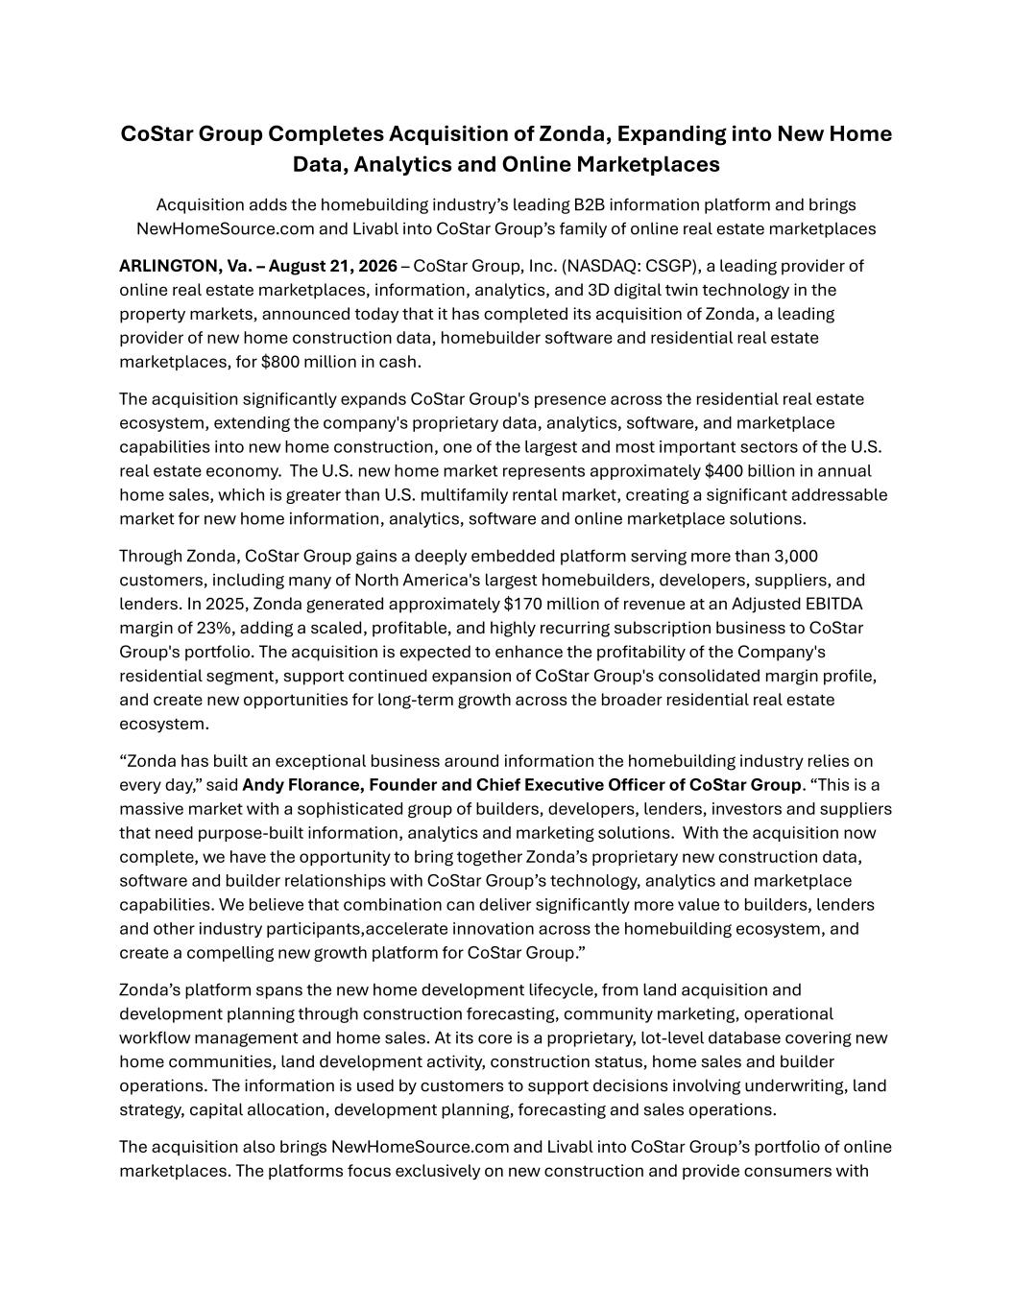

CoStar Group Completes Acquisition of Zonda, Expanding into New Home Data, Analytics and Online Marketplaces Acquisition adds the homebuilding industry’s leading B2B information platform and brings NewHomeSource.com and Livabl into CoStar Group’s family of online real estate marketplaces ARLINGTON, Va. – August 21, 2026 – CoStar Group, Inc. (NASDAQ: CSGP), a leading provider of online real estate marketplaces, information, analytics, and 3D digital twin technology in the property markets, announced today that it has completed its acquisition of Zonda, a leading provider of new home construction data, homebuilder software and residential real estate marketplaces, for $800 million in cash. The acquisition significantly expands CoStar Group's presence across the residential real estate ecosystem, extending the company's proprietary data, analytics, software, and marketplace capabilities into new home construction, one of the largest and most important sectors of the U.S. real estate economy. The U.S. new home market represents approximately $400 billion in annual home sales, which is greater than U.S. multifamily rental market, creating a significant addressable market for new home information, analytics, software and online marketplace solutions. Through Zonda, CoStar Group gains a deeply embedded platform serving more than 3,000 customers, including many of North America's largest homebuilders, developers, suppliers, and lenders. In 2025, Zonda generated approximately $170 million of revenue at an Adjusted EBITDA margin of 23%, adding a scaled, profitable, and highly recurring subscription business to CoStar Group's portfolio. The acquisition is expected to enhance the profitability of the Company's residential segment, support continued expansion of CoStar Group's consolidated margin profile, and create new opportunities for long-term growth across the broader residential real estate ecosystem. “Zonda has built an exceptional business around information the homebuilding industry relies on every day,” said Andy Florance, Founder and Chief Executive Officer of CoStar Group. “This is a massive market with a sophisticated group of builders, developers, lenders, investors and suppliers that need purpose-built information, analytics and marketing solutions. With the acquisition now complete, we have the opportunity to bring together Zonda’s proprietary new construction data, software and builder relationships with CoStar Group’s technology, analytics and marketplace capabilities. We believe that combination can deliver significantly more value to builders, lenders and other industry participants,accelerate innovation across the homebuilding ecosystem, and create a compelling new growth platform for CoStar Group.” Zonda’s platform spans the new home development lifecycle, from land acquisition and development planning through construction forecasting, community marketing, operational workflow management and home sales. At its core is a proprietary, lot-level database covering new home communities, land development activity, construction status, home sales and builder operations. The information is used by customers to support decisions involving underwriting, land strategy, capital allocation, development planning, forecasting and sales operations. The acquisition also brings NewHomeSource.com and Livabl into CoStar Group’s portfolio of online marketplaces. The platforms focus exclusively on new construction and provide consumers with

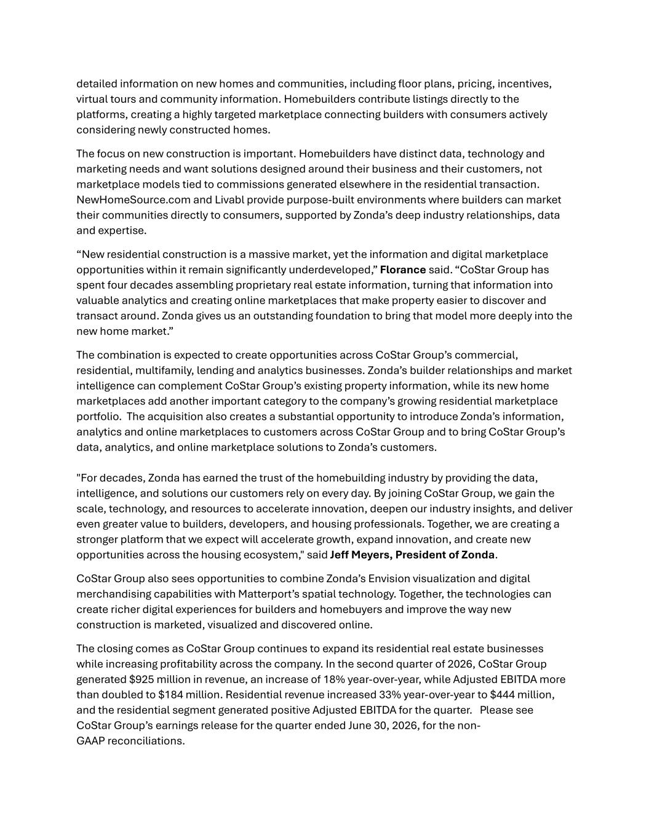
detailed information on new homes and communities, including floor plans, pricing, incentives, virtual tours and community information. Homebuilders contribute listings directly to the platforms, creating a highly targeted marketplace connecting builders with consumers actively considering newly constructed homes. The focus on new construction is important. Homebuilders have distinct data, technology and marketing needs and want solutions designed around their business and their customers, not marketplace models tied to commissions generated elsewhere in the residential transaction. NewHomeSource.com and Livabl provide purpose-built environments where builders can market their communities directly to consumers, supported by Zonda’s deep industry relationships, data and expertise. “New residential construction is a massive market, yet the information and digital marketplace opportunities within it remain significantly underdeveloped,” Florance said. “CoStar Group has spent four decades assembling proprietary real estate information, turning that information into valuable analytics and creating online marketplaces that make property easier to discover and transact around. Zonda gives us an outstanding foundation to bring that model more deeply into the new home market.” The combination is expected to create opportunities across CoStar Group’s commercial, residential, multifamily, lending and analytics businesses. Zonda’s builder relationships and market intelligence can complement CoStar Group’s existing property information, while its new home marketplaces add another important category to the company’s growing residential marketplace portfolio. The acquisition also creates a substantial opportunity to introduce Zonda’s information, analytics and online marketplaces to customers across CoStar Group and to bring CoStar Group’s data, analytics, and online marketplace solutions to Zonda’s customers. "For decades, Zonda has earned the trust of the homebuilding industry by providing the data, intelligence, and solutions our customers rely on every day. By joining CoStar Group, we gain the scale, technology, and resources to accelerate innovation, deepen our industry insights, and deliver even greater value to builders, developers, and housing professionals. Together, we are creating a stronger platform that we expect will accelerate growth, expand innovation, and create new opportunities across the housing ecosystem," said Jeff Meyers, President of Zonda. CoStar Group also sees opportunities to combine Zonda’s Envision visualization and digital merchandising capabilities with Matterport’s spatial technology. Together, the technologies can create richer digital experiences for builders and homebuyers and improve the way new construction is marketed, visualized and discovered online. The closing comes as CoStar Group continues to expand its residential real estate businesses while increasing profitability across the company. In the second quarter of 2026, CoStar Group generated $925 million in revenue, an increase of 18% year-over-year, while Adjusted EBITDA more than doubled to $184 million. Residential revenue increased 33% year-over-year to $444 million, and the residential segment generated positive Adjusted EBITDA for the quarter. Please see CoStar Group’s earnings release for the quarter ended June 30, 2026, for the non- GAAP reconciliations.

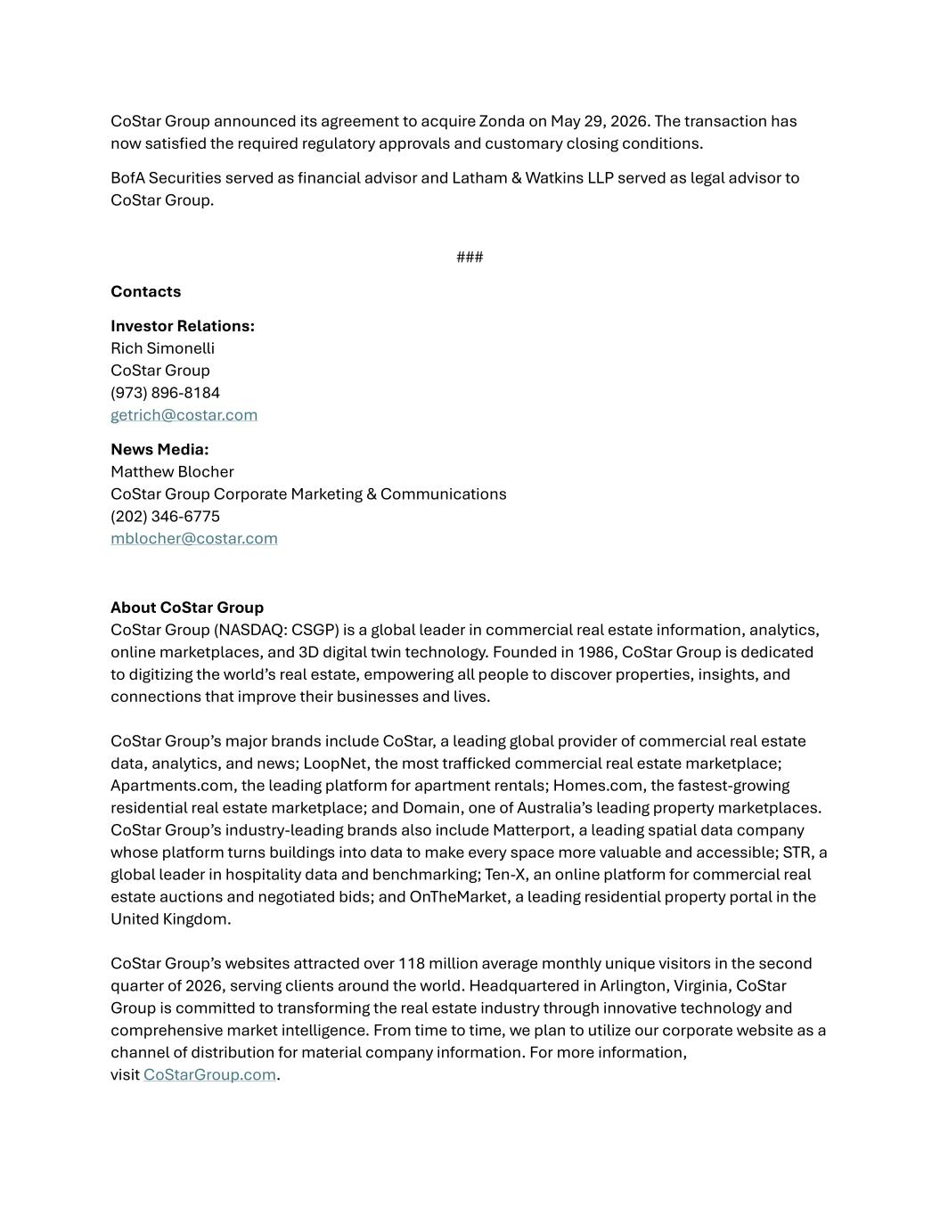
CoStar Group announced its agreement to acquire Zonda on May 29, 2026. The transaction has now satisfied the required regulatory approvals and customary closing conditions. BofA Securities served as financial advisor and Latham & Watkins LLP served as legal advisor to CoStar Group. ### Contacts Investor Relations: Rich Simonelli CoStar Group (973) 896-8184 getrich@costar.com News Media: Matthew Blocher CoStar Group Corporate Marketing & Communications (202) 346-6775 mblocher@costar.com About CoStar Group CoStar Group (NASDAQ: CSGP) is a global leader in commercial real estate information, analytics, online marketplaces, and 3D digital twin technology. Founded in 1986, CoStar Group is dedicated to digitizing the world’s real estate, empowering all people to discover properties, insights, and connections that improve their businesses and lives. CoStar Group’s major brands include CoStar, a leading global provider of commercial real estate data, analytics, and news; LoopNet, the most trafficked commercial real estate marketplace; Apartments.com, the leading platform for apartment rentals; Homes.com, the fastest-growing residential real estate marketplace; and Domain, one of Australia’s leading property marketplaces. CoStar Group’s industry-leading brands also include Matterport, a leading spatial data company whose platform turns buildings into data to make every space more valuable and accessible; STR, a global leader in hospitality data and benchmarking; Ten-X, an online platform for commercial real estate auctions and negotiated bids; and OnTheMarket, a leading residential property portal in the United Kingdom. CoStar Group’s websites attracted over 118 million average monthly unique visitors in the second quarter of 2026, serving clients around the world. Headquartered in Arlington, Virginia, CoStar Group is committed to transforming the real estate industry through innovative technology and comprehensive market intelligence. From time to time, we plan to utilize our corporate website as a channel of distribution for material company information. For more information, visit CoStarGroup.com.

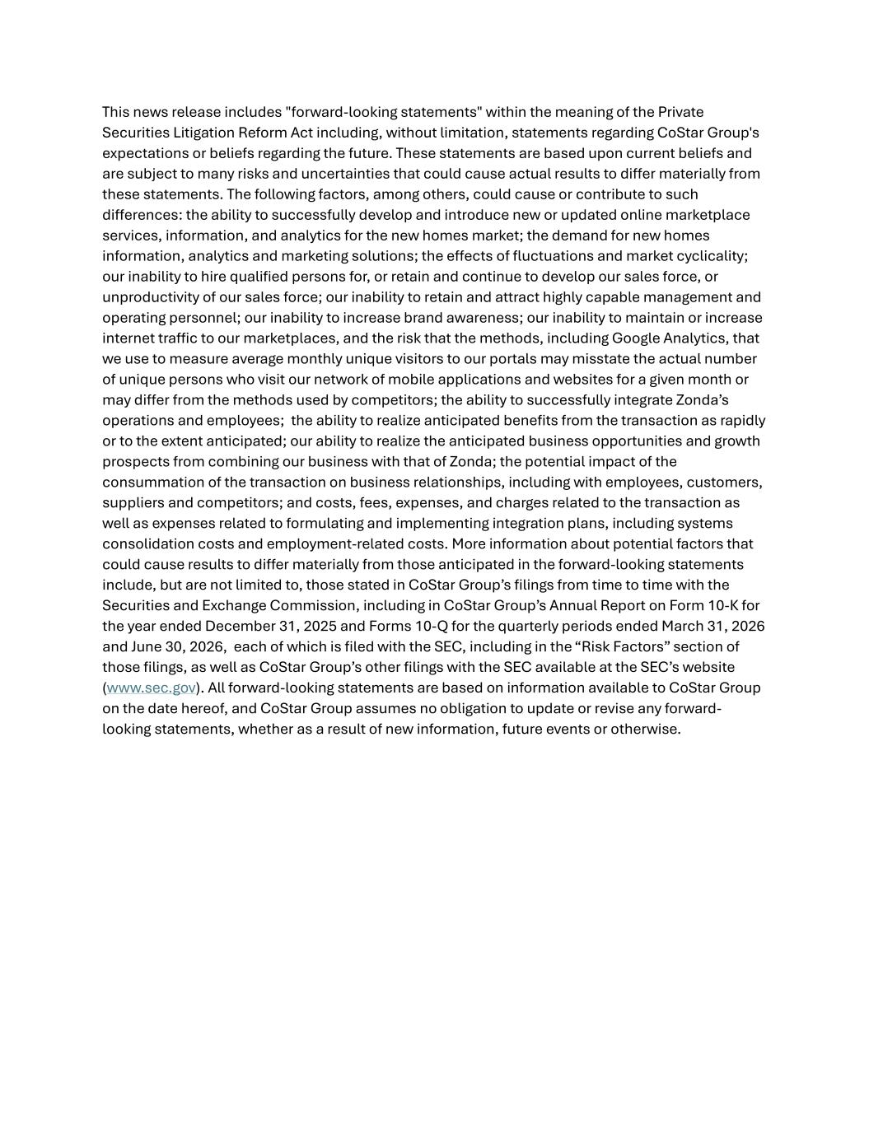
This news release includes "forward-looking statements" within the meaning of the Private Securities Litigation Reform Act including, without limitation, statements regarding CoStar Group's expectations or beliefs regarding the future. These statements are based upon current beliefs and are subject to many risks and uncertainties that could cause actual results to differ materially from these statements. The following factors, among others, could cause or contribute to such differences: the ability to successfully develop and introduce new or updated online marketplace services, information, and analytics for the new homes market; the demand for new homes information, analytics and marketing solutions; the effects of fluctuations and market cyclicality; our inability to hire qualified persons for, or retain and continue to develop our sales force, or unproductivity of our sales force; our inability to retain and attract highly capable management and operating personnel; our inability to increase brand awareness; our inability to maintain or increase internet traffic to our marketplaces, and the risk that the methods, including Google Analytics, that we use to measure average monthly unique visitors to our portals may misstate the actual number of unique persons who visit our network of mobile applications and websites for a given month or may differ from the methods used by competitors; the ability to successfully integrate Zonda’s operations and employees; the ability to realize anticipated benefits from the transaction as rapidly or to the extent anticipated; our ability to realize the anticipated business opportunities and growth prospects from combining our business with that of Zonda; the potential impact of the consummation of the transaction on business relationships, including with employees, customers, suppliers and competitors; and costs, fees, expenses, and charges related to the transaction as well as expenses related to formulating and implementing integration plans, including systems consolidation costs and employment-related costs. More information about potential factors that could cause results to differ materially from those anticipated in the forward-looking statements include, but are not limited to, those stated in CoStar Group’s filings from time to time with the Securities and Exchange Commission, including in CoStar Group’s Annual Report on Form 10-K for the year ended December 31, 2025 and Forms 10-Q for the quarterly periods ended March 31, 2026 and June 30, 2026, each of which is filed with the SEC, including in the “Risk Factors” section of those filings, as well as CoStar Group’s other filings with the SEC available at the SEC’s website (www.sec.gov). All forward-looking statements are based on information available to CoStar Group on the date hereof, and CoStar Group assumes no obligation to update or revise any forward- looking statements, whether as a result of new information, future events or otherwise.

