UNITED STATES
SECURITIES AND EXCHANGE COMMISSION
Washington, D.C. 20549
FORM 8-K

CURRENT REPORT
Pursuant to Section 13 or 15(d) of the
Securities Exchange Act of 1934

Date of Report (Date of earliest event reported): July 7, 2026

COSTAR GROUP, INC.
(Exact name of registrant as specified in its charter)
Delaware |  |  | 0-24531 |  |  | 52-2091509
(State or other jurisdiction of incorporation or organization) |  |  | (Commission File Number) |  |  | (I.R.S. Employer Identification No.)
 |  |  | 1201 Wilson Blvd. |  |  | Arlington, |  |  | VA |  |  |  |  |  |  |  |  |  |  |  | 22209
(Address of principal executive offices) |  |  |  |  |  |  |  |  |  |  |  |  |  |  |  |  |  |  |  |  | (Zip Code)
Registrant’s telephone number, including area code: (202) 346-6500
Not Applicable
(Former name or former address, if changed since last report.)
Check the appropriate box below if the Form 8-K filing is intended to simultaneously satisfy the filing obligation of the registrant under any of the following provisions:
☐ Written communications pursuant to Rule 425 under the Securities Act (17 CFR 230.425)
☐ Soliciting material pursuant to Rule 14a-12 under the Exchange Act (17 CFR 240.14a-12)
☐ Pre-commencement communications pursuant to Rule 14d-2(b) under the Exchange Act (17 CFR 240.14d-2(b))
☐ Pre-commencement communications pursuant to Rule 13e-4(c) under the Exchange Act (17 CFR 240.13e-4(c))

Securities registered pursuant to Section 12(b) of the Act:
Title of each class |  |  | Trading Symbol |  |  | Name of each exchange on which registered
Common Stock ($0.01 par value) |  |  | CSGP |  |  | Nasdaq Global Select Market
Indicate by check mark whether the registrant is an emerging growth company as defined in Rule 405 of the Securities Act of 1933 (§230.405 of this chapter) or Rule 12b-2 of the Securities Exchange Act of 1934 (§240.12b-2 of this chapter).
Emerging growth company ☐

If an emerging growth company, indicate by check mark if the registrant has elected not to use the extended transition period for complying with any new or revised financial accounting standards provided pursuant to Section 13(a) of the Exchange Act.
☐

Item 5.02 Departure of Directors or Certain Officers; Election of Directors; Appointment of Certain Officers; Compensatory Arrangements of Certain Officers.

On July 13, 2026, the Board of Directors (the “Board”) of CoStar Group, Inc. (the “Company” or “CoStar Group”) appointed Robin Rossmann to serve as the Company’s Chief Financial Officer, effective July 31, 2026 (“Effective Date”). Mr. Rossmann, 45, who currently serves as the Company’s Managing Director, Europe, and is a member of the Company's executive leadership team, brings more than 20 years of financial, operational and strategic leadership experience to the role of Chief Financial Officer. Over his nearly seven years with the Company, Mr. Rossmann has led several of CoStar Group’s businesses internationally, distinguished himself by dramatically improving the margins of CoStar Group's European business while delivering double-digit revenue growth and launching CoStar in France. Rossmann joined STR in 2016, leading its businesses across EMEA, Asia Pacific and Latin America, and became part of CoStar Group through the Company's acquisition of STR in 2019. Over the past decade with STR and CoStar Group, he has played a central role in launching CoStar Group products across global markets, executing and integrating acquisitions, scaling international operations and advancing strategic initiatives that have strengthened the Company's competitive position. Prior to joining STR, Rossmann spent 13 years at Deloitte, where he served as a Senior Director advising many of the world's leading public and private real estate and hospitality companies across the United States, the United Kingdom and other international markets. His experience included financial assurance, internal controls and risk management, financial and commercial due diligence, capital markets transactions, debt advisory, valuation, business planning and investment appraisal. Mr. Rossmann is a Chartered Accountant (South Africa) and a graduate of Stellenbosch University.

In connection with Mr. Rossmann’s appointment, the Company entered into an offer letter agreement with him, pursuant to which, following the Effective Date, he will be entitled to receive an annual base salary of £440,000, which will transition to $590,000 upon his relocation to Arlington, VA (which is expected to occur following receipt of U.S. work authorization and on or before December 31, 2026). He will be eligible to receive an annual incentive bonus opportunity with a target of 100% of base salary. Additionally, Mr. Rossmann is entitled to receive a one-time equity grant (“Additional 2026 Equity Award”) under CoStar Group, Inc.’s 2025 Stock Incentive Plan (the “Plan”) valued at $2,500,000 as of July 31, 2026 (“Grant Date”). Consistent with the equity awards granted in 2026 to other executive officers of the Company, the Additional 2026 Equity Award will be structured as follows: (i) 40% in restricted stock units that vest in three equal, annual installments on or around the anniversary of the Grant Date, and (ii) 60% in the form of performance stock units that vest on the date that the Compensation Committee of the Board determines the extent to which the applicable performance metrics for the 2026 – 2028 performance period have been satisfied, in each case, subject generally to continued employment. The Additional 2026 Equity Award will be subject to the terms and conditions of the Plan and award agreements thereunder. In connection with his relocation to the United States upon receiving U.S. work authorization, Mr. Rossmann will be eligible to receive relocation services (with an additional payment for out-of-pocket tax costs) and a cash relocation subsidy equal to $500,000 in the aggregate (less applicable taxes and withholdings), which will be payable subject to continued employment in good standing.

Mr. Rossmann will also be eligible to participate in the Company’s Executive Severance Plan, as may be amended from time to time, on the same terms and conditions as the Company’s other “Executive Officers” (as defined therein).

The foregoing descriptions of the offer letter agreement and the Executive Severance Plan do not purport to be complete and are qualified in their entirety by reference to the full text of the offer letter agreement (which will be filed as an exhibit with the Company’s Quarterly Report on Form 10-Q for the quarterly period ending September 30, 2026) and the Executive Severance Plan.

On July 7, 2026, Christian Lown, Chief Financial Officer (Principal Financial Officer) of the Company, informed the Company of his decision to resign, effective July 31, 2026, for another opportunity outside the Company’s industry. Mr. Lown has advised the Company that his resignation was not a result of any disagreement with the Company on any matter related to the Company’s operations, policies or practices.

Item 7.01 Regulation FD Disclosure.

On July 13, 2026, the Company issued a press release (the “Press Release”) regarding the appointment of Mr. Rossmann as the Company’s Chief Financial Officer. A copy of the Press Release is attached hereto as Exhibit 99.1 and is incorporated by reference herein.

The information set forth in this Item 7.01, including Exhibit 99.1, is being furnished and shall not be deemed “filed” for purposes of Section 18 of the Securities Exchange Act of 1934, as amended (the “Exchange Act”), or otherwise subject to the liabilities of that section. The information set forth in this Item 7.01, including Exhibit 99.1, shall not be deemed incorporated by reference into any

other filing under the Securities Act of 1933, as amended, or the Exchange Act, except as shall be expressly set forth by specific reference in such a filing.

Item 9.01 Financial Statements and Exhibits.

(d) Exhibits.

Exhibit No. Description
99.1 CoStar Group, Inc. Press Release dated July 13, 2026.
104 Cover Page Interactive Data File (formatted as inline XBRL and contained in Exhibit 101).

SIGNATURES

Pursuant to the requirements of the Securities Exchange Act of 1934, the registrant has duly caused this report to be signed on its behalf by the undersigned hereunto duly authorized.
 |  |  |  |  |  | COSTAR GROUP, INC.
 |  |  |  |  |  | By:
Date: |  |  | July 13, 2026 |  |  | /s/ Gene Boxer
 |  |  |  |  |  | Name: Gene Boxer
 |  |  |  |  |  | Title: General Counsel and Corporate Secretary
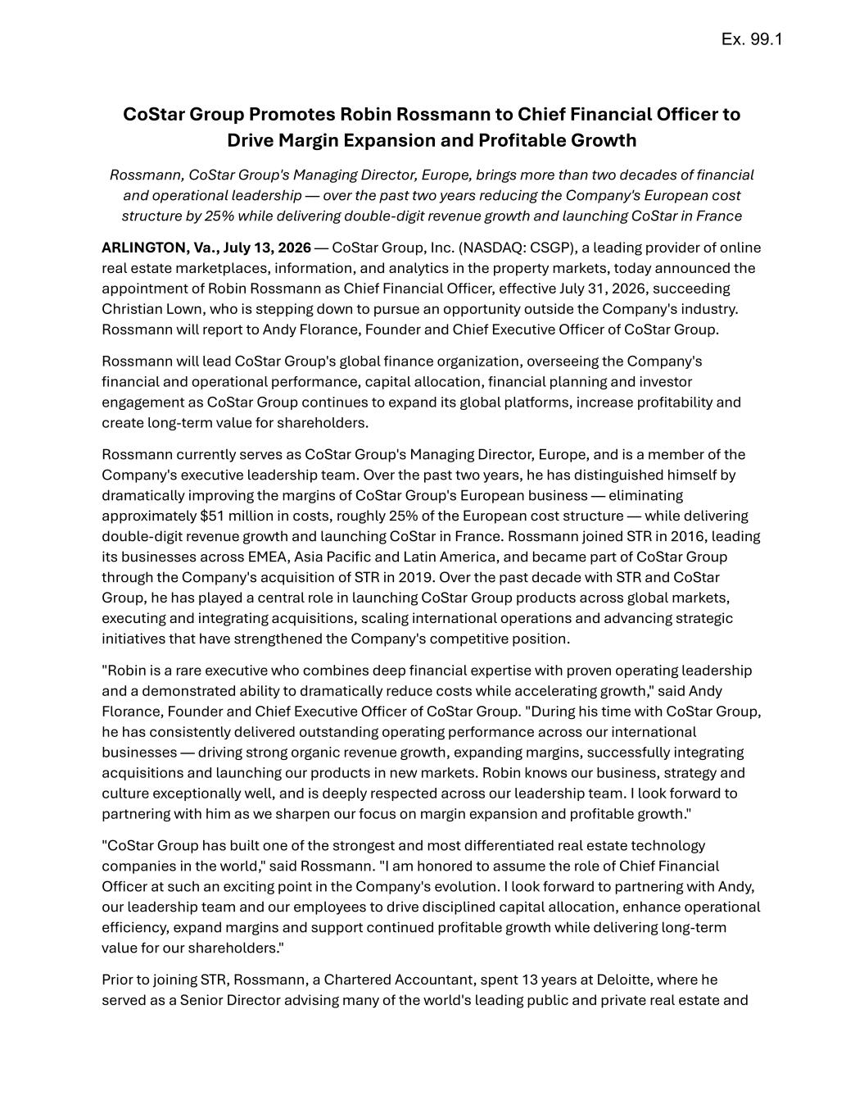

CoStar Group Promotes Robin Rossmann to Chief Financial Officer to Drive Margin Expansion and Profitable Growth Rossmann, CoStar Group's Managing Director, Europe, brings more than two decades of financial and operational leadership — over the past two years reducing the Company's European cost structure by 25% while delivering double-digit revenue growth and launching CoStar in France ARLINGTON, Va., July 13, 2026 — CoStar Group, Inc. (NASDAQ: CSGP), a leading provider of online real estate marketplaces, information, and analytics in the property markets, today announced the appointment of Robin Rossmann as Chief Financial Officer, effective July 31, 2026, succeeding Christian Lown, who is stepping down to pursue an opportunity outside the Company's industry. Rossmann will report to Andy Florance, Founder and Chief Executive Officer of CoStar Group. Rossmann will lead CoStar Group's global finance organization, overseeing the Company's financial and operational performance, capital allocation, financial planning and investor engagement as CoStar Group continues to expand its global platforms, increase profitability and create long-term value for shareholders. Rossmann currently serves as CoStar Group's Managing Director, Europe, and is a member of the Company's executive leadership team. Over the past two years, he has distinguished himself by dramatically improving the margins of CoStar Group's European business — eliminating approximately $51 million in costs, roughly 25% of the European cost structure — while delivering double-digit revenue growth and launching CoStar in France. Rossmann joined STR in 2016, leading its businesses across EMEA, Asia Pacific and Latin America, and became part of CoStar Group through the Company's acquisition of STR in 2019. Over the past decade with STR and CoStar Group, he has played a central role in launching CoStar Group products across global markets, executing and integrating acquisitions, scaling international operations and advancing strategic initiatives that have strengthened the Company's competitive position. "Robin is a rare executive who combines deep financial expertise with proven operating leadership and a demonstrated ability to dramatically reduce costs while accelerating growth," said Andy Florance, Founder and Chief Executive Officer of CoStar Group. "During his time with CoStar Group, he has consistently delivered outstanding operating performance across our international businesses — driving strong organic revenue growth, expanding margins, successfully integrating acquisitions and launching our products in new markets. Robin knows our business, strategy and culture exceptionally well, and is deeply respected across our leadership team. I look forward to partnering with him as we sharpen our focus on margin expansion and profitable growth." "CoStar Group has built one of the strongest and most differentiated real estate technology companies in the world," said Rossmann. "I am honored to assume the role of Chief Financial Officer at such an exciting point in the Company's evolution. I look forward to partnering with Andy, our leadership team and our employees to drive disciplined capital allocation, enhance operational efficiency, expand margins and support continued profitable growth while delivering long-term value for our shareholders." Prior to joining STR, Rossmann, a Chartered Accountant, spent 13 years at Deloitte, where he served as a Senior Director advising many of the world's leading public and private real estate and Ex. 99.1

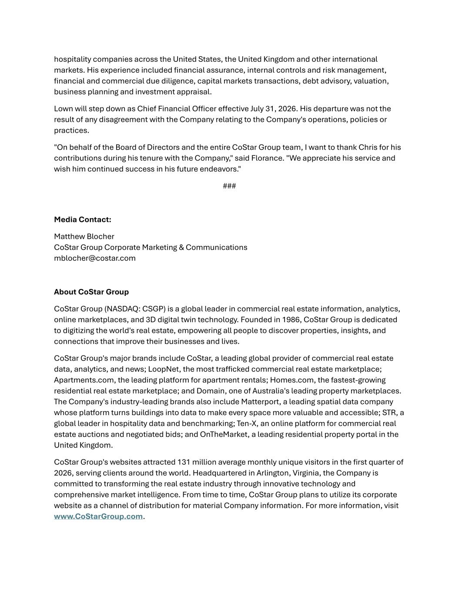
hospitality companies across the United States, the United Kingdom and other international markets. His experience included financial assurance, internal controls and risk management, financial and commercial due diligence, capital markets transactions, debt advisory, valuation, business planning and investment appraisal. Lown will step down as Chief Financial Officer effective July 31, 2026. His departure was not the result of any disagreement with the Company relating to the Company's operations, policies or practices. "On behalf of the Board of Directors and the entire CoStar Group team, I want to thank Chris for his contributions during his tenure with the Company," said Florance. "We appreciate his service and wish him continued success in his future endeavors." ### Media Contact: Matthew Blocher CoStar Group Corporate Marketing & Communications mblocher@costar.com About CoStar Group CoStar Group (NASDAQ: CSGP) is a global leader in commercial real estate information, analytics, online marketplaces, and 3D digital twin technology. Founded in 1986, CoStar Group is dedicated to digitizing the world's real estate, empowering all people to discover properties, insights, and connections that improve their businesses and lives. CoStar Group's major brands include CoStar, a leading global provider of commercial real estate data, analytics, and news; LoopNet, the most trafficked commercial real estate marketplace; Apartments.com, the leading platform for apartment rentals; Homes.com, the fastest-growing residential real estate marketplace; and Domain, one of Australia's leading property marketplaces. The Company's industry-leading brands also include Matterport, a leading spatial data company whose platform turns buildings into data to make every space more valuable and accessible; STR, a global leader in hospitality data and benchmarking; Ten-X, an online platform for commercial real estate auctions and negotiated bids; and OnTheMarket, a leading residential property portal in the United Kingdom. CoStar Group's websites attracted 131 million average monthly unique visitors in the first quarter of 2026, serving clients around the world. Headquartered in Arlington, Virginia, the Company is committed to transforming the real estate industry through innovative technology and comprehensive market intelligence. From time to time, CoStar Group plans to utilize its corporate website as a channel of distribution for material Company information. For more information, visit www.CoStarGroup.com.

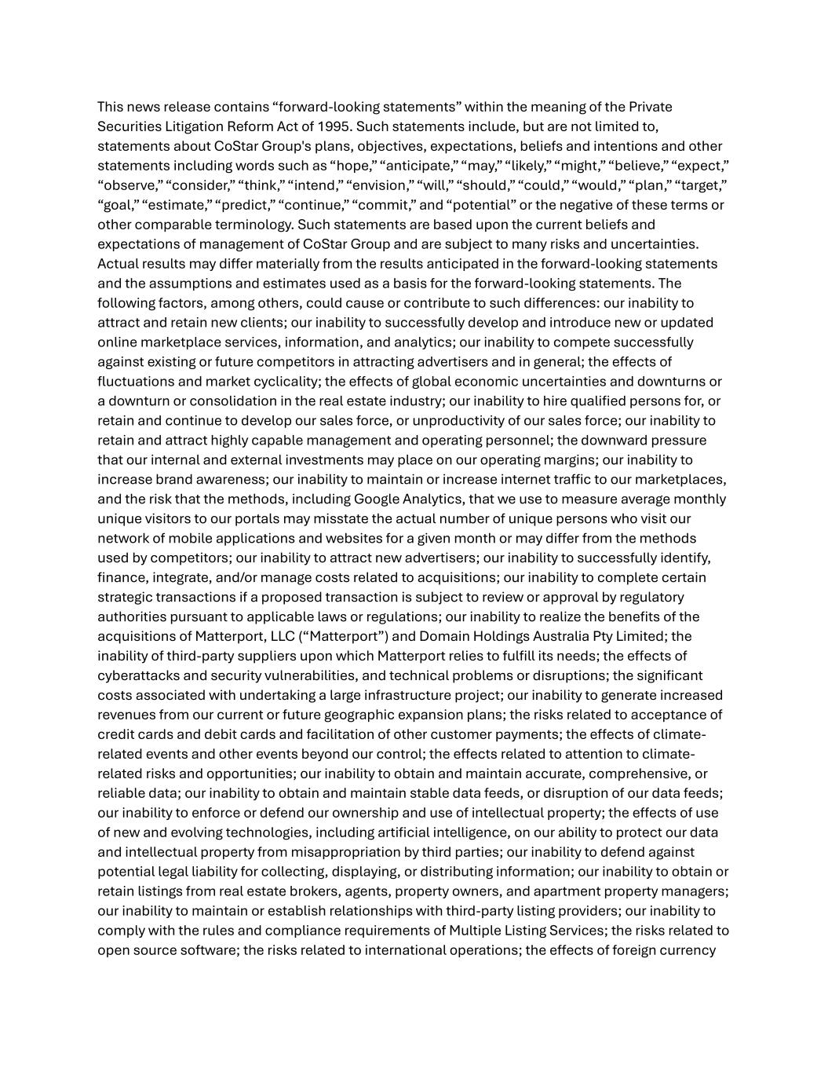
This news release contains “forward-looking statements” within the meaning of the Private Securities Litigation Reform Act of 1995. Such statements include, but are not limited to, statements about CoStar Group's plans, objectives, expectations, beliefs and intentions and other statements including words such as “hope,” “anticipate,” “may,” “likely,” “might,” “believe,” “expect,” “observe,” “consider,” “think,” “intend,” “envision,” “will,” “should,” “could,” “would,” “plan,” “target,” “goal,” “estimate,” “predict,” “continue,” “commit,” and “potential” or the negative of these terms or other comparable terminology. Such statements are based upon the current beliefs and expectations of management of CoStar Group and are subject to many risks and uncertainties. Actual results may differ materially from the results anticipated in the forward-looking statements and the assumptions and estimates used as a basis for the forward-looking statements. The following factors, among others, could cause or contribute to such differences: our inability to attract and retain new clients; our inability to successfully develop and introduce new or updated online marketplace services, information, and analytics; our inability to compete successfully against existing or future competitors in attracting advertisers and in general; the effects of fluctuations and market cyclicality; the effects of global economic uncertainties and downturns or a downturn or consolidation in the real estate industry; our inability to hire qualified persons for, or retain and continue to develop our sales force, or unproductivity of our sales force; our inability to retain and attract highly capable management and operating personnel; the downward pressure that our internal and external investments may place on our operating margins; our inability to increase brand awareness; our inability to maintain or increase internet traffic to our marketplaces, and the risk that the methods, including Google Analytics, that we use to measure average monthly unique visitors to our portals may misstate the actual number of unique persons who visit our network of mobile applications and websites for a given month or may differ from the methods used by competitors; our inability to attract new advertisers; our inability to successfully identify, finance, integrate, and/or manage costs related to acquisitions; our inability to complete certain strategic transactions if a proposed transaction is subject to review or approval by regulatory authorities pursuant to applicable laws or regulations; our inability to realize the benefits of the acquisitions of Matterport, LLC (“Matterport”) and Domain Holdings Australia Pty Limited; the inability of third-party suppliers upon which Matterport relies to fulfill its needs; the effects of cyberattacks and security vulnerabilities, and technical problems or disruptions; the significant costs associated with undertaking a large infrastructure project; our inability to generate increased revenues from our current or future geographic expansion plans; the risks related to acceptance of credit cards and debit cards and facilitation of other customer payments; the effects of climate- related events and other events beyond our control; the effects related to attention to climate- related risks and opportunities; our inability to obtain and maintain accurate, comprehensive, or reliable data; our inability to obtain and maintain stable data feeds, or disruption of our data feeds; our inability to enforce or defend our ownership and use of intellectual property; the effects of use of new and evolving technologies, including artificial intelligence, on our ability to protect our data and intellectual property from misappropriation by third parties; our inability to defend against potential legal liability for collecting, displaying, or distributing information; our inability to obtain or retain listings from real estate brokers, agents, property owners, and apartment property managers; our inability to maintain or establish relationships with third-party listing providers; our inability to comply with the rules and compliance requirements of Multiple Listing Services; the risks related to open source software; the risks related to international operations; the effects of foreign currency

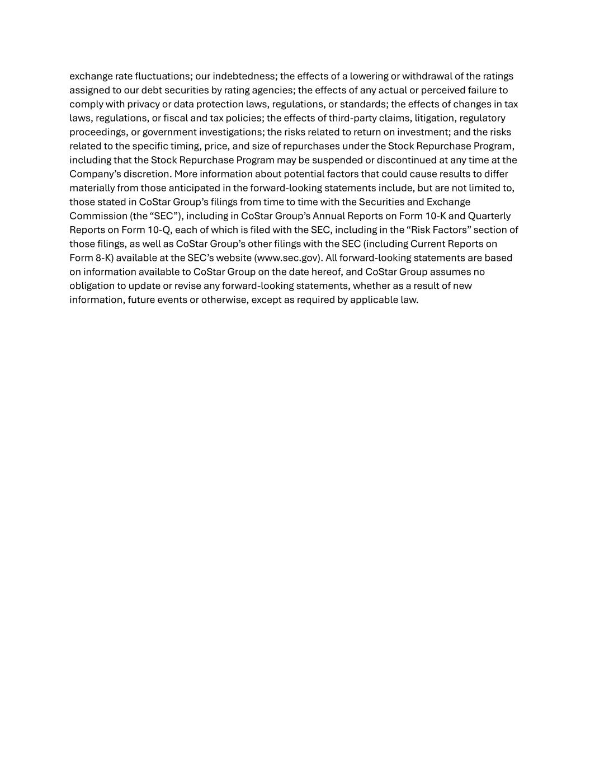
exchange rate fluctuations; our indebtedness; the effects of a lowering or withdrawal of the ratings assigned to our debt securities by rating agencies; the effects of any actual or perceived failure to comply with privacy or data protection laws, regulations, or standards; the effects of changes in tax laws, regulations, or fiscal and tax policies; the effects of third-party claims, litigation, regulatory proceedings, or government investigations; the risks related to return on investment; and the risks related to the specific timing, price, and size of repurchases under the Stock Repurchase Program, including that the Stock Repurchase Program may be suspended or discontinued at any time at the Company’s discretion. More information about potential factors that could cause results to differ materially from those anticipated in the forward-looking statements include, but are not limited to, those stated in CoStar Group’s filings from time to time with the Securities and Exchange Commission (the “SEC”), including in CoStar Group’s Annual Reports on Form 10-K and Quarterly Reports on Form 10-Q, each of which is filed with the SEC, including in the “Risk Factors” section of those filings, as well as CoStar Group’s other filings with the SEC (including Current Reports on Form 8-K) available at the SEC’s website (www.sec.gov). All forward-looking statements are based on information available to CoStar Group on the date hereof, and CoStar Group assumes no obligation to update or revise any forward-looking statements, whether as a result of new information, future events or otherwise, except as required by applicable law.

