UNITED STATES
SECURITIES AND EXCHANGE COMMISSION
Washington, D.C. 20549
FORM 8-K

CURRENT REPORT
Pursuant to Section 13 or 15(d) of the
Securities Exchange Act of 1934

Date of Report (Date of earliest event reported): February 24, 2026
COSTAR GROUP, INC.
(Exact name of registrant as specified in its charter)
Delaware |  |  | 0-24531 |  |  | 52-2091509
(State or other jurisdiction of incorporation or organization) |  |  | (Commission File Number) |  |  | (I.R.S. Employer Identification No.)
 |  |  | 1201 Wilson Blvd. |  |  |  |  |  |  |  |  | Arlington, |  |  | VA |  |  |  |  |  |  |  |  |  |  |  | 22209
(Address of principal executive offices) |  |  |  |  |  |  |  |  |  |  |  |  |  |  |  |  |  |  |  |  |  |  |  |  |  |  | (Zip Code)
Registrant’s telephone number, including area code: (202) 346-6500
Not Applicable
(Former name or former address, if changed since last report.)
Check the appropriate box below if the Form 8-K filing is intended to simultaneously satisfy the filing obligation of the registrant under any of the following provisions:
☐ Written communications pursuant to Rule 425 under the Securities Act (17 CFR 230.425)
☐ Soliciting material pursuant to Rule 14a-12 under the Exchange Act (17 CFR 240.14a-12)
☐ Pre-commencement communications pursuant to Rule 14d-2(b) under the Exchange Act (17 CFR 240.14d-2(b))
☐ Pre-commencement communications pursuant to Rule 13e-4(c) under the Exchange Act (17 CFR 240.13e-4(c))

Securities registered pursuant to Section 12(b) of the Act:
Title of each class |  |  | Trading Symbol |  |  | Name of each exchange on which registered
Common Stock ($0.01 par value) |  |  | CSGP |  |  | Nasdaq Global Select Market

Indicate by check mark whether the registrant is an emerging growth company as defined in Rule 405 of the Securities Act of 1933 (§230.405 of this chapter) or Rule 12b-2 of the Securities Exchange Act of 1934 (§240.12b-2 of this chapter).

Emerging Growth Company ☐

If an emerging growth company, indicate by check mark if the registrant has elected not to use the extended transition period for complying with any new or revised financial accounting standards provided pursuant to Section 13(a) of the Exchange Act.
o

Item 2.02 Results of Operations and Financial Condition.

On February 24, 2026, CoStar Group, Inc. (“CoStar Group” or the “Company”) announced its financial and operating results for the quarter and year ended December 31, 2025. The full text of the press release (the “Press Release”) issued in connection with the announcement is furnished as Exhibit 99.1 to this Current Report on Form 8-K.

The information contained in this Item 2.02 and the Press Release shall be considered “furnished” and shall not be deemed “filed” for purposes of Section 18 of the Securities Exchange Act of 1934, as amended, or otherwise subject to the liabilities of that Section or Sections 11 and 12(a)(2) of the Securities Act of 1933, as amended, nor shall it be deemed incorporated by reference into any reports or filings with the Securities and Exchange Commission (the "SEC"), whether made before or after the date hereof, except as expressly set forth by specific reference in such a filing.

Item 7.01 Regulation FD Disclosure.

The Company intends to utilize its corporate website as a channel of distribution for material company information, including, but not limited to, the posting of investor presentations from time to time. For more information, visit investors.costargroup.com. The information posted on the Company's website is not incorporated by reference into this Current Report on Form 8-K or in any other report or document the Company files with the SEC.

Item 9.01 Financial Statements and Exhibits.

Exhibit No. |  |  | Description
99.1 |  |  | CoStar Group, Inc. Press Release Dated February 24, 2026.
104 |  |  | Cover Page Interactive Data File (formatted as inline XBRL and contained in Exhibit 101).

SIGNATURES
Pursuant to the requirements of the Securities Exchange Act of 1934, the registrant has duly caused this report to be signed on its behalf by the undersigned hereunto duly authorized.
 |  |  |  |  |  | COSTAR GROUP, INC.
 |  |  |  |  |  | By: /s/ Christian M. Lown
Date: |  |  | February 24, 2026 |  |  | Name: Christian M. Lown
 |  |  |  |  |  | Title: Chief Financial Officer
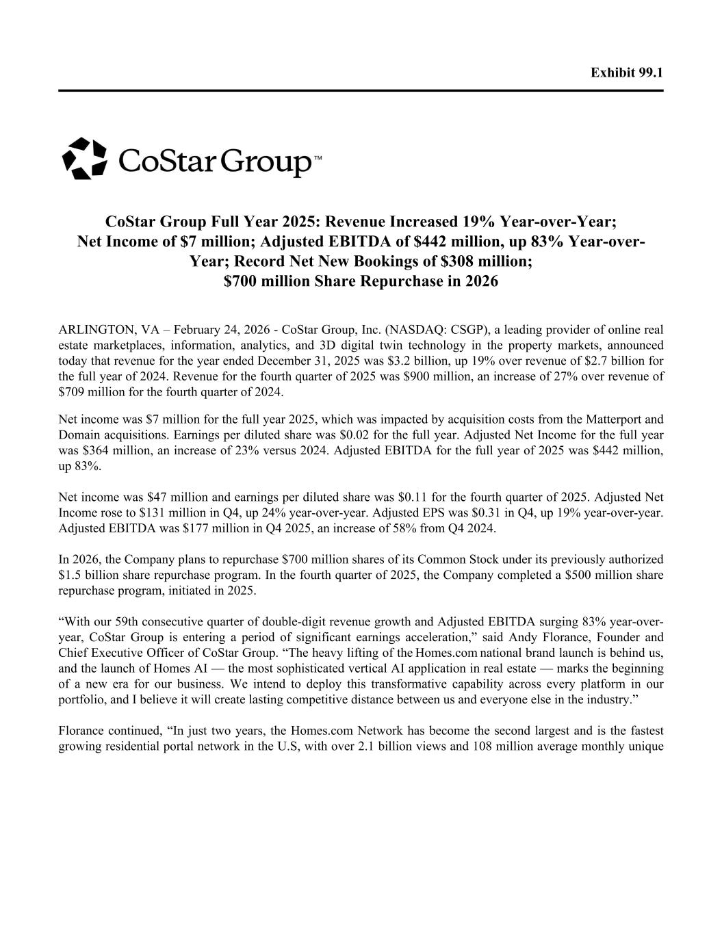

Exhibit 99.1 CoStar Group Full Year 2025: Revenue Increased 19% Year-over-Year; Net Income of $7 million; Adjusted EBITDA of $442 million, up 83% Year-over- Year; Record Net New Bookings of $308 million; $700 million Share Repurchase in 2026 ARLINGTON, VA – February 24, 2026 - CoStar Group, Inc. (NASDAQ: CSGP), a leading provider of online real estate marketplaces, information, analytics, and 3D digital twin technology in the property markets, announced today that revenue for the year ended December 31, 2025 was $3.2 billion, up 19% over revenue of $2.7 billion for the full year of 2024. Revenue for the fourth quarter of 2025 was $900 million, an increase of 27% over revenue of $709 million for the fourth quarter of 2024. Net income was $7 million for the full year 2025, which was impacted by acquisition costs from the Matterport and Domain acquisitions. Earnings per diluted share was $0.02 for the full year. Adjusted Net Income for the full year was $364 million, an increase of 23% versus 2024. Adjusted EBITDA for the full year of 2025 was $442 million, up 83%. Net income was $47 million and earnings per diluted share was $0.11 for the fourth quarter of 2025. Adjusted Net Income rose to $131 million in Q4, up 24% year-over-year. Adjusted EPS was $0.31 in Q4, up 19% year-over-year. Adjusted EBITDA was $177 million in Q4 2025, an increase of 58% from Q4 2024. In 2026, the Company plans to repurchase $700 million shares of its Common Stock under its previously authorized $1.5 billion share repurchase program. In the fourth quarter of 2025, the Company completed a $500 million share repurchase program, initiated in 2025. “With our 59th consecutive quarter of double-digit revenue growth and Adjusted EBITDA surging 83% year-over- year, CoStar Group is entering a period of significant earnings acceleration,” said Andy Florance, Founder and Chief Executive Officer of CoStar Group. “The heavy lifting of the Homes.com national brand launch is behind us, and the launch of Homes AI — the most sophisticated vertical AI application in real estate — marks the beginning of a new era for our business. We intend to deploy this transformative capability across every platform in our portfolio, and I believe it will create lasting competitive distance between us and everyone else in the industry.” Florance continued, “In just two years, the Homes.com Network has become the second largest and is the fastest growing residential portal network in the U.S, with over 2.1 billion views and 108 million average monthly unique

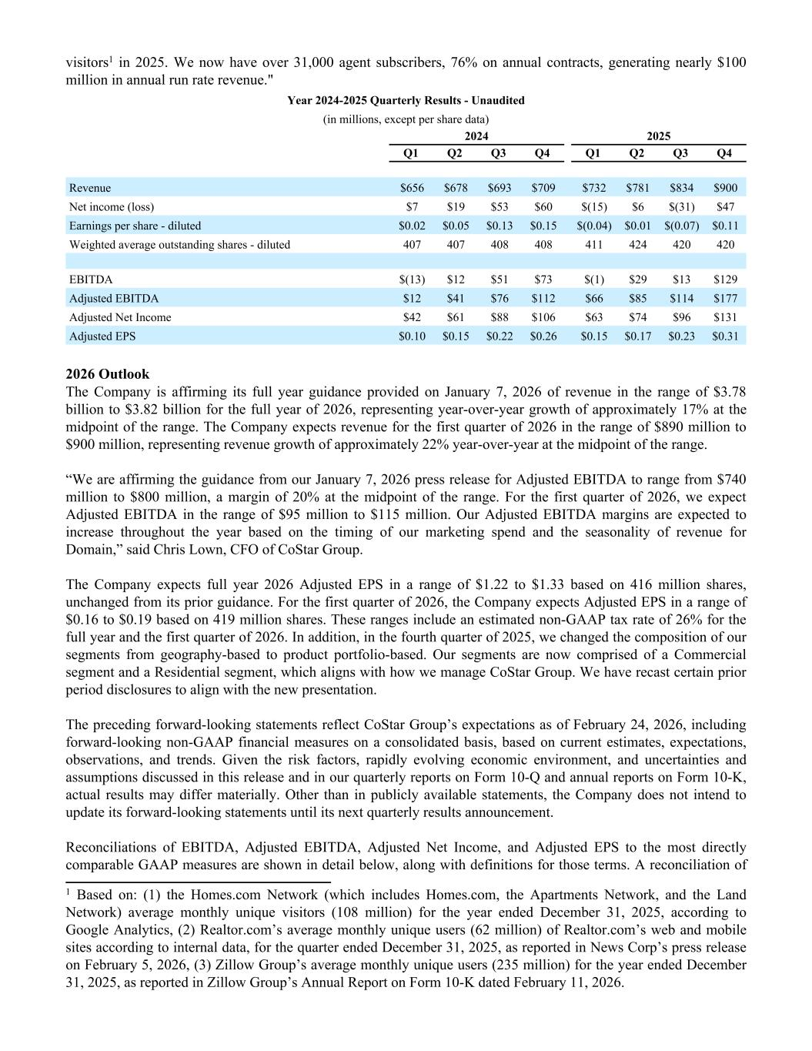
visitors1 in 2025. We now have over 31,000 agent subscribers, 76% on annual contracts, generating nearly $100 million in annual run rate revenue." Year 2024-2025 Quarterly Results - Unaudited (in millions, except per share data) 2024 2025 Q1 Q2 Q3 Q4 Q1 Q2 Q3 Q4 Revenue $656 $678 $693 $709 $732 $781 $834 $900 Net income (loss) $7 $19 $53 $60 $(15) $6 $(31) $47 Earnings per share - diluted $0.02 $0.05 $0.13 $0.15 $(0.04) $0.01 $(0.07) $0.11 Weighted average outstanding shares - diluted 407 407 408 408 411 424 420 420 EBITDA $(13) $12 $51 $73 $(1) $29 $13 $129 Adjusted EBITDA $12 $41 $76 $112 $66 $85 $114 $177 Adjusted Net Income $42 $61 $88 $106 $63 $74 $96 $131 Adjusted EPS $0.10 $0.15 $0.22 $0.26 $0.15 $0.17 $0.23 $0.31 2026 Outlook The Company is affirming its full year guidance provided on January 7, 2026 of revenue in the range of $3.78 billion to $3.82 billion for the full year of 2026, representing year-over-year growth of approximately 17% at the midpoint of the range. The Company expects revenue for the first quarter of 2026 in the range of $890 million to $900 million, representing revenue growth of approximately 22% year-over-year at the midpoint of the range. “We are affirming the guidance from our January 7, 2026 press release for Adjusted EBITDA to range from $740 million to $800 million, a margin of 20% at the midpoint of the range. For the first quarter of 2026, we expect Adjusted EBITDA in the range of $95 million to $115 million. Our Adjusted EBITDA margins are expected to increase throughout the year based on the timing of our marketing spend and the seasonality of revenue for Domain,” said Chris Lown, CFO of CoStar Group. The Company expects full year 2026 Adjusted EPS in a range of $1.22 to $1.33 based on 416 million shares, unchanged from its prior guidance. For the first quarter of 2026, the Company expects Adjusted EPS in a range of $0.16 to $0.19 based on 419 million shares. These ranges include an estimated non-GAAP tax rate of 26% for the full year and the first quarter of 2026. In addition, in the fourth quarter of 2025, we changed the composition of our segments from geography-based to product portfolio-based. Our segments are now comprised of a Commercial segment and a Residential segment, which aligns with how we manage CoStar Group. We have recast certain prior period disclosures to align with the new presentation. The preceding forward-looking statements reflect CoStar Group’s expectations as of February 24, 2026, including forward-looking non-GAAP financial measures on a consolidated basis, based on current estimates, expectations, observations, and trends. Given the risk factors, rapidly evolving economic environment, and uncertainties and assumptions discussed in this release and in our quarterly reports on Form 10-Q and annual reports on Form 10-K, actual results may differ materially. Other than in publicly available statements, the Company does not intend to update its forward-looking statements until its next quarterly results announcement. Reconciliations of EBITDA, Adjusted EBITDA, Adjusted Net Income, and Adjusted EPS to the most directly comparable GAAP measures are shown in detail below, along with definitions for those terms. A reconciliation of 1 Based on: (1) the Homes.com Network (which includes Homes.com, the Apartments Network, and the Land Network) average monthly unique visitors (108 million) for the year ended December 31, 2025, according to Google Analytics, (2) Realtor.com’s average monthly unique users (62 million) of Realtor.com’s web and mobile sites according to internal data, for the quarter ended December 31, 2025, as reported in News Corp’s press release on February 5, 2026, (3) Zillow Group’s average monthly unique users (235 million) for the year ended December 31, 2025, as reported in Zillow Group’s Annual Report on Form 10-K dated February 11, 2026.


forward-looking non-GAAP guidance to the most directly comparable GAAP measure, net income (loss), can be found within the tables included in this release.

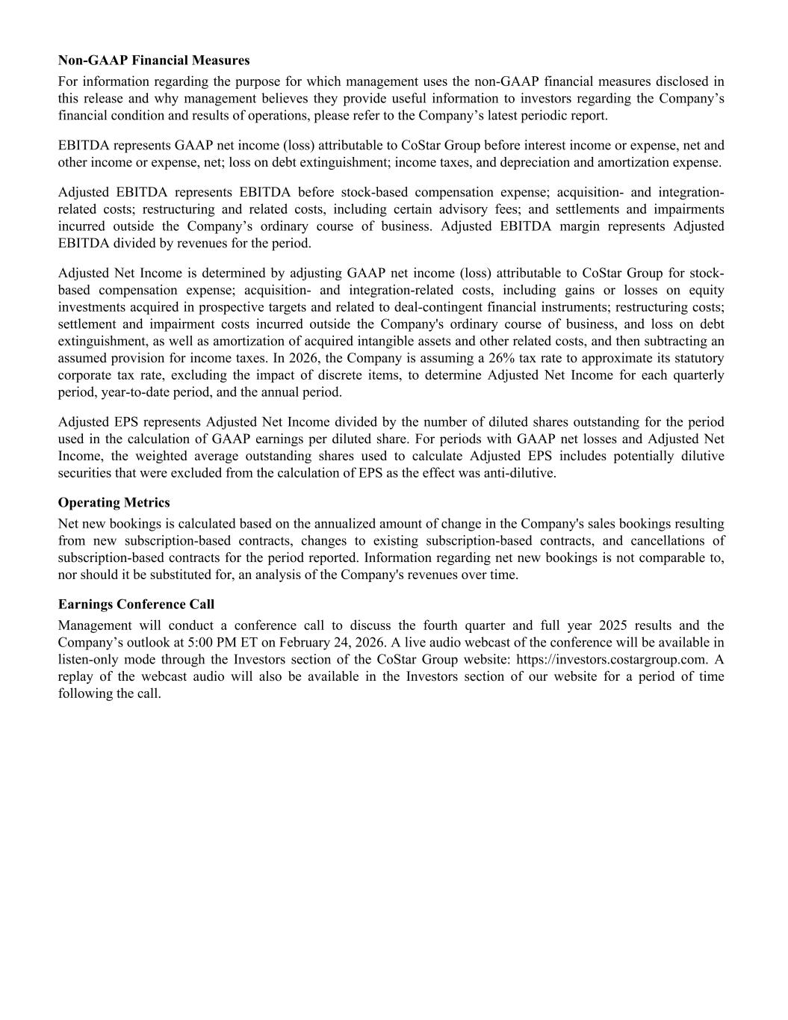
Non-GAAP Financial Measures For information regarding the purpose for which management uses the non-GAAP financial measures disclosed in this release and why management believes they provide useful information to investors regarding the Company’s financial condition and results of operations, please refer to the Company’s latest periodic report. EBITDA represents GAAP net income (loss) attributable to CoStar Group before interest income or expense, net and other income or expense, net; loss on debt extinguishment; income taxes, and depreciation and amortization expense. Adjusted EBITDA represents EBITDA before stock-based compensation expense; acquisition- and integration- related costs; restructuring and related costs, including certain advisory fees; and settlements and impairments incurred outside the Company’s ordinary course of business. Adjusted EBITDA margin represents Adjusted EBITDA divided by revenues for the period. Adjusted Net Income is determined by adjusting GAAP net income (loss) attributable to CoStar Group for stock- based compensation expense; acquisition- and integration-related costs, including gains or losses on equity investments acquired in prospective targets and related to deal-contingent financial instruments; restructuring costs; settlement and impairment costs incurred outside the Company's ordinary course of business, and loss on debt extinguishment, as well as amortization of acquired intangible assets and other related costs, and then subtracting an assumed provision for income taxes. In 2026, the Company is assuming a 26% tax rate to approximate its statutory corporate tax rate, excluding the impact of discrete items, to determine Adjusted Net Income for each quarterly period, year-to-date period, and the annual period. Adjusted EPS represents Adjusted Net Income divided by the number of diluted shares outstanding for the period used in the calculation of GAAP earnings per diluted share. For periods with GAAP net losses and Adjusted Net Income, the weighted average outstanding shares used to calculate Adjusted EPS includes potentially dilutive securities that were excluded from the calculation of EPS as the effect was anti-dilutive. Operating Metrics Net new bookings is calculated based on the annualized amount of change in the Company's sales bookings resulting from new subscription-based contracts, changes to existing subscription-based contracts, and cancellations of subscription-based contracts for the period reported. Information regarding net new bookings is not comparable to, nor should it be substituted for, an analysis of the Company's revenues over time. Earnings Conference Call Management will conduct a conference call to discuss the fourth quarter and full year 2025 results and the Company’s outlook at 5:00 PM ET on February 24, 2026. A live audio webcast of the conference will be available in listen-only mode through the Investors section of the CoStar Group website: https://investors.costargroup.com. A replay of the webcast audio will also be available in the Investors section of our website for a period of time following the call.

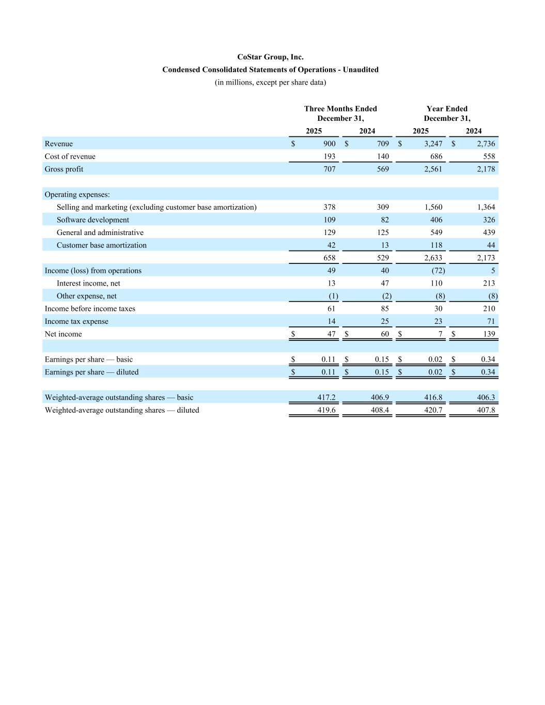
CoStar Group, Inc. Condensed Consolidated Statements of Operations - Unaudited (in millions, except per share data) Three Months Ended December 31, Year Ended December 31, 2025 2024 2025 2024 Revenue $ 900 $ 709 $ 3,247 $ 2,736 Cost of revenue 193 140 686 558 Gross profit 707 569 2,561 2,178 Operating expenses: Selling and marketing (excluding customer base amortization) 378 309 1,560 1,364 Software development 109 82 406 326 General and administrative 129 125 549 439 Customer base amortization 42 13 118 44 658 529 2,633 2,173 Income (loss) from operations 49 40 (72) 5 Interest income, net 13 47 110 213 Other expense, net (1) (2) (8) (8) Income before income taxes 61 85 30 210 Income tax expense 14 25 23 71 Net income $ 47 $ 60 $ 7 $ 139 Earnings per share — basic $ 0.11 $ 0.15 $ 0.02 $ 0.34 Earnings per share — diluted $ 0.11 $ 0.15 $ 0.02 $ 0.34 Weighted-average outstanding shares — basic 417.2 406.9 416.8 406.3 Weighted-average outstanding shares — diluted 419.6 408.4 420.7 407.8

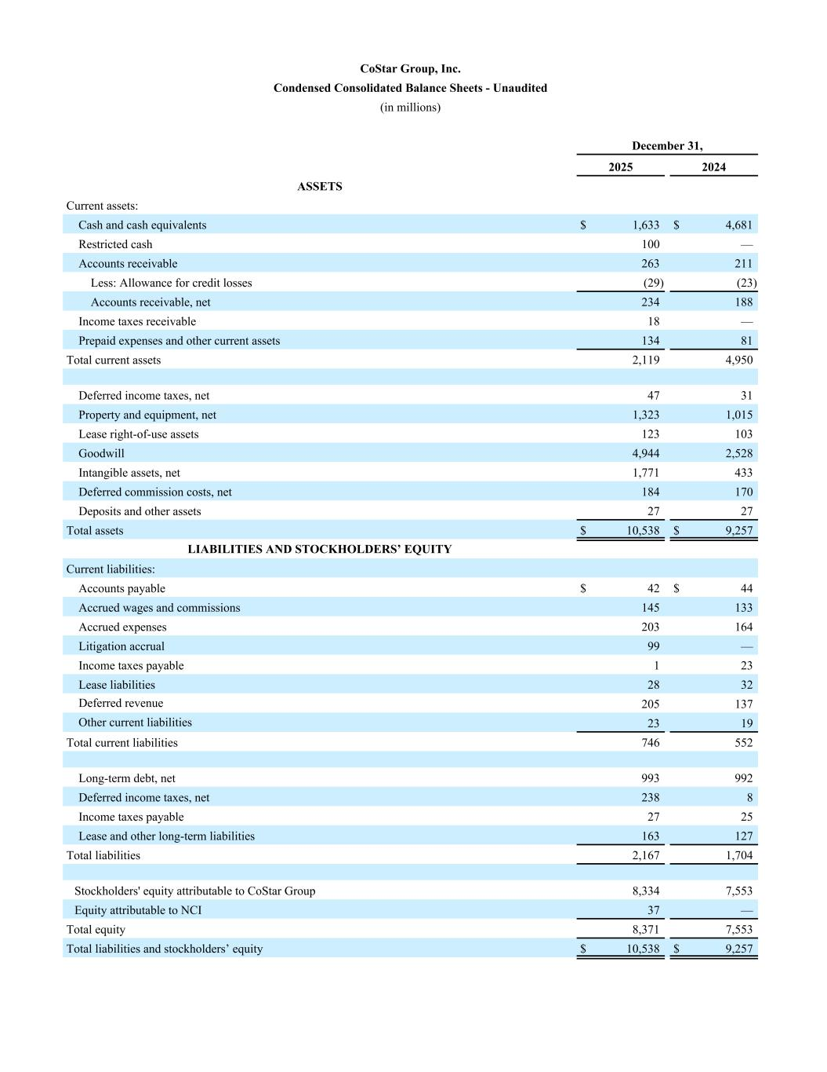
CoStar Group, Inc. Condensed Consolidated Balance Sheets - Unaudited (in millions) December 31, 2025 2024 ASSETS Current assets: Cash and cash equivalents $ 1,633 $ 4,681 Restricted cash 100 — Accounts receivable 263 211 Less: Allowance for credit losses (29) (23) Accounts receivable, net 234 188 Income taxes receivable 18 — Prepaid expenses and other current assets 134 81 Total current assets 2,119 4,950 Deferred income taxes, net 47 31 Property and equipment, net 1,323 1,015 Lease right-of-use assets 123 103 Goodwill 4,944 2,528 Intangible assets, net 1,771 433 Deferred commission costs, net 184 170 Deposits and other assets 27 27 Total assets $ 10,538 $ 9,257 LIABILITIES AND STOCKHOLDERS’ EQUITY Current liabilities: Accounts payable $ 42 $ 44 Accrued wages and commissions 145 133 Accrued expenses 203 164 Litigation accrual 99 — Income taxes payable 1 23 Lease liabilities 28 32 Deferred revenue 205 137 Other current liabilities 23 19 Total current liabilities 746 552 Long-term debt, net 993 992 Deferred income taxes, net 238 8 Income taxes payable 27 25 Lease and other long-term liabilities 163 127 Total liabilities 2,167 1,704 Stockholders' equity attributable to CoStar Group 8,334 7,553 Equity attributable to NCI 37 — Total equity 8,371 7,553 Total liabilities and stockholders’ equity $ 10,538 $ 9,257

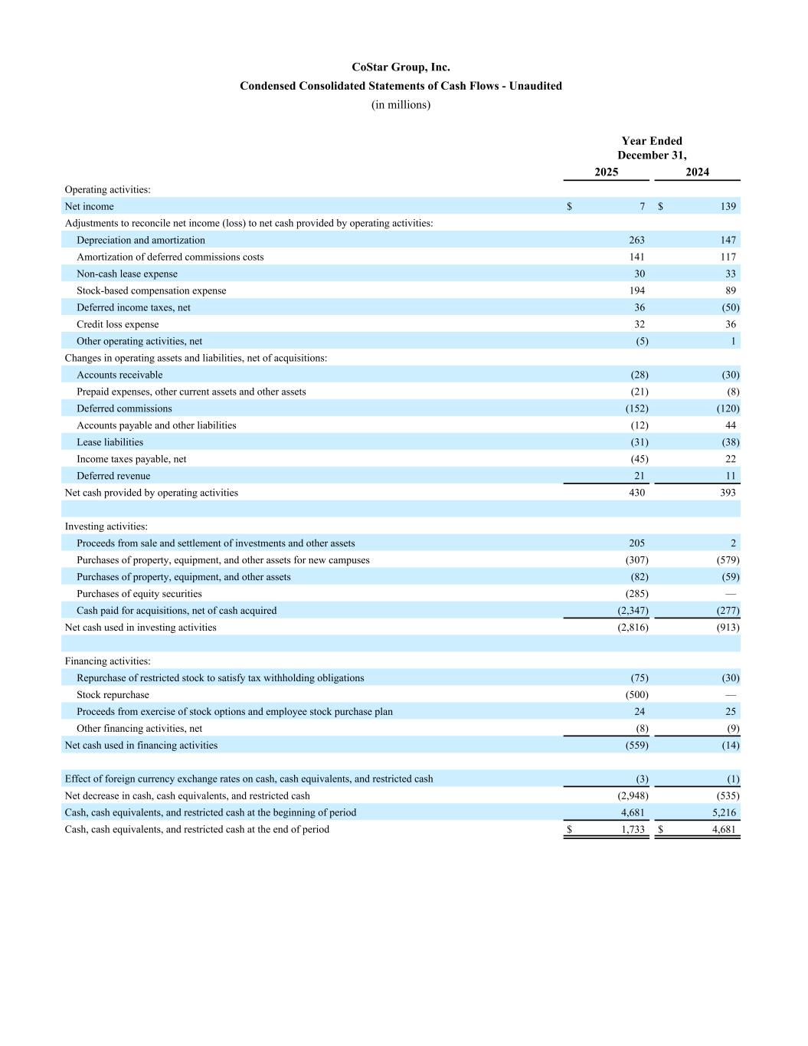
CoStar Group, Inc. Condensed Consolidated Statements of Cash Flows - Unaudited (in millions) Year Ended December 31, 2025 2024 Operating activities: Net income $ 7 $ 139 Adjustments to reconcile net income (loss) to net cash provided by operating activities: Depreciation and amortization 263 147 Amortization of deferred commissions costs 141 117 Non-cash lease expense 30 33 Stock-based compensation expense 194 89 Deferred income taxes, net 36 (50) Credit loss expense 32 36 Other operating activities, net (5) 1 Changes in operating assets and liabilities, net of acquisitions: Accounts receivable (28) (30) Prepaid expenses, other current assets and other assets (21) (8) Deferred commissions (152) (120) Accounts payable and other liabilities (12) 44 Lease liabilities (31) (38) Income taxes payable, net (45) 22 Deferred revenue 21 11 Net cash provided by operating activities 430 393 Investing activities: Proceeds from sale and settlement of investments and other assets 205 2 Purchases of property, equipment, and other assets for new campuses (307) (579) Purchases of property, equipment, and other assets (82) (59) Purchases of equity securities (285) — Cash paid for acquisitions, net of cash acquired (2,347) (277) Net cash used in investing activities (2,816) (913) Financing activities: Repurchase of restricted stock to satisfy tax withholding obligations (75) (30) Stock repurchase (500) — Proceeds from exercise of stock options and employee stock purchase plan 24 25 Other financing activities, net (8) (9) Net cash used in financing activities (559) (14) Effect of foreign currency exchange rates on cash, cash equivalents, and restricted cash (3) (1) Net decrease in cash, cash equivalents, and restricted cash (2,948) (535) Cash, cash equivalents, and restricted cash at the beginning of period 4,681 5,216 Cash, cash equivalents, and restricted cash at the end of period $ 1,733 $ 4,681

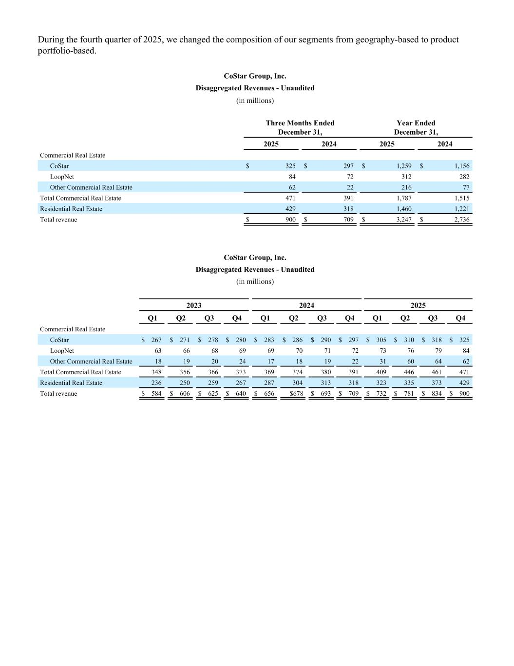
During the fourth quarter of 2025, we changed the composition of our segments from geography-based to product portfolio-based. CoStar Group, Inc. Disaggregated Revenues - Unaudited (in millions) Three Months Ended December 31, Year Ended December 31, 2025 2024 2025 2024 Commercial Real Estate CoStar $ 325 $ 297 $ 1,259 $ 1,156 LoopNet 84 72 312 282 Other Commercial Real Estate 62 22 216 77 Total Commercial Real Estate 471 391 1,787 1,515 Residential Real Estate 429 318 1,460 1,221 Total revenue $ 900 $ 709 $ 3,247 $ 2,736 CoStar Group, Inc. Disaggregated Revenues - Unaudited (in millions) 2023 2024 2025 Q1 Q2 Q3 Q4 Q1 Q2 Q3 Q4 Q1 Q2 Q3 Q4 Commercial Real Estate CoStar $ 267 $ 271 $ 278 $ 280 $ 283 $ 286 $ 290 $ 297 $ 305 $ 310 $ 318 $ 325 LoopNet 63 66 68 69 69 70 71 72 73 76 79 84 Other Commercial Real Estate 18 19 20 24 17 18 19 22 31 60 64 62 Total Commercial Real Estate 348 356 366 373 369 374 380 391 409 446 461 471 Residential Real Estate 236 250 259 267 287 304 313 318 323 335 373 429 Total revenue $ 584 $ 606 $ 625 $ 640 $ 656 $678 $ 693 $ 709 $ 732 $ 781 $ 834 $ 900

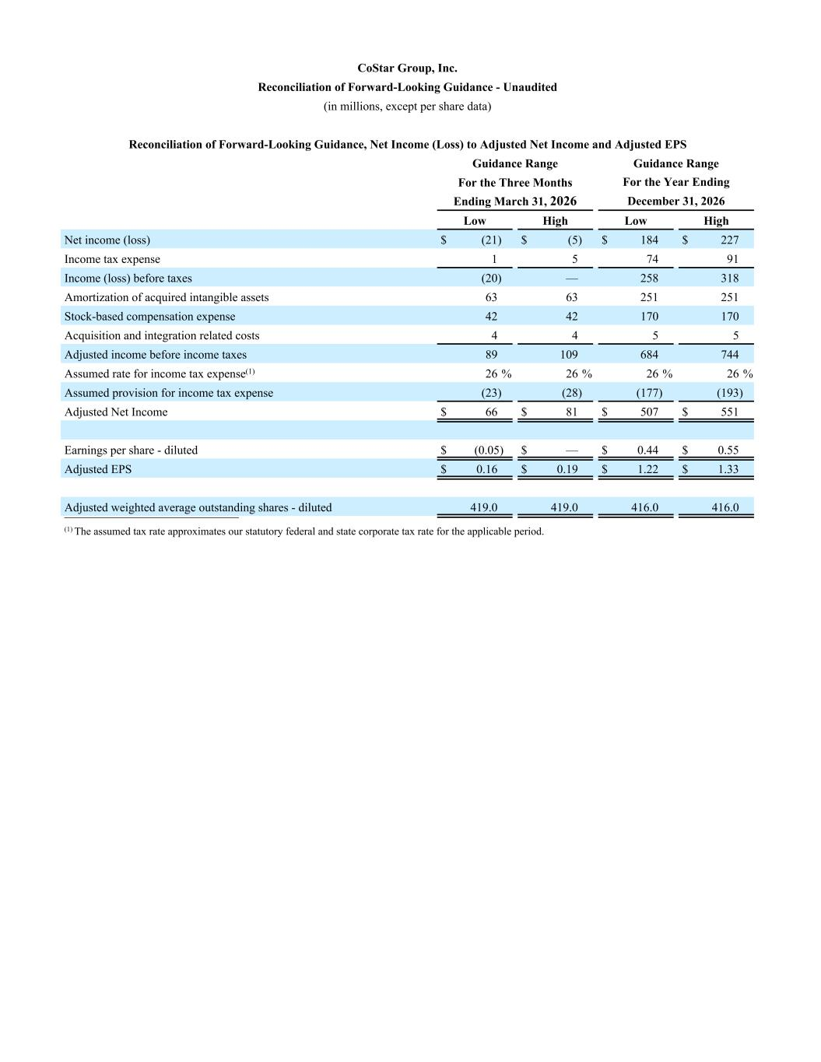
CoStar Group, Inc. Reconciliation of Forward-Looking Guidance - Unaudited (in millions, except per share data) Reconciliation of Forward-Looking Guidance, Net Income (Loss) to Adjusted Net Income and Adjusted EPS Guidance Range Guidance Range For the Three Months For the Year Ending Ending March 31, 2026 December 31, 2026 Low High Low High Net income (loss) $ (21) $ (5) $ 184 $ 227 Income tax expense 1 5 74 91 Income (loss) before taxes (20) — 258 318 Amortization of acquired intangible assets 63 63 251 251 Stock-based compensation expense 42 42 170 170 Acquisition and integration related costs 4 4 5 5 Adjusted income before income taxes 89 109 684 744 Assumed rate for income tax expense(1) 26 % 26 % 26 % 26 % Assumed provision for income tax expense (23) (28) (177) (193) Adjusted Net Income $ 66 $ 81 $ 507 $ 551 Earnings per share - diluted $ (0.05) $ — $ 0.44 $ 0.55 Adjusted EPS $ 0.16 $ 0.19 $ 1.22 $ 1.33 Adjusted weighted average outstanding shares - diluted 419.0 419.0 416.0 416.0 __________________________ (1) The assumed tax rate approximates our statutory federal and state corporate tax rate for the applicable period.

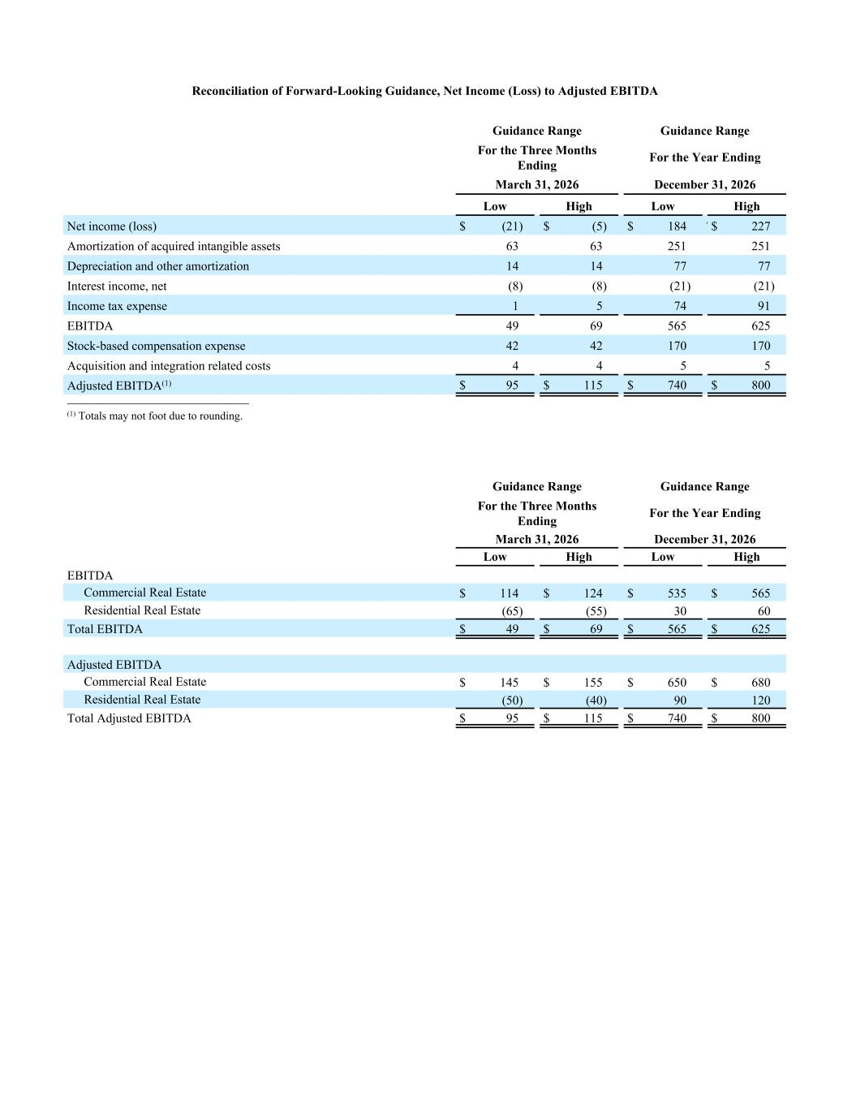
Reconciliation of Forward-Looking Guidance, Net Income (Loss) to Adjusted EBITDA Guidance Range Guidance Range For the Three Months Ending For the Year Ending March 31, 2026 December 31, 2026 Low High Low High Net income (loss) $ (21) $ (5) $ 184 2 7$ 227 Amortization of acquired intangible assets 63 63 251 251 Depreciation and other amortization 14 14 77 77 Interest income, net (8) (8) (21) (21) Income tax expense 1 5 74 91 EBITDA 49 69 565 625 Stock-based compensation expense 42 42 170 170 Acquisition and integration related costs 4 4 5 5 Adjusted EBITDA(1) $ 95 $ 115 $ 740 $ 800 __________________________ (1) Totals may not foot due to rounding. Guidance Range Guidance Range For the Three Months Ending For the Year Ending March 31, 2026 December 31, 2026 Low High Low High EBITDA Commercial Real Estate $ 114 $ 124 $ 535 $ 565 Residential Real Estate (65) (55) 30 60 Total EBITDA $ 49 $ 69 $ 565 $ 625 Adjusted EBITDA Commercial Real Estate $ 145 $ 155 $ 650 $ 680 Residential Real Estate (50) (40) 90 120 Total Adjusted EBITDA $ 95 $ 115 $ 740 $ 800

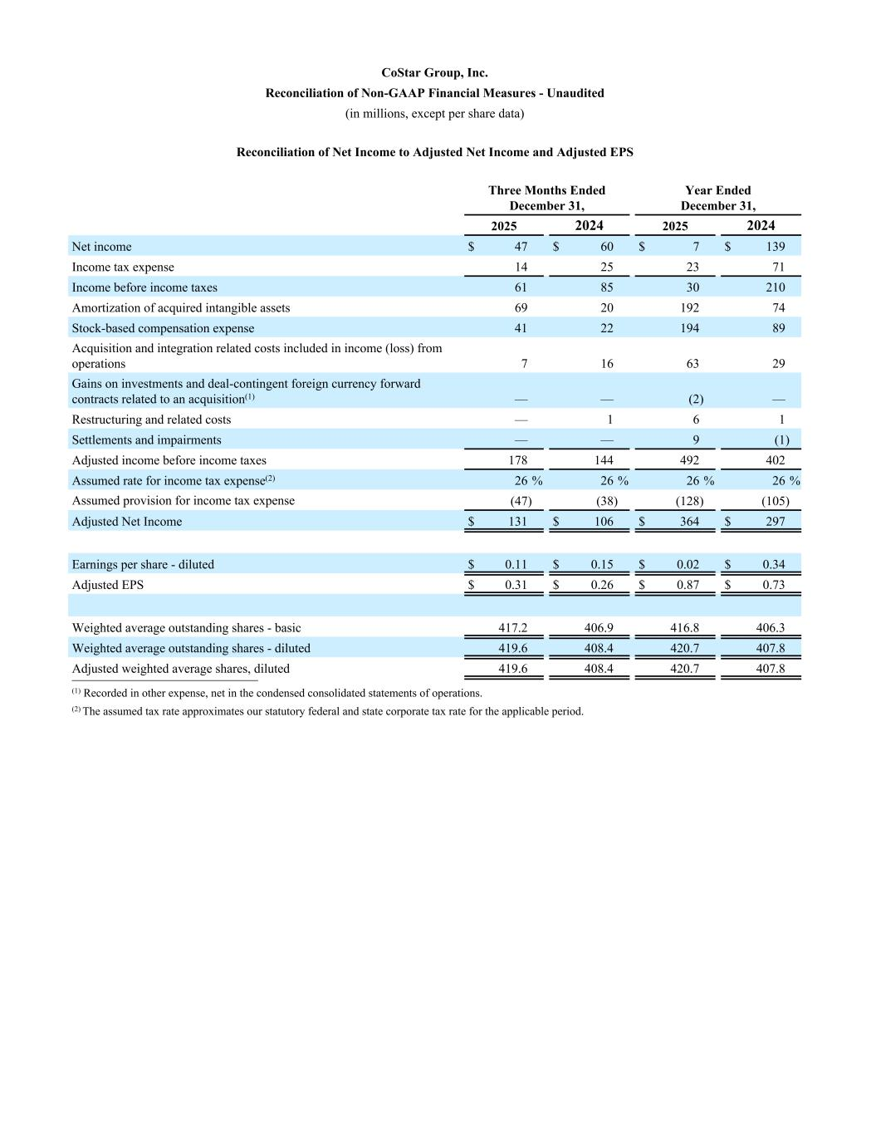
CoStar Group, Inc. Reconciliation of Non-GAAP Financial Measures - Unaudited (in millions, except per share data) Reconciliation of Net Income to Adjusted Net Income and Adjusted EPS Three Months Ended December 31, Year Ended December 31, 2025 2024 2025 2024 Net income $ 47 $ 60 $ 7 $ 139 Income tax expense 14 25 23 71 Income before income taxes 61 85 30 210 Amortization of acquired intangible assets 69 20 192 74 Stock-based compensation expense 41 22 194 89 Acquisition and integration related costs included in income (loss) from operations 7 16 63 29 Gains on investments and deal-contingent foreign currency forward contracts related to an acquisition(1) — — (2) — Restructuring and related costs — 1 6 1 Settlements and impairments — — 9 (1) Adjusted income before income taxes 178 144 492 402 Assumed rate for income tax expense(2) 26 % 26 % 26 % 26 % Assumed provision for income tax expense (47) (38) (128) (105) Adjusted Net Income $ 131 $ 106 $ 364 $ 297 Earnings per share - diluted $ 0.11 $ 0.15 $ 0.02 $ 0.34 Adjusted EPS $ 0.31 $ 0.26 $ 0.87 $ 0.73 Weighted average outstanding shares - basic 417.2 406.9 416.8 406.3 Weighted average outstanding shares - diluted 419.6 408.4 420.7 407.8 Adjusted weighted average shares, diluted 419.6 408.4 420.7 407.8 __________________________ (1) Recorded in other expense, net in the condensed consolidated statements of operations. (2) The assumed tax rate approximates our statutory federal and state corporate tax rate for the applicable period.

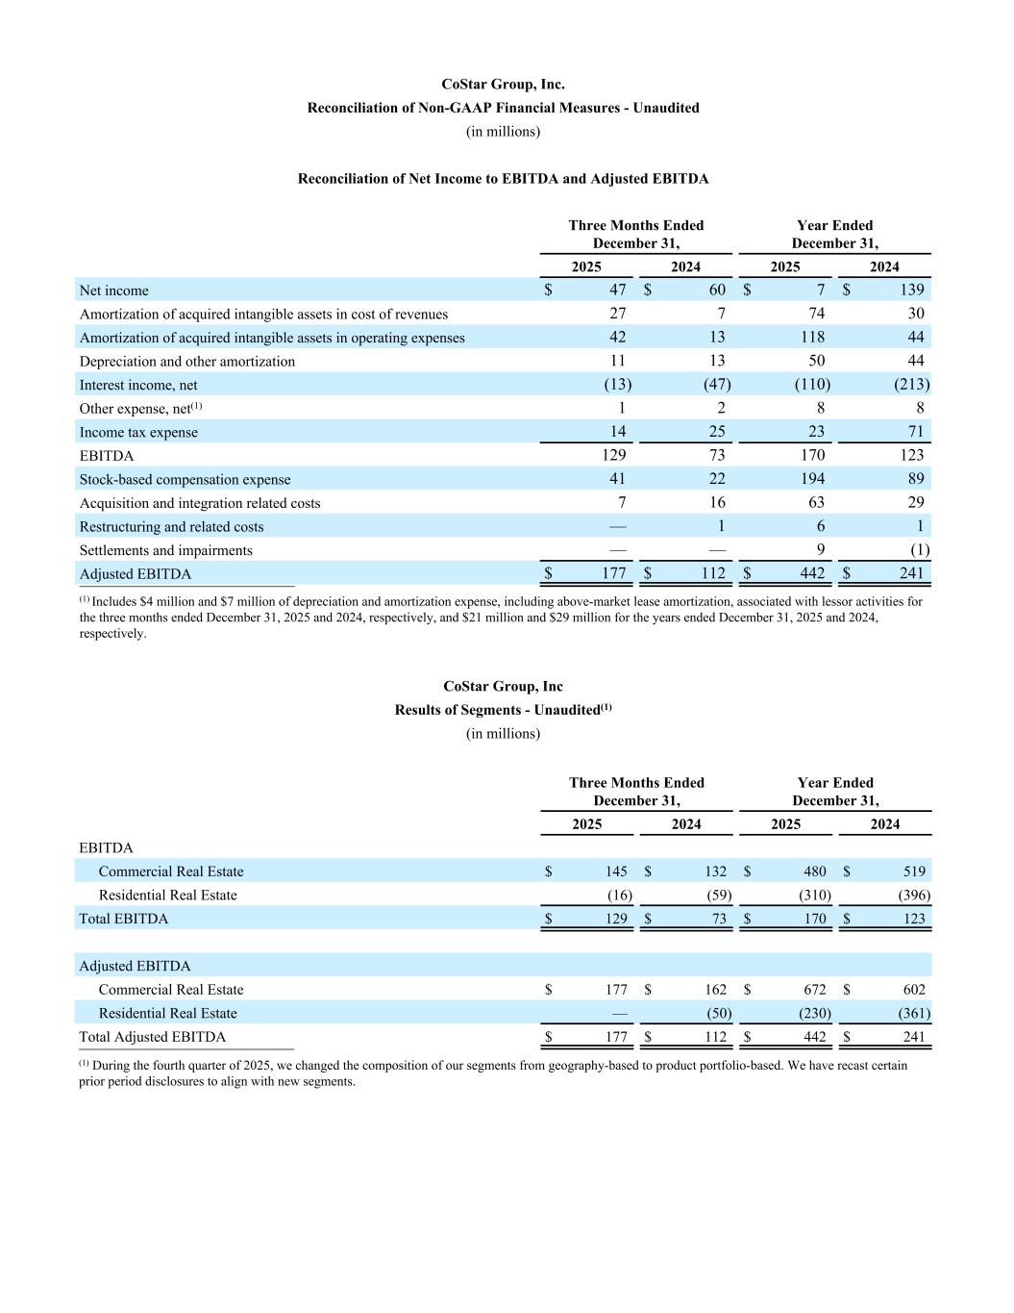
CoStar Group, Inc. Reconciliation of Non-GAAP Financial Measures - Unaudited (in millions) Reconciliation of Net Income to EBITDA and Adjusted EBITDA Three Months Ended December 31, Year Ended December 31, 2025 2024 2025 2024 Net income $ 47 $ 60 $ 7 $ 139 Amortization of acquired intangible assets in cost of revenues 27 7 74 30 Amortization of acquired intangible assets in operating expenses 42 13 118 44 Depreciation and other amortization 11 13 50 44 Interest income, net (13) (47) (110) (213) Other expense, net(1) 1 2 8 8 Income tax expense 14 25 23 71 EBITDA 129 73 170 123 Stock-based compensation expense 41 22 194 89 Acquisition and integration related costs 7 16 63 29 Restructuring and related costs — 1 6 1 Settlements and impairments — — 9 (1) Adjusted EBITDA $ 177 $ 112 $ 442 $ 241 __________________________ (1) Includes $4 million and $7 million of depreciation and amortization expense, including above-market lease amortization, associated with lessor activities for the three months ended December 31, 2025 and 2024, respectively, and $21 million and $29 million for the years ended December 31, 2025 and 2024, respectively. CoStar Group, Inc Results of Segments - Unaudited(1) (in millions) Three Months Ended December 31, Year Ended December 31, 2025 2024 2025 2024 EBITDA Commercial Real Estate $ 145 $ 132 $ 480 $ 519 Residential Real Estate (16) (59) (310) (396) Total EBITDA $ 129 $ 73 $ 170 $ 123 Adjusted EBITDA Commercial Real Estate $ 177 $ 162 $ 672 $ 602 Residential Real Estate — (50) (230) (361) Total Adjusted EBITDA $ 177 $ 112 $ 442 $ 241 __________________________ (1) During the fourth quarter of 2025, we changed the composition of our segments from geography-based to product portfolio-based. We have recast certain prior period disclosures to align with new segments.

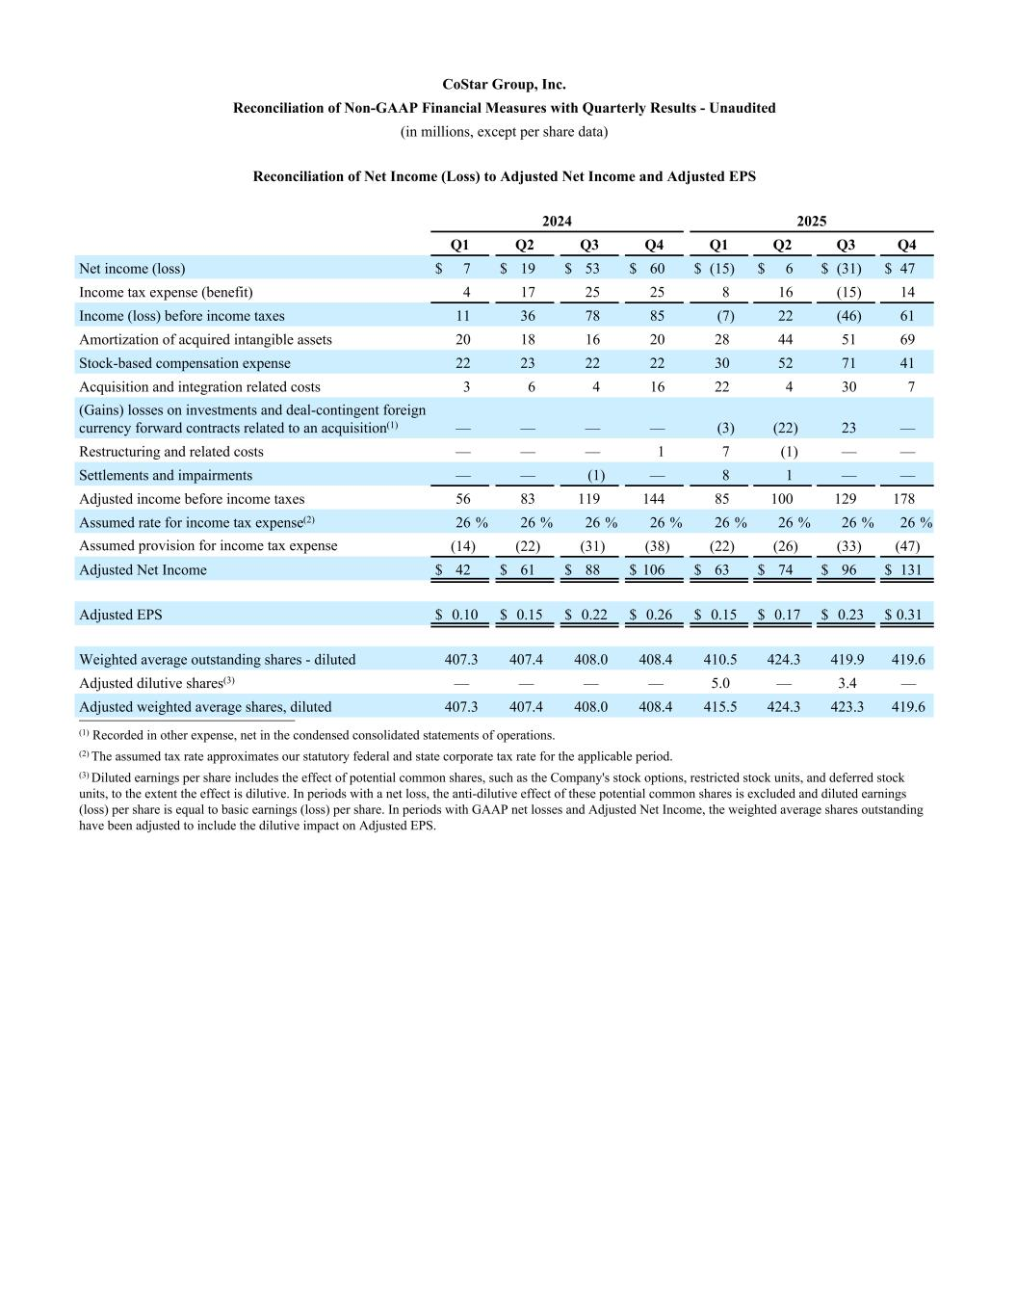
CoStar Group, Inc. Reconciliation of Non-GAAP Financial Measures with Quarterly Results - Unaudited (in millions, except per share data) Reconciliation of Net Income (Loss) to Adjusted Net Income and Adjusted EPS 2024 2025 Q1 Q2 Q3 Q4 Q1 Q2 Q3 Q4 Net income (loss) $ 7 $ 19 $ 53 $ 60 $ (15) $ 6 $ (31) $ 47 Income tax expense (benefit) 4 17 25 25 8 16 (15) 14 Income (loss) before income taxes 11 36 78 85 (7) 22 (46) 61 Amortization of acquired intangible assets 20 18 16 20 28 44 51 69 Stock-based compensation expense 22 23 22 22 30 52 71 41 Acquisition and integration related costs 3 6 4 16 22 4 30 7 (Gains) losses on investments and deal-contingent foreign currency forward contracts related to an acquisition(1) — — — — (3) (22) 23 — Restructuring and related costs — — — 1 7 (1) — — Settlements and impairments — — (1) — 8 1 — — Adjusted income before income taxes 56 83 119 144 85 100 129 178 Assumed rate for income tax expense(2) 26 % 26 % 26 % 26 % 26 % 26 % 26 % 26 % Assumed provision for income tax expense (14) (22) (31) (38) (22) (26) (33) (47) Adjusted Net Income $ 42 $ 61 $ 88 $ 106 $ 63 $ 74 $ 96 $ 131 Adjusted EPS $ 0.10 $ 0.15 $ 0.22 $ 0.26 $ 0.15 $ 0.17 $ 0.23 $ 0.31 Weighted average outstanding shares - diluted 407.3 407.4 408.0 408.4 410.5 424.3 419.9 419.6 Adjusted dilutive shares(3) — — — — 5.0 — 3.4 — Adjusted weighted average shares, diluted 407.3 407.4 408.0 408.4 415.5 424.3 423.3 419.6__________________________ (1) Recorded in other expense, net in the condensed consolidated statements of operations. (2) The assumed tax rate approximates our statutory federal and state corporate tax rate for the applicable period. (3) Diluted earnings per share includes the effect of potential common shares, such as the Company's stock options, restricted stock units, and deferred stock units, to the extent the effect is dilutive. In periods with a net loss, the anti-dilutive effect of these potential common shares is excluded and diluted earnings (loss) per share is equal to basic earnings (loss) per share. In periods with GAAP net losses and Adjusted Net Income, the weighted average shares outstanding have been adjusted to include the dilutive impact on Adjusted EPS.

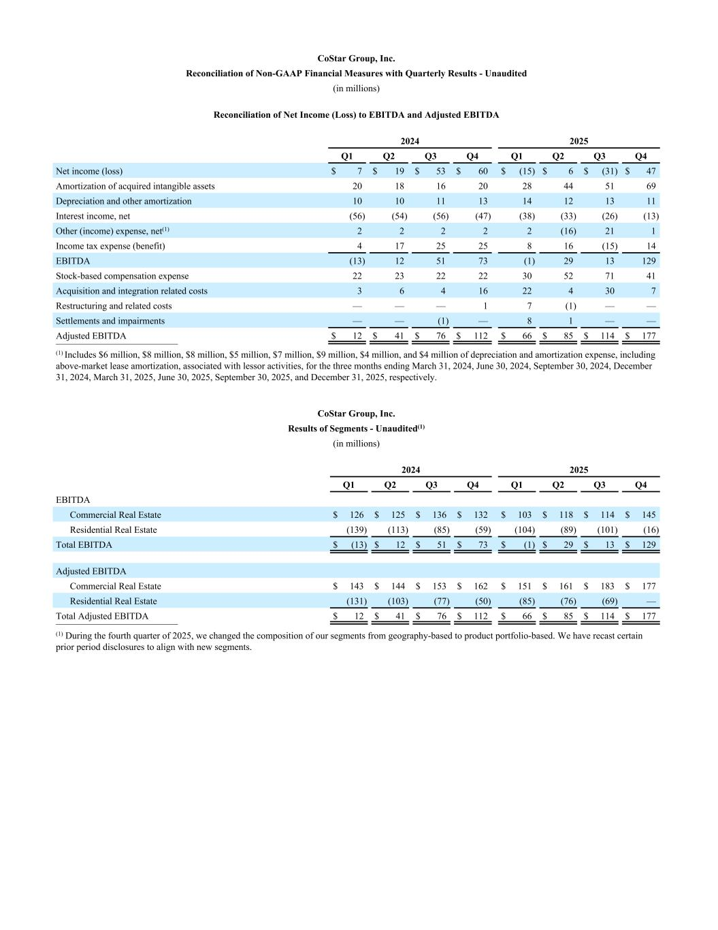
CoStar Group, Inc. Reconciliation of Non-GAAP Financial Measures with Quarterly Results - Unaudited (in millions) Reconciliation of Net Income (Loss) to EBITDA and Adjusted EBITDA 2024 2025 Q1 Q2 Q3 Q4 Q1 Q2 Q3 Q4 Net income (loss) $ 7 $ 19 $ 53 $ 60 $ (15) $ 6 $ (31) $ 47 Amortization of acquired intangible assets 20 18 16 20 28 44 51 69 Depreciation and other amortization 10 10 11 13 14 12 13 11 Interest income, net (56) (54) (56) (47) (38) (33) (26) (13) Other (income) expense, net(1) 2 2 2 2 2 (16) 21 1 Income tax expense (benefit) 4 17 25 25 8 16 (15) 14 EBITDA (13) 12 51 73 (1) 29 13 129 Stock-based compensation expense 22 23 22 22 30 52 71 41 Acquisition and integration related costs 3 6 4 16 22 4 30 7 Restructuring and related costs — — — 1 7 (1) — — Settlements and impairments — — (1) — 8 1 — — Adjusted EBITDA $ 12 $ 41 $ 76 $ 112 $ 66 $ 85 $ 114 $ 177 __________________________ (1) Includes $6 million, $8 million, $8 million, $5 million, $7 million, $9 million, $4 million, and $4 million of depreciation and amortization expense, including above-market lease amortization, associated with lessor activities, for the three months ending March 31, 2024, June 30, 2024, September 30, 2024, December 31, 2024, March 31, 2025, June 30, 2025, September 30, 2025, and December 31, 2025, respectively. CoStar Group, Inc. Results of Segments - Unaudited(1) (in millions) 2024 2025 Q1 Q2 Q3 Q4 Q1 Q2 Q3 Q4 EBITDA Commercial Real Estate $ 126 $ 125 $ 136 $ 132 $ 103 $ 118 $ 114 $ 145 Residential Real Estate (139) (113) (85) (59) (104) (89) (101) (16) Total EBITDA $ (13) $ 12 $ 51 $ 73 $ (1) $ 29 $ 13 $ 129 Adjusted EBITDA Commercial Real Estate $ 143 $ 144 $ 153 $ 162 $ 151 $ 161 $ 183 $ 177 Residential Real Estate (131) (103) (77) (50) (85) (76) (69) — Total Adjusted EBITDA $ 12 $ 41 $ 76 $ 112 $ 66 $ 85 $ 114 $ 177 __________________________ (1) During the fourth quarter of 2025, we changed the composition of our segments from geography-based to product portfolio-based. We have recast certain prior period disclosures to align with new segments.

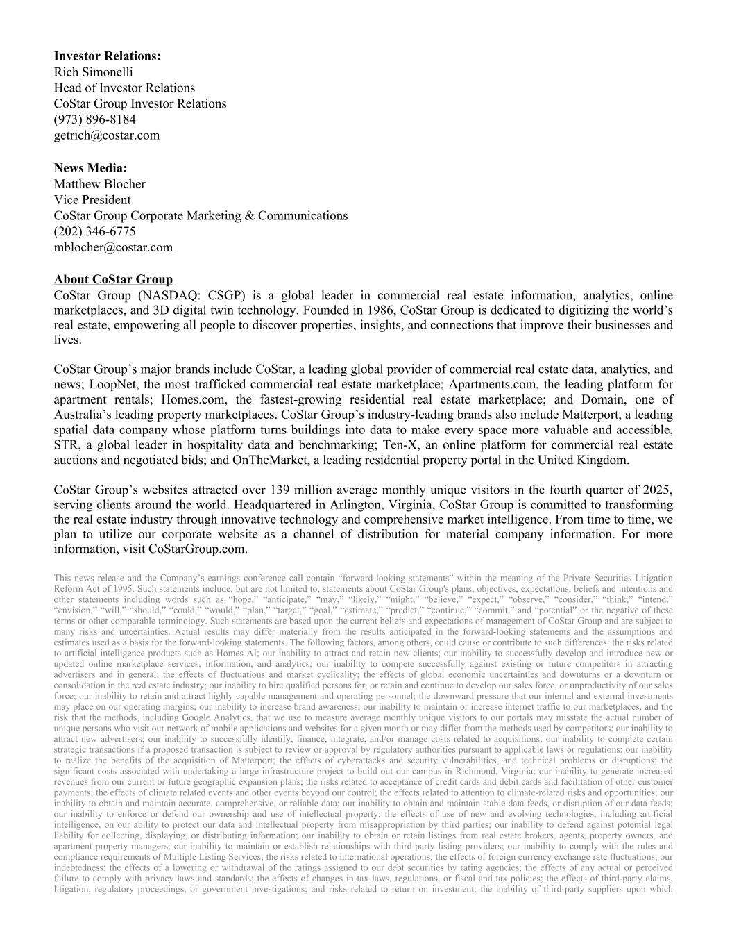
Investor Relations: Rich Simonelli Head of Investor Relations CoStar Group Investor Relations (973) 896-8184 getrich@costar.com News Media: Matthew Blocher Vice President CoStar Group Corporate Marketing & Communications (202) 346-6775 mblocher@costar.com About CoStar Group CoStar Group (NASDAQ: CSGP) is a global leader in commercial real estate information, analytics, online marketplaces, and 3D digital twin technology. Founded in 1986, CoStar Group is dedicated to digitizing the world’s real estate, empowering all people to discover properties, insights, and connections that improve their businesses and lives. CoStar Group’s major brands include CoStar, a leading global provider of commercial real estate data, analytics, and news; LoopNet, the most trafficked commercial real estate marketplace; Apartments.com, the leading platform for apartment rentals; Homes.com, the fastest-growing residential real estate marketplace; and Domain, one of Australia’s leading property marketplaces. CoStar Group’s industry-leading brands also include Matterport, a leading spatial data company whose platform turns buildings into data to make every space more valuable and accessible, STR, a global leader in hospitality data and benchmarking; Ten-X, an online platform for commercial real estate auctions and negotiated bids; and OnTheMarket, a leading residential property portal in the United Kingdom. CoStar Group’s websites attracted over 139 million average monthly unique visitors in the fourth quarter of 2025, serving clients around the world. Headquartered in Arlington, Virginia, CoStar Group is committed to transforming the real estate industry through innovative technology and comprehensive market intelligence. From time to time, we plan to utilize our corporate website as a channel of distribution for material company information. For more information, visit CoStarGroup.com. This news release and the Company’s earnings conference call contain “forward-looking statements” within the meaning of the Private Securities Litigation Reform Act of 1995. Such statements include, but are not limited to, statements about CoStar Group's plans, objectives, expectations, beliefs and intentions and other statements including words such as “hope,” “anticipate,” “may,” “likely,” “might,” “believe,” “expect,” “observe,” “consider,” “think,” “intend,” “envision,” “will,” “should,” “could,” “would,” “plan,” “target,” “goal,” “estimate,” “predict,” “continue,” “commit,” and “potential” or the negative of these terms or other comparable terminology. Such statements are based upon the current beliefs and expectations of management of CoStar Group and are subject to many risks and uncertainties. Actual results may differ materially from the results anticipated in the forward-looking statements and the assumptions and estimates used as a basis for the forward-looking statements. The following factors, among others, could cause or contribute to such differences: the risks related to artificial intelligence products such as Homes AI; our inability to attract and retain new clients; our inability to successfully develop and introduce new or updated online marketplace services, information, and analytics; our inability to compete successfully against existing or future competitors in attracting advertisers and in general; the effects of fluctuations and market cyclicality; the effects of global economic uncertainties and downturns or a downturn or consolidation in the real estate industry; our inability to hire qualified persons for, or retain and continue to develop our sales force, or unproductivity of our sales force; our inability to retain and attract highly capable management and operating personnel; the downward pressure that our internal and external investments may place on our operating margins; our inability to increase brand awareness; our inability to maintain or increase internet traffic to our marketplaces, and the risk that the methods, including Google Analytics, that we use to measure average monthly unique visitors to our portals may misstate the actual number of unique persons who visit our network of mobile applications and websites for a given month or may differ from the methods used by competitors; our inability to attract new advertisers; our inability to successfully identify, finance, integrate, and/or manage costs related to acquisitions; our inability to complete certain strategic transactions if a proposed transaction is subject to review or approval by regulatory authorities pursuant to applicable laws or regulations; our inability to realize the benefits of the acquisition of Matterport; the effects of cyberattacks and security vulnerabilities, and technical problems or disruptions; the significant costs associated with undertaking a large infrastructure project to build out our campus in Richmond, Virginia; our inability to generate increased revenues from our current or future geographic expansion plans; the risks related to acceptance of credit cards and debit cards and facilitation of other customer payments; the effects of climate related events and other events beyond our control; the effects related to attention to climate-related risks and opportunities; our inability to obtain and maintain accurate, comprehensive, or reliable data; our inability to obtain and maintain stable data feeds, or disruption of our data feeds; our inability to enforce or defend our ownership and use of intellectual property; the effects of use of new and evolving technologies, including artificial intelligence, on our ability to protect our data and intellectual property from misappropriation by third parties; our inability to defend against potential legal liability for collecting, displaying, or distributing information; our inability to obtain or retain listings from real estate brokers, agents, property owners, and apartment property managers; our inability to maintain or establish relationships with third-party listing providers; our inability to comply with the rules and compliance requirements of Multiple Listing Services; the risks related to international operations; the effects of foreign currency exchange rate fluctuations; our indebtedness; the effects of a lowering or withdrawal of the ratings assigned to our debt securities by rating agencies; the effects of any actual or perceived failure to comply with privacy laws and standards; the effects of changes in tax laws, regulations, or fiscal and tax policies; the effects of third-party claims, litigation, regulatory proceedings, or government investigations; and risks related to return on investment; the inability of third-party suppliers upon which


Matterport relies to fulfill its needs; the risks associated with the ability to integrate Domain Holdings Australia Limited (the "Domain Transaction") and realize the benefits of the Domain Transaction; the risks related to open source software; and the risks related to the specific timing, price, and size of repurchases under the Stock Repurchase Program, including that the Stock Repurchase Program may be suspended or discontinued at any time at the Company’s discretion. More information about potential factors that could cause results to differ materially from those anticipated in the forward-looking statements include, but are not limited to, those stated in CoStar Group’s filings from time to time with the Securities and Exchange Commission (the "SEC"), including in CoStar Group’s Annual Reports on Form 10-K and Quarterly Reports on Form 10-Q, each of which is filed with the SEC, including in the “Risk Factors” section of those filings, as well as CoStar Group’s other filings with the SEC (including Current Reports on Form 8-K) available at the SEC’s website (www.sec.gov). All forward- looking statements are based on information available to CoStar Group on the date hereof, and CoStar Group assumes no obligation to update or revise any forward-looking statements, whether as a result of new information, future events or otherwise, except as required by applicable law.

