UNITED STATES

SECURITIES AND EXCHANGE COMMISSION

Washington, D.C. 20549

FORM 10-Q

- QUARTERLY REPORT PURSUANT TO SECTION 13 OR 15(d) OF THE SECURITIES EXCHANGE ACT OF 1934

For the quarterly period ended September 30, 2025

OR

- TRANSITION REPORT PURSUANT TO SECTION 13 OR 15(d) OF THE SECURITIES EXCHANGE ACT OF 1934

For the transition period from ______ to ______

Commission file number 0-24531


CoStar Group, Inc.

(Exact name of registrant as specified in its charter)

 | Delaware |  | 52-2091509
(State or other jurisdiction of incorporation or organization) |  |  | (I.R.S. Employer Identification No.)
 |  | 1201 Wilson Blvd
 |  | Arlington | VA 22209

(Address of principal executive offices) (Zip Code)

(202) 346-6500

(Registrant’s telephone number, including area code)

Securities registered pursuant to Section 12(b) of the Act:
 | Title of each class |  | Trading Symbol |  |  | Name of each exchange on which registered
Common Stock ($0.01 par value) |  |  |  | CSGP |  | Nasdaq Global Select Market

Indicate by check mark whether the registrant (1) has filed all reports required to be filed by Section 13 or 15(d) of the Securities Exchange Act of 1934 during the preceding 12 months (or for such shorter period that the registrant was required to file such reports) and (2) has been subject to such filing requirements for the past 90 days. Yes x No o

Indicate by check mark whether the registrant has submitted electronically every Interactive Data File required to be submitted pursuant to Rule 405 of Regulation S-T (§232.405 of this chapter) during the preceding 12 months (or for such shorter period that the registrant was required to submit such files). Yes x No o

Indicate by check mark whether the registrant is a large accelerated filer, an accelerated filer, a non-accelerated filer, a smaller reporting company, or an emerging growth company. See the definitions of “large accelerated filer,” “accelerated filer,” “smaller reporting company,” and “emerging growth company” in Rule 12b-2 of the Exchange Act.

Large accelerated filer | x | Accelerated filer | ☐
Non-accelerated filer | ☐ | Smaller reporting company | ☐
 |  | Emerging growth company | ☐

If an emerging growth company, indicate by check mark if the registrant has elected not to use the extended transition period for complying with any new or revised financial accounting standards provided pursuant to Section 13(a) of the Exchange Act. o

Indicate by check mark whether the registrant is a shell company (as defined in Rule 12b-2 of the Exchange Act). Yes ☐ No x As of October 27, 2025, there were 423,822,791 shares of the registrant’s common stock outstanding.

COSTAR GROUP, INC.

FORM 10-Q

TABLE OF CONTENTS

 |  |  | Glossary of Terms |  |  |  |  |  |  |  |  |  |  |  |  |  |  | 3
 | PART I |  | FINANCIAL INFORMATION
 | Item 1. |  | Financial Statements |  |  |  |  |  |  |  |  |  |  |  |  |  |  | 6
 |  |  | Condensed Consolidated Statements of Operations |  |  |  |  |  |  |  |  |  |  |  |  |  |  | 6
 |  |  | Condensed Consolidated Statements of Comprehensive Income |  |  |  |  |  |  |  |  |  |  |  |  |  |  | 7
 |  |  | Condensed Consolidated Balance Sheets |  |  |  |  |  |  |  |  |  |  |  |  |  |  | 8
 |  |  | Condensed Consolidated Statements of Changes in Stockholders’ Equity |  |  |  |  |  |  |  |  |  |  |  |  |  |  | 9
 |  |  | Condensed Consolidated Statements of Cash Flows |  |  |  |  |  |  |  |  |  |  |  |  |  |  | 11
 |  |  | Notes to Condensed Consolidated Financial Statements |  |  |  |  |  |  |  |  |  |  |  |  |  |  | 12
 | Item 2. |  | Management’s Discussion and Analysis of Financial Condition and Results of Operations |  |  |  |  |  |  |  |  |  |  |  |  |  |  | 46
 | Item 3. |  | Quantitative and Qualitative Disclosures About Market Risk |  |  |  |  |  |  |  |  |  |  |  |  |  |  | 61
 | Item 4. |  | Controls and Procedures |  |  |  |  |  |  |  |  |  |  |  |  |  |  | 62
 | PART II |  | OTHER INFORMATION
 | Item 1. |  | Legal Proceedings |  |  |  |  |  |  |  |  |  |  |  |  |  |  | 63
 | Item 1A. |  | Risk Factors |  |  |  |  |  |  |  |  |  |  |  |  |  |  | 63
 | Item 2. |  | Unregistered Sales of Equity Securities and Use of Proceeds |  |  |  |  |  |  |  |  |  |  |  |  |  |  | 65
 | Item 3. |  | Defaults Upon Senior Securities |  |  |  |  |  |  |  |  |  |  |  |  |  |  | 65
 | Item 4. |  | Mine Safety Disclosures |  |  |  |  |  |  |  |  |  |  |  |  |  |  | 65
 | Item 5. |  | Other Information |  |  |  |  |  |  |  |  |  |  |  |  |  |  | 65
 | Item 6. |  | Exhibits |  |  |  |  |  |  |  |  |  |  |  |  |  |  | 66
 | Signatures |  |  |  |  |  |  |  |  |  |  |  |  |  |  |  |  | 67
 |  |  | 2

Glossary of Terms

The following abbreviations or acronyms used in this Quarterly Report on Form 10-Q (this “Report”) are defined below:

Abbreviation or Acronym | Definition
2024 Credit Agreement | The credit agreement the Company entered into on May 24, 2024
2024 Form 10-K | CoStar Group's Annual Report on Form 10-K for the year ended December 31, 2024 filed with
 | the SEC on February 19, 2025
A$ | Australian dollars
AI | Artificial Intelligence
AOMs | Structured equity vehicles operating under Domain's Agent Ownership Model. The AOMs
 | function as strategic partnership tools that provide residential and commercial real estate agencies
 | an economic stake in Domain-affiliated entities, creating a mechanism to reward long-term
 | engagement and performance through profit-sharing rather than traditional commissions or
 | rebates.
ASC | Accounting Standards Codification
Assumed Matterport Plans | The Matterport 2021 Incentive Award Plan and Matterport, Inc. Amended and Restated 2011
 | Stock Incentive Plan assumed by CoStar Group in connection with the Matterport Acquisition
ASU | Accounting Standards Update
BizBuySell Network | BizBuySell.com and its network of business for-sale websites
Board of Directors | The CoStar Group Board of Directors
CECL | Current expected credit losses
CODM | Chief Operating Decision Maker
CoStar Group (also the | The legal entity, CoStar Group, Inc., a Delaware corporation, one or more of its consolidated
“Company,” “we,” “us,” or | subsidiaries or operating segments, or the entirety of CoStar Group, Inc. and its consolidated
“our”) | subsidiaries
CoStar Group Share | A share of the common stock of the Company, par value $0.01 per share
CRI | The legal entity CoStar Realty Information, Inc., a Delaware corporation and wholly owned
 | subsidiary (and primary operating entity in the United States) of CoStar Group, Inc.
Domain | Domain Holdings Australia Limited
Domain Acquisition | CoStar's acquisition of Domain completed on August 27, 2025, pursuant to the Scheme
 | Implementation Deed
Domain Proposal | The Company’s non-binding indicative proposal to acquire 100% of the issued capital of Domain
 | by way of scheme of arrangement for a cash consideration of A$4.43 per ordinary share of
 | Domain
Domain SID | The Company's binding Scheme Implementation Deed to acquire 100% of the issued capital of
 | Domain for a cash consideration of A$4.43 per ordinary share of Domain
Domain Transaction | The transactions entered into by the Company to acquire Domain pursuant to the Domain SID.
DSUs | Deferred Stock Units
EBITDA | Net income (loss) before interest income or expense, net; other income or expense, net; loss on
 | debt extinguishment; income taxes; depreciation; and amortization
ESPP | Employee Stock Purchase Plan
EURIBOR | Euro Interbank Offered Rate
Exchange Act | The Securities Exchange Act of 1934, as amended
FASB | Financial Accounting Standards Board
GAAP | Generally accepted accounting principles in the U.S.
GILTI | Global intangible low taxed income inclusion
 | 3

Abbreviation or Acronym | Definition
Homes.com | The flagship brand of our North American residential products and a homes for-sale listings site,
 | which manages workflow and marketing for residential real estate agents and brokers and allows
 | homebuyers to view residential property listings, research communities, and connect with real
 | estate agents and brokers
Land.com Network | Our network of sites featuring rural lands for sale including Land.com, LandsofAmerica,
 | LandAndFarm, and LandWatch
Matching RSUs | Awards of matching restricted stock units awarded under the Company's Management Stock
 | Purchase Plan
Matterport | The legal entity Matterport, LLC, formerly known as Matterport Inc., a Delaware corporation and
 | provider of a technology platform that uses spatial data to transform physical buildings and spaces
 | into dimensionally accurate, digital images
Matterport Acquisition | CoStar's acquisition of Matterport completed on February 28, 2025, pursuant to the Matterport
 | Merger Agreement
Matterport Common Stock | Matterport Class A common stock, par value $0.0001 per share
Matterport Merger | A ratio of 0.03552 which was determined by the Matterport Merger Agreement and was set on the
Exchange Ratio | collar floor as the volume-weighted average price at which the CoStar Group Shares traded on the
 | Nasdaq Global Select Market for the 20 consecutive Trading Days was below the Floor Price of a
 | symmetrical collar of $77.42
Matterport Merger | On April 21, 2024, CoStar entered into an Agreement and Plan of Merger and Reorganization
Agreement | with Matterport, Matrix Merger Sub I LLC, and Matrix Merger Sub II LLC.
MLSs | Multiple listing services
MSPP | Management Stock Purchase Plan
NCI | Noncontrolling interest
OBBBA | H.R. 1 “A bill to provide for reconciliation pursuant to Title II of H. Con. Res. 14,” commonly
 | referred to as the One Big Beautiful Bill Act, signed into law on July 4, 2025
OnTheMarket | The legal entity OnTheMarket Limited, the operator of onthemarket.com, a U.K. residential
 | property portal
ROU | Right-of-use
SEC | The U.S. Securities and Exchange Commission
Securities Act | The Securities Act of 1933, as amended
Senior Notes | 2.800% notes issued by CoStar Group, Inc. due July 15, 2030
SOFR | Secured Overnight Financing Rate
SONIA | Sterling Overnight Index Average
Stock Repurchase Program | The stock repurchase program the Board of Directors approved in February 2025 that authorizes
 | the repurchase of up to $500 million CoStar Group Shares
STR | The legal entity STR LLC, together with STR Global Ltd, is a global data and analytics company
 | that specializes in benchmarking hotel performance and providing market insights to the industry
Ten-X | The legal entity Ten-X Holding Company, Inc. and its directly and indirectly owned subsidiaries
Term SOFR | The forward-looking SOFR term rates administered by CME Group Benchmark Administration
 | Limited
TSR | Total shareholder return
U.K. | The United Kingdom of Great Britain and Northern Ireland
U.S. | The United States of America
VIE | Variable Interest Entity
Visual Lease | The legal entity Visual Lease, LLC, a Delaware limited liability company and operator of Visual
 | Lease, a SaaS platform for integrated lease management and lease accounting
 | 4

Abbreviation or Acronym | Definition
Visual Lease Acquisition | CoStar's acquisition of all of the outstanding equity interest in Visual Lease completed on
 | November 1, 2024, pursuant to the Visual Lease Merger Agreement
Visual Lease Merger | The Agreement and Plan of Merger dated as of October 18, 2024, between CRI; Neptune Merger
Agreement | Sub; Visual Lease, LLC; and Shareholder Representative Services LLC as the Holder
 | Representative, pursuant to which, among other things, and subject to its terms, Neptune Merger
 | Sub merged with and into Visual Lease with Visual Lease surviving the merger as a wholly-
 | owned subsidiary of CRI
 | 5

PART I — FINANCIAL INFORMATION

Item 1. Financial Statements

COSTAR GROUP, INC.

CONDENSED CONSOLIDATED STATEMENTS OF OPERATIONS

(in millions, except per share data)

(unaudited)

 | Three Months Ended |  |  |  |  |  |  | Nine Months Ended
 |  | September 30, |  |  |  |  |  | September 30,
 | 2025 |  |  | 2024 |  |  |  | 2025 |  |  | 2024
Revenues | $ | 833.6 |  | $ | 692.6 |  | $ | 2,347.1 |  | $ | 2,026.8
Cost of revenues |  | 172.2 |  |  | 140.6 |  |  | 493.3 |  |  | 417.6
Gross profit |  | 661.4 |  |  | 552.0 |  |  | 1,853.8 |  |  | 1,609.2
Operating expenses:
Selling and marketing (excluding customer base amortization) |  | 418.3 |  |  | 331.2 |  |  | 1,182.1 |  |  | 1,055.7
Software development |  | 105.4 |  |  | 81.0 |  |  | 297.0 |  |  | 243.0
General and administrative |  | 157.0 |  |  | 105.8 |  |  | 420.3 |  |  | 314.3
Customer base amortization |  | 31.8 |  |  | 10.3 |  |  | 75.5 |  |  | 31.5
 |  | 712.5 |  |  | 528.3 |  |  | 1,974.9 |  |  | 1,644.5
Income (loss) from operations |  | (51.1) |  |  | 23.7 |  |  | (121.1) |  |  | (35.3)
Interest income, net |  | 26.0 |  |  | 55.6 |  |  | 97.0 |  |  | 165.3
Other expense, net |  | (20.7) |  |  | (1.6) |  |  | (6.8) |  |  | (4.9)
Income (loss) before income taxes |  | (45.8) |  |  | 77.7 |  |  | (30.9) |  |  | 125.1
Income tax expense (benefit) |  | (14.9) |  |  | 24.7 |  |  | 8.6 |  |  | 46.2
Net income (loss) | $ | (30.9) |  | $ | 53.0 |  | $ | (39.5) |  | $ | 78.9
Net income (loss) per share - basic | $ | (0.07) |  | $ | 0.13 |  | $ | (0.09) |  | $ | 0.19
Net income (loss) per share - diluted | $ | (0.07) |  | $ | 0.13 |  | $ | (0.09) |  | $ | 0.19
Weighted-average outstanding shares - basic |  | 419.9 |  |  | 406.8 |  |  | 416.7 |  |  | 406.2
Weighted-average outstanding shares - diluted
Weighted-average outstanding shares - diluted |  | 419.9 |  |  | 408.0 |  |  | 416.7 |  |  | 407.6

See accompanying notes.

6

COSTAR GROUP, INC.

CONDENSED CONSOLIDATED STATEMENTS OF COMPREHENSIVE INCOME

(in millions)

(unaudited)

 | Three Months Ended |  |  |  |  |  |  | Nine Months Ended
 |  | September 30, |  |  |  |  |  | September 30,
 | 2025 |  |  | 2024 |  |  |  | 2025 |  |  | 2024
Net income (loss) | $ | (30.9) |  | $ | 53.0 |  | $ | (39.5) |  | $ | 78.9
Other comprehensive income, net of tax
Foreign currency translation adjustment |  | 36.8 |  |  | 18.0 |  |  | 82.5 |  |  | 13.5
Total other comprehensive income |  | 36.8 |  |  | 18.0 |  |  | 82.5 |  |  | 13.5
Total comprehensive income | $ | 5.9 |  | $ | 71.0 |  | $ | 43.0 |  | $ | 92.4

See accompanying notes.

7

COSTAR GROUP, INC.

CONDENSED CONSOLIDATED BALANCE SHEETS

(in millions)

(unaudited)

 |  | September 30, |  |  | December 31,
 |  | 2025 |  |  | 2024
ASSETS
Current assets:
Cash and cash equivalents | $ | 1,935.3 |  | $ | 4,681.0
Restricted cash |  | 99.5 |  |  | —
Accounts receivable |  | 273.7 |  |  | 210.7
Less: Allowance for credit losses |  | (29.9) |  |  | (22.8)
Accounts receivable, net |  | 243.8 |  |  | 187.9
Prepaid expenses and other current assets |  | 126.5 |  |  | 81.3
Total current assets |  | 2,405.1 |  |  | 4,950.2
Deferred income taxes, net |  | 65.9 |  |  | 30.6
Property and equipment, net |  | 1,269.6 |  |  | 1,014.9
Lease right-of-use assets |  | 111.3 |  |  | 103.0
Goodwill |  | 4,915.4 |  |  | 2,527.6
Intangible assets, net |  | 1,844.4 |  |  | 433.2
Deferred commission costs, net |  | 178.0 |  |  | 169.6
Deposits and other assets |  | 30.2 |  |  | 27.7
Total assets | $ | 10,819.9 |  | $ | 9,256.8
LIABILITIES AND STOCKHOLDERS’ EQUITY
Current liabilities:
Accounts payable | $ | 46.5 |  | $ | 47.0
Accrued wages and commissions |  | 145.2 |  |  | 133.3
Accrued expenses |  | 217.0 |  |  | 163.7
Litigation accrual |  | 98.8 |  |  | —
Income taxes payable |  | 9.5 |  |  | 23.2
Lease liabilities |  | 28.4 |  |  | 32.0
Deferred revenue |  | 201.6 |  |  | 137.1
Other current liabilities |  | 23.5 |  |  | 16.0
Total current liabilities |  | 770.5 |  |  | 552.3
Long-term debt, net |  | 992.9 |  |  | 991.9
Deferred income taxes, net |  | 248.6 |  |  | 7.6
Income taxes payable |  | 27.3 |  |  | 25.0
Lease and other long-term liabilities |  | 156.7 |  |  | 126.5
Total liabilities |  | 2,196.0 |  |  | 1,703.3
Stockholders' equity attributable to CoStar Group |  | 8,615.8 |  |  | 7,553.5
Equity attributable to NCI |  | 8.1 |  |  | —
Total equity |  | 8,623.9 |  |  | 7,553.5
Total liabilities and stockholders' equity | $ | 10,819.9 |  | $ | 9,256.8
See accompanying notes.
8

COSTAR GROUP, INC.

CONDENSED CONSOLIDATED STATEMENTS OF CHANGES IN STOCKHOLDERS’ EQUITY

(in millions)

(unaudited)

 | Common Stock |  |  |  |  |  | Additional |  |  | Treasury |  |  | Accumulated Other |  |  | Retained |  |  | Stockholders’ Equity |  |  | Equity
 |  |  |  |  |  |  |  |  |  |  |  | Comprehensive Income |  |  |  |  |  | Attributable to CoStar |  |  |  | Attributable to
 | Shares |  |  | Amount |  | Paid-In Capital |  |  |  | Stock |  |  | (Loss) |  |  | Earnings |  |  | Group |  |  | NCI |  |  | Total Equity
Balance at December 31, 2024 | 409.5 |  | $ | 4.1 |  | $ | 5,231.9 |  | $ | — |  | $ | (25.5) |  | $ | 2,343.0 |  | $ | 7,553.5 |  | $ | — |  | $ | 7,553.5
Net income (loss) | — |  |  | — |  |  | — |  |  | — |  |  | — |  |  | (14.8) |  |  | (14.8) |  |  | — |  |  | (14.8)
Other comprehensive income (loss) | — |  |  | — |  |  | — |  |  | — |  |  | 8.8 |  |  | — |  |  | 8.8 |  |  | — |  |  | 8.8
Exercise of stock options | 0.1 |  |  | — |  |  | 0.9 |  |  | — |  |  | — |  |  | — |  |  | 0.9 |  |  | — |  |  | 0.9
Restricted stock grants | 2.3 |  |  | — |  |  | — |  |  | — |  |  | — |  |  | — |  |  | — |  |  | — |  |  | —
Restricted stock grants surrendered | (0.3) |  |  | — |  |  | (33.4) |  |  | — |  |  | — |  |  | — |  |  | (33.4) |  |  | — |  |  | (33.4)
Employee stock purchase plan | 0.1 |  |  | — |  |  | 6.3 |  |  | — |  |  | — |  |  | — |  |  | 6.3 |  |  | — |  |  | 6.3
Management stock purchase plan | — |  |  | — |  |  | (1.3) |  |  | — |  |  | — |  |  | — |  |  | (1.3) |  |  | — |  |  | (1.3)
Stock-based compensation expense | — |  |  | — |  |  | 29.7 |  |  | — |  |  | — |  |  | — |  |  | 29.7 |  |  | — |  |  | 29.7
Stock repurchases under stock repurchase programs (0.2
million shares) | — |  |  | — |  |  | — |  |  | (18.5) |  |  | — |  |  | — |  |  | (18.5) |  |  | — |  |  | (18.5)
Common stock issued for Matterport Acquisition | 11.7 |  |  | 0.1 |  |  | 1,024.9 |  |  | — |  |  | — |  |  | — |  |  | 1,025.0 |  |  | — |  |  | 1,025.0
Balance at March 31, 2025 | 423.4 |  |  | 4.2 |  |  | 6,259.0 |  |  | (18.5) |  |  | (16.7) |  |  | 2,328.2 |  |  | 8,556.2 |  |  | — |  |  | 8,556.2
Net income (loss) | — |  |  | — |  |  | — |  |  | — |  |  | — |  |  | 6.2 |  |  | 6.2 |  |  | — |  |  | 6.2
Other comprehensive income (loss) | — |  |  | — |  |  | — |  |  | — |  |  | 36.9 |  |  | — |  |  | 36.9 |  |  | — |  |  | 36.9
Exercise of stock options | 0.4 |  |  | — |  |  | 3.7 |  |  | — |  |  | — |  |  | — |  |  | 3.7 |  |  | — |  |  | 3.7
Restricted stock grants | 0.3 |  |  | — |  |  | — |  |  | — |  |  | — |  |  | — |  |  | — |  |  | — |  |  | —
Restricted stock grants surrendered | (0.1) |  |  | — |  |  | (11.9) |  |  | — |  |  | — |  |  | — |  |  | (11.9) |  |  | — |  |  | (11.9)
Employee stock purchase plan | 0.1 |  |  | — |  |  | 4.5 |  |  | — |  |  | — |  |  | — |  |  | 4.5 |  |  | — |  |  | 4.5
Management stock purchase plan | — |  |  | — |  |  | (0.4) |  |  | — |  |  | — |  |  | — |  |  | (0.4) |  |  | — |  |  | (0.4)
Stock-based compensation expense | — |  |  | — |  |  | 51.5 |  |  | — |  |  | — |  |  | — |  |  | 51.5 |  |  | — |  |  | 51.5
Stock repurchases under stock repurchase programs (0.6
million shares) | — |  |  | — |  |  | — |  |  | (45.3) |  |  | — |  |  | — |  |  | (45.3) |  |  | — |  |  | (45.3)
Balance at June 30, 2025 | 424.1 |  |  | 4.2 |  |  | 6,306.4 |  |  | (63.8) |  |  | 20.2 |  |  | 2,334.4 |  |  | 8,601.4 |  |  | — |  |  | 8,601.4
Net income (loss) | — |  |  | — |  |  | — |  |  | — |  |  | — |  |  | (30.9) |  |  | (30.9) |  |  | — |  |  | (30.9)
Domain acquisition | — |  |  | — |  |  | — |  |  | — |  |  | — |  |  | — |  |  | — |  |  | 7.8 |  |  | 7.8
Other comprehensive income (loss) | — |  |  | — |  |  | — |  |  | — |  |  | 36.8 |  |  | — |  |  | 36.8 |  |  | — |  |  | 36.8
Change in NCI | — |  |  | — |  |  | — |  |  | — |  |  | — |  |  | — |  |  | — |  |  | 0.3 |  |  | 0.3
Exercise of stock options | 0.2 |  |  | — |  |  | 1.4 |  |  | — |  |  | — |  |  | — |  |  | 1.4 |  |  | — |  |  | 1.4
Restricted stock grants | 0.6 |  |  | — |  |  | — |  |  | — |  |  | — |  |  | — |  |  | — |  |  | — |  |  | —
Restricted stock grants surrendered | (0.1) |  |  | — |  |  | (17.0) |  |  | — |  |  | — |  |  | — |  |  | (17.0) |  |  | — |  |  | (17.0)
Employee stock purchase plan | 0.1 |  |  | — |  |  | 5.1 |  |  | — |  |  | — |  |  | — |  |  | 5.1 |  |  | — |  |  | 5.1
Management stock purchase plan | — |  |  | — |  |  | (0.1) |  |  | — |  |  | — |  |  | — |  |  | (0.1) |  |  | — |  |  | (0.1)
Stock-based compensation expense | — |  |  | — |  |  | 70.3 |  |  | — |  |  | — |  |  | — |  |  | 70.3 |  |  | — |  |  | 70.3
Stock repurchases under stock repurchase programs (0.6
million shares) | — |  |  | — |  |  | — |  |  | (51.2) |  |  | — |  |  | — |  |  | (51.2) |  |  | — |  |  | (51.2)
Balance at September 30, 2025 | 424.9 |  | $ | 4.2 |  | $ | 6,366.1 |  | $ | (115.0) |  | $ | 57.0 |  | $ | 2,303.5 |  | $ | 8,615.8 |  | $ | 8.1 |  | $ | 8,623.9

See accompanying notes.

9

COSTAR GROUP, INC.

CONDENSED CONSOLIDATED STATEMENTS OF CHANGES IN STOCKHOLDERS’ EQUITY

(in millions)

(unaudited)

 | Common Stock |  |  |  |  | Additional Paid- |  |  |  | Accumulated Other |  |  | Retained |  | Total Stockholders'
 |  |  |  |  |  |  |  |  |  | Comprehensive Income
 | Shares |  | Amount |  |  |  | In Capital |  |  | (Loss) |  |  | Earnings |  |  | Equity
Balance at December 31, 2023 | 408.1 |  | $ | 4.1 |  | $ | 5,147.8 |  | $ | (17.6) |  | $ | 2,204.3 |  | $ | 7,338.6
Net income (loss) | — |  |  | — |  |  | — |  |  | — |  |  | 6.7 |  |  | 6.7
Other comprehensive income (loss) | — |  |  | — |  |  | — |  |  | (4.3) |  |  | — |  |  | (4.3)
Restricted stock grants | 1.4 |  |  | — |  |  | — |  |  | — |  |  | — |  |  | —
Restricted stock grants surrendered | (0.4) |  |  | — |  |  | (24.5) |  |  | — |  |  | — |  |  | (24.5)
Employee stock purchase plan | 0.1 |  |  | — |  |  | 5.2 |  |  | — |  |  | — |  |  | 5.2
Management stock purchase plan | — |  |  | — |  |  | (1.5) |  |  | — |  |  | — |  |  | (1.5)
Stock-based compensation expense | — |  |  | — |  |  | 22.4 |  |  | — |  |  | — |  |  | 22.4
Balance at March 31, 2024 | 409.2 |  |  | 4.1 |  |  | 5,149.4 |  |  | (21.9) |  |  | 2,211.0 |  |  | 7,342.6
Net income (loss) | — |  |  | — |  |  | — |  |  | — |  |  | 19.2 |  |  | 19.2
Other comprehensive income (loss) | — |  |  | — |  |  | — |  |  | (0.2) |  |  | — |  |  | (0.2)
Exercise of stock options | 0.1 |  |  | — |  |  | 7.1 |  |  | — |  |  | — |  |  | 7.1
Restricted stock grants | 0.1 |  |  | — |  |  | — |  |  | — |  |  | — |  |  | —
Restricted stock grants surrendered | (0.2) |  |  | — |  |  | (0.7) |  |  | — |  |  | — |  |  | (0.7)
Employee stock purchase plan | 0.1 |  |  | — |  |  | 6.0 |  |  | — |  |  | — |  |  | 6.0
Management stock purchase plan | — |  |  | — |  |  | (0.2) |  |  | — |  |  | — |  |  | (0.2)
Stock-based compensation expense | — |  |  | — |  |  | 21.9 |  |  | — |  |  | — |  |  | 21.9
Balance at June 30, 2024 | 409.3 |  |  | 4.1 |  |  | 5,183.5 |  |  | (22.1) |  |  | 2,230.2 |  |  | 7,395.7
Net income (loss) | — |  |  | — |  |  | — |  |  | — |  |  | 53.0 |  |  | 53.0
Other comprehensive income (loss) | — |  |  | — |  |  | — |  |  | 18.0 |  |  | — |  |  | 18.0
Restricted stock grants | 0.2 |  |  | — |  |  | — |  |  | — |  |  | — |  |  | —
Restricted stock grants surrendered | (0.1) |  |  | — |  |  | (1.9) |  |  | — |  |  | — |  |  | (1.9)
Employee stock purchase plan | 0.1 |  |  | — |  |  | 5.0 |  |  | — |  |  | — |  |  | 5.0
Stock-based compensation expense | — |  |  | — |  |  | 21.3 |  |  | — |  |  | — |  |  | 21.3
Balance at September 30, 2024 | 409.5 |  | $ | 4.1 |  | $ | 5,207.9 |  | $ | (4.1) |  | $ | 2,283.2 |  | $ | 7,491.1

See accompanying notes.

10

COSTAR GROUP, INC.

CONDENSED CONSOLIDATED STATEMENTS OF CASH FLOWS

(in millions)

(unaudited)

Nine Months Ended

September 30,

 | 2025 |  |  |  | 2024
Operating activities:
Net income (loss) | $ | (39.5) |  | $ | 78.9
Adjustments to reconcile net income (loss) to net cash provided by operating activities:
Depreciation and amortization |  | 182.0 |  |  | 107.6
Amortization of deferred commissions costs |  | 110.4 |  |  | 86.1
Non-cash lease expense |  | 22.3 |  |  | 25.1
Stock-based compensation expense |  | 153.0 |  |  | 67.3
Deferred income taxes, net |  | 5.4 |  |  | (15.4)
Credit loss expense |  | 25.9 |  |  | 25.8
Other operating activities, net |  | (5.9) |  |  | 1.7
Changes in operating assets and liabilities, net of acquisitions:
Accounts receivable |  | (32.3) |  |  | (13.7)
Prepaid expenses, other current assets and other assets |  | (19.2) |  |  | (8.2)
Deferred commissions |  | (117.2) |  |  | (91.7)
Accounts payable and other liabilities |  | 10.9 |  |  | 57.9
Lease liabilities |  | (23.8) |  |  | (29.9)
Income taxes payable, net |  | (21.2) |  |  | (1.7)
Deferred revenue |  | 17.1 |  |  | 8.2
Net cash provided by operating activities |  | 267.9 |  |  | 298.0
Investing activities:
Proceeds from sale and settlement of investments |  | 203.4 |  |  | —
Proceeds from sale of property, equipment, and other assets |  | 1.3 |  |  | 1.4
Purchases of property, equipment, and other assets for new campuses |  | (246.2) |  |  | (509.6)
Purchases of property, equipment, and other assets |  | (76.3) |  |  | (49.5)
Purchases of equity securities |  | (284.8) |  |  | —
Cash paid for acquisitions, net of cash acquired |  | (2,347.2) |  |  | (5.1)
Net cash used in investing activities |  | (2,749.8) |  |  | (562.8)
Financing activities:
Payments of debt issuance costs |  | — |  |  | (3.4)
Repurchase of restricted stock to satisfy tax withholding obligations |  | (64.2) |  |  | (28.7)
Stock repurchase |  | (115.0) |  |  | —
Proceeds from exercise of stock options and employee stock purchase plan |  | 20.4 |  |  | 21.7
Principal repayments of financing lease obligations |  | (3.3) |  |  | (3.4)
Net cash used in financing activities |  | (162.1) |  |  | (13.8)
Effect of foreign currency exchange rates on cash, cash equivalents, and restricted cash |  | (2.2) |  |  | 0.3
Net decrease in cash, cash equivalents, and restricted cash |  | (2,646.2) |  |  | (278.3)
Cash, cash equivalents, and restricted cash at the beginning of period |  | 4,681.0 |  |  | 5,215.9
Cash, cash equivalents, and restricted cash at the end of period | $ | 2,034.8 |  | $ | 4,937.6
Supplemental cash flow disclosures:
Interest paid | $ | 29.5 |  | $ | 29.8
Income taxes paid | $ | 56.4 |  | $ | 63.4
Supplemental non-cash investing and financing activities:
Accrued capital expenditures and non-cash landlord incentives | $ | 80.5 |  | $ | 47.8

See accompanying notes.

11

COSTAR GROUP, INC.

NOTES TO CONDENSED CONSOLIDATED FINANCIAL STATEMENTS (unaudited)

1. ORGANIZATION

CoStar Group is a leading global provider of real estate information, analytics, online marketplaces, and 3D digital twin technology. The Company has created and compiled a standardized platform of real estate information and analytics and online marketplaces where industry professionals, consumers of real estate, and the related business communities can continuously interact and facilitate transactions by efficiently accessing and exchanging accurate and standardized real estate-related information. The Company's service offerings span all property types, including office, residential, retail, industrial, multifamily, land, mixed-use, and hospitality. The Company's services are typically distributed to its customers under subscription-based agreements that generally renew automatically and have a minimum term of one year. The Company operates within two operating segments, North America, which includes the U.S. and Canada, and International, which primarily includes Asia-Pacific, Europe, and Latin America.

The Company completed the Visual Lease Acquisition, Matterport Acquisition, and Domain Acquisition in November 2024, February 2025, and August 2025, respectively. See Note 5 for further discussion of these acquisitions.

- SUMMARY OF SIGNIFICANT ACCOUNTING POLICIES Basis of Presentation
The condensed consolidated financial statements include the accounts of the Company and its wholly-owned subsidiaries. All intercompany balances and transactions have been eliminated in consolidation. Accounting policies are consistent for each operating segment.

Principles of Consolidation

The consolidated financial statements include CoStar Group, Inc. and all entities in which we have a controlling financial interest. To determine whether such an interest exists, we assess whether the entity qualifies as a VIE.

We consolidate VIEs when we are the primary beneficiary. We are deemed the primary beneficiary of a VIE when we have both (a) the power to direct the activities of the VIE that most significantly impact its economic performance, and (b) the obligation to absorb losses or the right to receive benefits that could potentially be significant to the VIE.

In determining whether we are the primary beneficiary, we consider various factors regarding the nature of our involvement with the VIE, including our economic interests, voting rights, authority to appoint or remove directors, and ability to authorize key decisions. We also analyze the VIE’s design, including its capital structure, cash flows, and classes of shares.

As part of the Domain Acquisition, the Company obtained ownership interests in the AOMs, which are considered VIEs for which the Company is the primary beneficiary. Domain introduced the AOMs to incentivize real estate agencies to utilize Domain's services through a revenue sharing model. The assets of these VIEs are not available to us, and the creditors of the VIEs do not have recourse to CoStar. Domain provides corporate services to the VIEs under services agreements. In addition, Domain has issued letters of support to the VIEs, committing to provide financial support in the event that the VIEs are unable to meet their liabilities independently.

See Note 5 for additional details regarding the Domain acquisition.

Interim Financial Statements

The accompanying unaudited condensed consolidated financial statements of the Company have been prepared in accordance with GAAP for interim financial information. In the opinion of the Company’s management, the financial statements reflect all adjustments, consisting only of a normal recurring nature, necessary to present fairly the Company’s financial position at September 30, 2025 and December 31, 2024, the results of its operations for the three and nine months ended September 30, 2025 and 2024, its comprehensive income for the three and nine months ended September 30, 2025 and 2024, its changes in stockholders' equity for the three and nine months ended September 30, 2025 and 2024, and its cash flows for the nine months ended September 30, 2025 and 2024.

12

Certain notes and other information have been condensed or omitted from the interim financial statements presented in this Report. Therefore, these financial statements should be read in conjunction with the Company’s 2024 Form 10-K.

Use of Estimates

The preparation of financial statements in conformity with GAAP requires management to make estimates and assumptions that affect the amounts reported in the financial statements and accompanying notes. On an ongoing basis, the Company evaluates its estimates and assumptions, including those related to revenue recognition, allowance for credit losses, the useful lives and recoverability of long-lived and intangible assets, goodwill impairment assessment, income taxes, accounting for business combinations, stock-based compensation, estimating the Company's incremental borrowing rate for its leases, the estimate of net realizable value of inventory, the determination of stand-alone selling prices of various performance obligations, and contingencies, among others. The Company bases these estimates on historical and anticipated results, trends, and various other assumptions that it believes are reasonable, including assumptions as to future events. These estimates form the basis for making judgments about the carrying values of assets and liabilities and recorded revenues and expenses. Actual results could differ from these estimates.

Revenue Recognition

The Company derives revenues primarily by (i) providing access to its proprietary database of commercial real estate information, including benchmarking and analytics for the hospitality industry and analytics for lenders, and (ii) providing online marketplaces for professional property management companies, property owners, real estate agents and brokers, and landlords, in each case, typically through a fixed monthly fee for its subscription-based advertising services. Other subscription-based services include (i) real estate and lease management solutions to commercial customers and real estate investors, (ii) access to applications to manage workflow for residential real estate agents, and (iii) access to its AI-powered spatial data platform to create high-fidelity and high-accuracy digital twins of physical spaces.

Subscription contract rates are generally based on the number of sites, number of users, organization size, the customer’s business focus, geography, the number of properties reported on or analyzed, the number and types of services to which a customer subscribes, the number of properties a customer advertises, the number of digital twins hosted, the number of transactions and average transaction size a broker or agent has closed, and the prominence and placement of a customer's advertised properties in the search results. The Company’s subscription-based license, advertising packages, and membership agreements generally renew automatically, and a majority have a term of at least one year. Revenues from subscription-based contracts were approximately 92% and 96% of total revenues for the three months ended September 30, 2025 and 2024, respectively, and approximately 94% and 96% of total revenues for the nine months ended September 30, 2025 and 2024, respectively.

The Company also derives revenues from transaction-based services including: (i) providing premium listings for individual properties on our marketplaces, (ii) providing data capture services to create digital twins, (iii) the sale of Matterport cameras and capture equipment, (iv) an online auction platform for commercial real estate through Ten-X, and (v) ancillary products and services that are sold on an ad hoc basis.

The Company analyzes contracts to determine the appropriate revenue recognition using the following steps: (i) identification of contracts with customers, (ii) identification of distinct performance obligations in the contract, (iii) determination of contract transaction price, (iv) allocation of contract transaction price to the performance obligations, and (v) determination of revenue recognition based on timing of satisfaction of the performance obligations.

The Company recognizes revenues upon the satisfaction of its performance obligation(s) (upon transfer of control of promised services to its customers) in an amount that reflects the consideration to which it expects to be entitled to in exchange for those services. Revenues from subscription-based services are recognized on a straight-line basis over the term of the agreement. Revenues from premium listings sold on a transactional basis are recognized over the period the advertisements are placed. Revenues from all other transaction-based services are recognized when the promised product or services are delivered, which, in the case of Ten-X auctions, is at the time of a successful closing for the sale of a property. Revenues from product sales are recognized upon control transferring to the customers, which is generally upon shipment. Revenue for sales of Matterport cameras are recorded net of estimates of returns, as buyers are entitled to return the camera within 30 days from the date of purchase for a full refund. These rights are accounted for as variable consideration and recognized as a reduction to the revenue recognized.

13

In limited circumstances, the Company's contracts with customers include promises to transfer multiple services, such as contracts for its subscription-based services and professional services or product sales, digital twin capture services, and subscription-based hosting service. For these contracts, the Company accounts for individual performance obligations separately if they are distinct, which involves the determination of the standalone selling price for each distinct performance obligation.

Deferred revenue results from amounts billed in advance to customers or cash received from customers in advance of the Company's fulfillment of its performance obligation(s) and is recognized as those obligations are satisfied.

Contract assets represent a conditional right to consideration for satisfied performance obligations that become a receivable when the conditions are satisfied. Contract assets are generated when contractual billing schedules differ from revenue recognition timing.

Certain sales commissions are considered incremental and recoverable costs of obtaining a contract with a customer. Sales commissions incurred for obtaining new contracts are deferred and then amortized as selling and marketing expenses (excluding customer base amortization) over the period of benefit that the Company has determined to be two years for our residential products and three years for all other products. The amortization periods were determined based on several factors, including the nature of the technology and proprietary data underlying the services being purchased, customer contract renewal rates and industry competition. Sales commissions that do not represent incremental costs of obtaining a contract, or that would otherwise be amortized over a period of one year or less, are not subject to capitalization.

See Note 3 for further discussion of the Company's revenue recognition.

Cost of Revenues

Cost of revenues principally consists of salaries, benefits, bonuses, stock-based compensation expenses, and other indirect costs for the Company's researchers who collect and analyze the real estate data that is the basis for the Company's information, analytic, and online marketplace services and for employees that support these products. Additionally, cost of revenues includes amortization of acquired trade names, technology, and certain other intangible assets; product hosting costs; credit card and other transaction fees relating to processing customer transactions; cost of data from third-party data sources; costs of capture services; and costs of Matterport cameras sold.

Foreign Currency Translation

The Company’s reporting currency is the U.S. dollar. The functional currency for the majority of its operations is the local currency, with the exception of certain international locations for which the functional currency is the British Pound or U.S. dollar. Assets and liabilities denominated in a foreign currency are translated into U.S. dollars using the exchange rates in effect as of the balance sheet date. Gains and losses resulting from translation are included in accumulated other comprehensive income (loss). Currency gains and losses on the translation of intercompany loans made to foreign subsidiaries that are of a long-term investment nature are also included in accumulated other comprehensive income (loss). Gains and losses resulting from transactions denominated in a currency other than the functional currency of the entity are included in other expense, net in the condensed consolidated statements of operations using the average exchange rates in effect during the period. The Company recognized a net foreign currency loss of $0.1 million for the three months ended September 30, 2025 and a net foreign currency loss of $0.2 million for the three months ended September 30, 2024. The Company recognized a net foreign currency loss of $5.4 million for the nine months ended September 30, 2025 and a net foreign currency loss of $0.3 million for the nine months ended September 30, 2024.

14

Accumulated Other Comprehensive Income (Loss)
The components of accumulated other comprehensive income (loss) were as follows (in millions):
 |  | September 30, |  |  | December 31,
 |  | 2025 |  |  | 2024
Foreign currency translation income (loss) | $ | 57.0 |  | $ | (25.5)
Total accumulated other comprehensive income (loss) | $ | 57.0 |  | $ | (25.5)

There were no amounts reclassified out of accumulated other comprehensive loss to the condensed consolidated statements of operations for the nine months ended September 30, 2025 and 2024. Income Taxes

Deferred income taxes result from temporary differences between the tax basis of assets and liabilities and the basis reported in the Company’s condensed consolidated financial statements. Deferred tax liabilities and assets are determined based on the difference between the financial statement and the tax basis of assets and liabilities using enacted rates in effect during the year in which the Company expects differences to reverse. Valuation allowances are provided against assets, including net operating losses, if the Company determines it is more likely than not that some portion or all of an asset may not be realized. Interest and penalties related to income tax matters are recognized in income tax expense (benefit).

The Company has elected to record the GILTI under the current-period cost method.

On July 4, 2025, the U.S. enacted the OBBBA, which may impact the Company's recorded deferred tax assets and deferred tax liabilities, as well as its effective tax rate in future periods. The Company continues to evaluate the effects of the new legislation on its Condensed Consolidated Financial Statements. As a result of the enactment of the OBBBA, we anticipate an impact to our deferred tax asset and income tax payable related to the provisions for full expensing of domestic research and experimental expenditures and 100% bonus depreciation for assets placed in service after January 19, 2025. The Company does not expect any material change to our ongoing tax rate as a result of this legislation.

See Note 11 for further discussion of the Company's accounting for income taxes.

Net Income (Loss) Per Share

Net income (loss) per share is computed by dividing net income (loss) by the weighted-average number of common shares outstanding during the period on a basic and diluted basis.

15

The following table sets forth the calculation of basic and diluted net income (loss) per share (in millions, except per share data):

 | Three Months Ended |  |  |  |  |  |  | Nine Months Ended
 |  | September 30, |  |  |  |  |  | September 30,
 | 2025 |  |  | 2024 |  |  |  | 2025 |  |  | 2024
Numerator:
Net income (loss) | $ | (30.9) |  | $ | 53.0 |  | $ | (39.5) |  | $ | 78.9
Denominator:
Denominator for basic net income (loss) per share — weighted-average outstanding shares |  | 419.9 |  |  | 406.8 |  |  | 416.7 |  |  | 406.2
Effect of dilutive securities:
Stock options, restricted stock awards, and restricted stock units |  | — |  |  | 1.2 |  |  | — |  |  | 1.4
Denominator for diluted net income (loss) per share — weighted-average outstanding shares |  | 419.9 |  |  | 408.0 |  |  | 416.7 |  |  | 407.6
Net income (loss) per share — basic | $ | (0.07) |  | $ | 0.13 |  | $ | (0.09) |  | $ | 0.19
Net income (loss) per share — diluted | $ | (0.07) |  | $ | 0.13 |  | $ | (0.09) |  | $ | 0.19

The Company’s potentially dilutive securities include outstanding stock options and unvested stock-based awards, which include restricted stock awards that vest over a specific service period, restricted stock awards with a performance condition, restricted stock awards with a performance condition and a market condition, restricted stock units, and Matching RSUs awarded under the MSPP. Shares underlying unvested restricted stock awards that vest based on a performance condition and those that vest based on a performance and market condition that have not been achieved as of the end of the period are not included in the computation of basic or diluted earnings per share. Diluted net income (loss) per share considers the impact of potentially dilutive securities except when the inclusion of the potentially dilutive securities would have an anti-dilutive effect.

The following table summarizes the shares underlying the unvested performance-based restricted stock and anti-dilutive securities excluded from the basic and diluted earnings per share calculations (in millions):

 | Three Months Ended |  |  |  |  |  | Nine Months Ended
 |  | September 30, |  |  |  |  |  | September 30,
2025 |  | 2024 |  |  | 2025 |  |  | 2024
Performance-based restricted stock awards |  | 1.4 |  |  | 0.7 |  |  | 1.4 |  |  | 0.7
Anti-dilutive securities |  | 0.8 |  |  | 0.7 |  |  | 1.8 |  |  | 0.9

Stock-Based Compensation

Equity instruments issued in exchange for services performed by officers, employees, and directors of the Company are accounted for using a fair value-based method and the fair value of such equity instruments is recognized as expense in the condensed consolidated statements of operations.

For stock-based awards that vest over a specific service period, compensation expense is measured based on the fair value of the awards at the grant date and is recognized on a straight-line basis over the service period of the awards, net of an estimated forfeiture rate. For equity instruments that vest based on achievement of a performance condition or both a performance and a market condition, stock-based compensation expense is recognized over the service period of the awards based on the expected achievement of the related performance conditions at the end of each reporting period. If the Company's initial estimates of the achievement of the performance conditions change, the related stock-based compensation expense may fluctuate from period to period based on those estimates. If the performance conditions are not met, no stock-based compensation expense will be recognized and any previously recognized stock-based compensation expense will be reversed. For awards with both a performance and a market condition, the Company estimates the fair value of each equity instrument granted on the date of grant using a Monte-Carlo simulation model. This pricing model uses multiple simulations to evaluate

16

the probability of achieving the market condition to calculate the fair value of the awards, which includes the recent market price and volatility of the Company's shares. When determining the grant date fair value of all stock-based awards, the Company considers whether it is in possession of any material, non-public information that upon its release would have a material effect on its share price, and if so, whether the observable share price or expected volatility assumptions used in determining the fair value of the awards should be adjusted.

Stock-based compensation expense for stock options, restricted stock awards, and restricted stock units issued under equity incentive plans, stock purchases under the ESPP, and DSUs and

Matching RSUs awarded under the MSPP included in the Company’s condensed consolidated statements of operations were as follows (in millions):

 | Three Months Ended |  |  |  |  |  |  | Nine Months Ended
 |  | September 30, |  |  |  |  |  | September 30,
 | 2025 |  |  | 2024 |  |  |  | 2025 |  |  | 2024
Cost of revenues | $ | 5.9 |  | $ | 3.6 |  | $ | 15.6 |  | $ | 10.9
Selling and marketing (excluding customer base amortization) |  | 13.0 |  |  | 2.9 |  |  | 26.6 |  |  | 8.4
Software development |  | 14.3 |  |  | 5.3 |  |  | 34.2 |  |  | 16.3
General and administrative |  | 37.6 |  |  | 10.0 |  |  | 76.6 |  |  | 31.7
Total stock-based compensation expense | $ | 70.8 |  | $ | 21.8 |  | $ | 153.0 |  | $ | 67.3

Loss Contingencies and Litigation Expense

The Company is subject to the possibility of losses from various contingencies, including certain legal proceedings. Significant judgment is necessary to estimate the probability and amount of a loss, if any, from such contingencies. An accrual is made when it is probable that a liability has been incurred or an asset has been impaired, and the amount of loss can be reasonably estimated. In accounting for the resolution of contingencies, significant judgment may be necessary to estimate amounts pertaining to periods prior to the resolution that are charged to operations in the period of resolution and amounts related to future periods. If only a range of estimated losses can be determined, the Company records an amount within the range that, in its judgment, reflects the most likely outcome; if none of the estimates within that range are a better estimate than any other amount, the Company records the low end of the range. Any such accrual would be charged to expense in the appropriate period.

Deal-Contingent Foreign Currency Forward Contracts

On May 9, 2025, the Company entered into deal-contingent foreign currency forward contracts to manage the risk of appreciation of the Australian dollar-denominated purchase price related to the Domain Transaction. Deal-contingent foreign currency forward contracts had an aggregate notional amount of A$2.4 billion ($1.5 billion). These derivative instruments were entered into as economic hedges and do not qualify for hedge accounting. The contracts were settled on August 22, 2025. The Company recognized losses of $23.4 million and $10.4 million for the three and nine months ended September 30, 2025, respectively, related to these contracts. The losses were recorded in other expense, net, in the condensed consolidated statements of operations.

See Note 5 for further discussion regarding the Company's acquisitions.

Cash, Cash Equivalents, and Restricted Cash

The Company considers all highly liquid investments purchased with an original maturity of three months or less to be cash equivalents. Restricted cash consists of cash deposited as collateral related to a litigation bond in a third-party insured account. See Note 12 for further discussion regarding the Company's litigation.

Cash, cash equivalents, and restricted cash within the condensed consolidated balance sheets and condensed consolidated statements of cash flows as of September 30, 2025 and December 31, 2024 were as follows (in millions):

17

 |  | September 30, 2025 |  |  | December 31, 2024
Cash and cash equivalents | $ | 1,935.3 |  | $ | 4,681.0
Restricted cash |  | 99.5 |  |  | —
Total cash, cash equivalents, and restricted cash | $ | 2,034.8 |  | $ | 4,681.0

Allowance for Credit Losses

The Company maintains an allowance for credit losses to cover its current expected credit losses on its trade receivables and contract assets arising from the failure of customers to make contractual payments. The Company estimates credit losses expected over the life of its trade receivables and contract assets based on historical information combined with current conditions that may affect a customer’s ability to pay and reasonable and supportable forecasts. While the Company uses various credit quality metrics, it primarily monitors collectability by reviewing the duration of collection pursuits on its delinquent trade receivables and historical write-off trends. Based on the Company’s experience, the customer's delinquency status, which is analyzed periodically, is the strongest indicator of the credit quality of the underlying trade receivables. The Company’s policy is to write off trade receivables when they are deemed uncollectible.

Under the CECL impairment model, the Company develops and documents its allowance for credit losses on its trade receivables based on five portfolio segments. The determination of portfolio segments is based primarily on the qualitative consideration of the nature of the Company’s business operations and the characteristics of the underlying trade receivables, as follows:

- CoStar Portfolio Segment - The CoStar portfolio segment consists of two classes of trade receivables based on geographical location: North America and International.

- Information Services Portfolio Segment - The Information Services portfolio segment consists of four classes of trade receivables: CoStar Real Estate Manager; Hospitality, North America; Hospitality, International, and other Information Services.

- Multifamily Portfolio Segment - The Multifamily portfolio segment consists of one class of trade receivables.

- LoopNet Portfolio Segment - The LoopNet portfolio segment consists of one class of trade receivables.

- Other Revenues Portfolio Segment - The Other Revenues portfolio segment consists of two classes of trade receivables: Matterport, and other marketplaces.

The majority of Residential revenue in the North America segment is e-commerce based and does not result in accounts receivable. The International segment's Residential revenue results in accounts receivable and its allowance for credit losses is not material.

See Note 4 for further discussion of the Company’s accounting for allowance for credit losses.

Inventories

Inventories consist primarily of finished goods, assemblies, and raw materials. Assemblies are generally purchased from contract manufacturers. Inventories are valued at the lower of cost or net realizable value. Costs are determined using standard cost, which approximates actual cost on a first-in, first-out basis. The Company assesses the valuation of inventory and periodically adjusts the value for estimated excess and obsolete inventory based upon estimates of future demand and market conditions, as well as damaged or otherwise impaired goods. Inventories are included in prepaid expenses and other current assets on the Company's condensed consolidated balance sheets.

Inventories related to the Matterport Acquisition as of September 30, 2025 consisted of the following (in millions):

18

 |  | September 30, 2025
Finished goods | $ | 3.4
Work in process |  | 0.2
Purchased parts and raw materials |  | 2.7
Total inventories | $ | 6.3

Leases

The determination of whether an arrangement contains a lease and the classification of a lease, if applicable, is made at the commencement of the arrangement, at which time the Company also measures and recognizes a ROU asset, representing the Company’s right to use the underlying asset, and a lease liability, representing the Company’s obligation to make lease payments under the terms of the arrangement. For the purposes of recognizing ROU assets and lease liabilities associated with the Company’s leases, the Company has elected the practical expedient to not recognize a ROU asset or lease liability for short-term leases, which are leases with a term of 12 months or less. The lease term is defined as the noncancellable portion of the lease term, plus any periods covered by an option to extend the lease if it is reasonably certain that the option will be exercised.

In determining the amount of lease payments used in measuring ROU assets and lease liabilities, the Company has elected the practical expedient not to separate non-lease components from lease components for all classes of underlying assets. Consideration deemed part of the lease payments used to measure ROU assets and lease liabilities generally includes fixed payments and variable payments based on either an index or a rate, offset by lease incentives. Upon commencement, the initial ROU asset also includes any lease prepayments. ROU assets and liabilities are recognized at the lease commencement date based on the present value of lease payments over the lease term. The rates implicit within the Company's leases are generally not determinable. Therefore, the Company's incremental borrowing rate is used to determine the present value of lease payments. The determination of the Company’s incremental borrowing rate requires judgment and is determined at lease commencement and is subsequently reassessed upon a modification to the lease arrangement.

Lease costs related to the Company's operating leases are generally recognized as a single ratable lease cost over the lease term.

See Note 7 for further discussion of the Company’s accounting for leases.

Long-Lived Assets, Intangible Assets, and Goodwill

Long-lived assets, such as property and equipment and purchased intangibles subject to amortization, are reviewed for impairment whenever events or changes in circumstances indicate that the carrying amount of an asset may not be recoverable. The Company capitalizes interest on borrowings during the active construction period of major capital projects. Capitalized interest is added to the cost of the underlying asset and amortized over the estimated useful life of the asset. Recoverability of assets to be held and used is measured by a comparison of the carrying amount of an asset to the estimated undiscounted future cash flows expected to be generated by the asset or asset group. If the carrying amount of an asset exceeds its estimated undiscounted future cash flows, an impairment charge is recognized in the amount by which the carrying amount of the asset exceeds the fair value of the asset.

Goodwill is tested for impairment at least annually, on October 1, or more frequently if an event or other circumstance indicates that the fair value of a reporting unit may be below its carrying amount. The Company may first assess qualitative factors to evaluate whether it is more likely than not that the fair value of a reporting unit is less than its carrying amount or elect to bypass the qualitative assessment. If it is determined that it is more likely than not that the fair value of a reporting unit is less than its carrying value, or the Company elects to bypass the qualitative assessment, the Company then performs a quantitative assessment by determining the fair value of each reporting unit. The estimate of the fair value of each reporting unit is based on a projected discounted cash flow model that includes significant assumptions and estimates, including the discount rate, growth rate, and future financial performance. Assumptions about the discount rate are based on a weighted-average cost of capital for comparable companies. Assumptions about the growth rate and future financial performance of a reporting unit are based on the Company’s forecasts, business plans, economic projections, and anticipated future cash flows. The fair value of each reporting unit is compared to the carrying amount of the reporting unit. If the carrying value of the reporting unit exceeds the fair value, then an impairment loss is recognized for the difference.

19

Leasing Operations and Other Expense, Net

In February 2024, the Company closed on the purchase of an office tower and the land on which it rests in Arlington, Virginia. In January 2025, the Company relocated its headquarters from Washington, D.C. to Arlington, VA, initially occupying approximately 30% of the building. The Company intends to build out further space in this building to support anticipated growth and expansion of its operations in the coming years. Maintenance, physical facilities, leasing, property management, and other key responsibilities related to property ownership are outsourced to professional real-estate managers. The office tower measures approximately 550,000 rentable square feet.

The Company accounted for the purchase of this building as an asset acquisition at the cost to acquire, including transaction costs. The Company estimated the fair values of acquired tangible assets (consisting of land, buildings, improvements, and other assets), identified intangible assets and liabilities (consisting of in-place leases and above- and below-market leases), and other liabilities based on its evaluation of information and estimates available at the date of acquisition. Based on these estimates, the Company allocated the total cost to the identified assets acquired and liabilities assumed based on their relative fair value.

The fair value of the building and building improvements consists of the physical structure containing rentable area, as well as amenities such as parking structures, and was valued as if vacant, using the cost approach, which uses replacement cost data obtained from industry recognized guides less depreciation as an input to estimate the fair value, with consideration given to its age, functionality, use classification, construction quality, replacement cost, and accumulated depreciation (effective age vs. economic life). The Company also considered the value of the building using an income approach. The income approach uses market leasing assumptions to estimate the fair value of the property as if vacant, assuming lease-up at prevailing market rental rates over a market-based lease-up period, including deductions for lost rent during lease-up and leasing costs. The cost and income approaches are reconciled to arrive at an estimated building fair value. The Company assessed the fair value of land based on market comparisons.

The fair values of identified intangible assets and liabilities were determined based on the following:

- The value allocable to the above- or below-market component of an acquired in-place lease is determined based upon the present value (using a discount rate that reflects the risks associated with the acquired lease) of the difference between: (i) the contractual amounts to be received pursuant to the lease over its remaining term and (ii) management's estimate of the amounts that would be received using market rates current at the time of the acquisition for the remaining term of the lease. Amounts allocated to above-market leases are recorded as above-market leases in intangible assets, net in the condensed consolidated balance sheets. These intangible assets are amortized on a straight-line basis as a component of leasing operations to other expense, net in the condensed consolidated statements of operations over the remaining terms of the respective leases.

- Factors considered in determining the value allocable to in-place leases during hypothetical lease-up periods related to space that is leased at the time of acquisition include: (i) lost rent and operating cost recoveries during the hypothetical lease-up period and (ii) theoretical leasing commissions required to execute similar leases. These intangible assets are recorded as in-place leases in intangible assets, net in the condensed consolidated balance sheets and are amortized to other expense, net in the condensed consolidated statements of operations over the remaining terms of the existing leases.

The total cost of the land and building was $343.0 million and was allocated to the following components (in millions):

Component | Balance Sheet Caption |  | Amount
Land | Property and equipment, net | $ | 17.2
Building | Property and equipment, net |  | 224.5
Land and building improvements | Property and equipment, net |  | 27.5
Above-market leases | Intangible assets, net |  | 41.7
In-place leases | Intangible assets, net |  | 32.1
 |  | $ | 343.0
 | 20

The cash paid for this asset acquisition was included in the caption purchases of property, equipment, and other assets for new campuses in the condensed consolidated statement of cash flows. The Company records the activity from this building's operations and leases, including building depreciation and operating expenses for space occupied by third parties, as other expense, net in the condensed consolidated statements of operations.

In October 2024, the Company and a building tenant modified a lease agreement to reduce the leased space and extend the lease term of a portion of the remaining space. Among other provisions, the modified lease agreement requires the tenant to make a $48 million buyout payment, in two equal installments, which will be recognized prospectively over the modified lease term. The Company received the first installment of the buyout payment in the fourth quarter of 2024. The second installment of the buyout payment was received in the second quarter of 2025. The tenant surrendered certain space concurrently with the execution of the modified lease agreement and the Company began to outfit this space to host its employees.

Deferred lease income as of September 30, 2025 and December 31, 2024 was as follows (in millions):

 |  | September 30, |  |  |  | December 31,
Balance | Balance Sheet Caption | 2025 |  |  |  | 2024
Current portion | Other current liabilities | $ | 5.9 |  | $ | 4
Non-current portion | Lease and other long-term liabilities |  | 36.7 |  |  | 18
Total deferred lease income |  | $ | 42.6 |  | $ | 23

Lease income includes base rent each tenant pays in accordance with the terms of its respective lease and is reported on a straight-line basis over the non-cancellable term of the lease, which includes the effects of periodic step-ups in rent and rent abatements under the lease. When a renewal option is included within the lease, the Company assesses whether the option is reasonably certain of being exercised against relevant economic factors to determine whether the option period should be included as part of the lease term. Further, lease income includes tenant reimbursement amounts for the recovery of the operating expenses and real estate taxes. Tenant reimbursements, which vary each period, are non-lease components that are not the predominant activity within the contract. The Company has elected the practical expedient that allows it to combine certain lease and non-lease components of operating leases. Non-lease components are recognized together with fixed base rent in “lease income,” as variable lease income in the same period as the related expenses are incurred. Variable lease income was not material for the three months ended September 30, 2025. Components of other expense, net related to leasing operations for the three months ended September 30, 2025 and 2024 were as follows (in millions):

 | Three Months Ended |  |  |  |  |  |  | Nine Months Ended
 |  | September 30, |  |  |  |  |  | September 30,
 | 2025 |  |  | 2024 |  |  |  | 2025 |  |  | 2024
Lease income⁽¹⁾ | $ | 4.3 |  | $ | 6.6 |  | $ | 13.3 |  | $ | 16.4
Less:
Property operating expenses |  | 1.6 |  |  | 2.5 |  |  | 4.4 |  |  | 6.7
Depreciation and amortization expense |  | 2.7 |  |  | 5.4 |  |  | 14.2 |  |  | 14.3
Other expense from leasing operations | $ | — |  | $ | (1.3) |  | $ | (5.3) |  | $ | (4.6)
__________________________

- Includes $1.0 million and $2.9 million of amortization expense of above-market leases for the three months ended September 30, 2025 and 2024, respectively, and $3.0 million and $7.8 million for the nine months ended September 30, 2025 and 2024, respectively.

Building depreciation and operating expenses for space occupied by the Company are allocated between cost of revenues, selling and marketing (excluding customer base amortization), software development, and general and administrative expenses on the condensed consolidated statement of operations based on the headcount of the respective departments occupying the building. As of September 30, 2025, the Company occupied approximately 50% of the property with the remainder leased or available to be leased to third parties.

Debt Issuance Costs

Costs incurred in connection with the issuance of long-term debt are deferred and amortized as interest expense over the term of the related debt using the effective interest method for term debt and on a straight-line basis for revolving debt. The Company made a policy election to classify deferred issuance costs on the revolving credit facility as a long-term asset on its

21

condensed consolidated balance sheets. Upon a refinancing or amendment, previously capitalized debt issuance costs are expensed and included in loss on extinguishment of debt if the Company determines that there has been a substantial modification of the related debt. If the Company determines that there has not been a substantial modification of the related debt, any previously capitalized debt issuance costs are amortized as interest expense over the term of the new debt instrument.

See Note 10 for further discussion of the Company's accounting for its outstanding debt, revolving credit facility, and related issuance costs.

Business Combinations

The Company includes the results of operations of the businesses that it acquires from the date of acquisition. The Company generally allocates the purchase consideration to the tangible assets acquired and liabilities assumed and intangible assets acquired based on their estimated fair values on the date of the acquisition. The purchase price is generally determined based on the fair value of the assets transferred, liabilities assumed, and equity interests issued, after considering any transactions that are separate from the business combination. The excess of the fair value of purchase consideration, the amount of any NCI in the acquiree and the fair value of any previous equity interest in the acquiree over the fair values of these identifiable assets and liabilities is recorded as goodwill. In a business combination achieved in stages, the Company shall remeasure its previously held equity interest in the acquiree at its acquisition-date fair value and recognize the resulting gain or loss, if any, in results of operations. The Company applies significant assumptions, estimates, and judgments in determining the fair value of assets acquired and liabilities assumed on the acquisition date, especially with respect to intangible assets and contingent liabilities. Significant estimates in valuing certain intangible assets include, but are not limited to, future expected cash flows from acquired customer bases, acquired technology, acquired trade names, useful lives, royalty rates, and discount rates. Estimates of fair value are based on assumptions believed to be reasonable, but which are inherently uncertain and unpredictable and, as a result, actual results may differ from estimates. Any adjustments to provisional amounts that are identified during the measurement period, not to exceed one year from the date of acquisition, are recorded in the reporting period in which the adjustment amounts are determined. Upon the conclusion of the measurement period, any subsequent adjustments are recorded to earnings.

The Company has elected the practical expedient provided under ASC 805, Business Combinations, which allows for contract assets and liabilities acquired or assumed in an acquisition to be measured in accordance with the accounting framework for revenue from contracts with customers as if the Company had originated the acquired contract. This is an exception to the general requirement to measure assets acquired and liabilities assumed at their fair value on the acquisition date.

For a given acquisition, the Company may identify certain pre-acquisition contingencies as of the acquisition date and may extend its review and evaluation of these pre-acquisition contingencies throughout the measurement period in order to obtain sufficient information to assess whether the Company includes these contingencies as part of the fair value estimates of assets acquired and liabilities assumed and, if so, to determine their estimated amounts.

If the Company cannot reasonably determine the fair value of a pre-acquisition contingency (non-income tax-related) by the end of the measurement period, which is generally the case given the nature of such matters, the Company will recognize an asset or a liability for such pre-acquisition contingency if: (i) it is probable that an asset existed or a liability had been assumed at the acquisition date and (ii) the amount of the asset or liability can be reasonably estimated. Subsequent to the measurement period, changes in the Company's estimates of such contingencies will affect earnings and could have a material effect on its results of operations and financial position.

In addition, uncertain tax positions and tax-related valuation allowances assumed in connection with a business combination are initially estimated as of the acquisition date. The Company reevaluates these items based upon facts and circumstances that existed as of the acquisition date with any adjustments to its preliminary estimates being recorded to goodwill, provided that the Company is within the measurement period. Subsequent to the measurement period, changes to these uncertain tax positions and tax-related valuation allowances will affect the Company's provision for income taxes in its condensed consolidated statements of operations and comprehensive income and could have a material impact on its results of operations and financial position.

Transaction costs associated with business combinations are expensed as incurred and are included in general and administrative expenses in the condensed consolidated statements of operations.

22

Recent Accounting Pronouncements

Recent Accounting Pronouncements Not Yet Adopted

In December 2023, the FASB issued ASU No. 2023-09 (Topic 740), Improvements to Income Tax Disclosures (Topic 740). The ASU requires disaggregated information about a reporting entity’s effective tax rate reconciliation as well as an expansion of other income tax disclosures. The ASU is effective on a prospective basis for annual reporting periods beginning after December 15, 2024. The Company is currently evaluating the impact this ASU will have on its consolidated financial statements and related disclosures.

In November 2024, the FASB issued ASU No. 2024-03, Income Statement - Reporting Comprehensive Income - Expense Disaggregation Disclosures (Subtopic 220-40). The ASU requires incremental disclosures about specific expense categories, including but not limited to, purchases of inventory, employee compensation, depreciation, amortization, and selling expenses. The amendments are effective for fiscal years beginning after December 15, 2026 and for interim periods within fiscal years beginning after December 15, 2027. Early adoption is permitted and the amendments may be applied either prospectively or retrospectively. Management is currently evaluating this ASU to determine its impact on the Company's disclosures.

In May 2025, The FASB issued ASU No. 2025-03, Business Combinations (Topic 805) and Consolidation (Topic 810): Determining the Accounting Acquirer in the Acquisition of a Variable Interest Entity. The ASU revises current guidance for determining the accounting acquirer for a transaction effected primarily by exchanging equity interests in which the legal acquiree is a VIE that meets the definition of a business. The amendments differ from current U.S. GAAP because, for certain transactions, they replace the requirement that the primary beneficiary of a VIE is always the acquirer with an assessment that requires an entity to consider the factors to determine which entity is the accounting acquirer. Under the amendments, acquisition transactions in which the legal acquiree is a VIE will, in more instances, result in the same accounting outcomes as economically similar transactions in which the legal acquiree is a voting interest entity. The ASU does not change the accounting for a transaction determined to be a reverse acquisition or a transaction in which the legal acquirer is not a business and is determined to be the accounting acquiree. The new guidance will become effective for interim and annual reporting periods beginning on January 1, 2027, will require a prospective transition method for business combinations that occur after the initial adoption date, and early adoption is permitted. Management is currently evaluating this ASU to determine its impact on the Company's disclosures.

In July 2025, the FASB issued ASU No. 2025-05, Financial Instruments—Credit Losses (Topic 326): Measurement of Credit Losses for Accounts Receivable and Contract Assets. The ASU provides a practical expedient for estimating expected credit losses on current accounts receivable and current contract assets arising from transactions accounted for under ASC 606. Under the expedient, entities may assume that current conditions as of the balance sheet date do not change for the remaining life of the asset when developing reasonable and supportable forecasts as part of estimating expected credit losses. The ASU is effective for annual reporting periods beginning after December 15, 2025 and interim reporting periods within those annual reporting periods. Early adoption is permitted, and the amendments should be applied prospectively. The Company is currently evaluating the impact this ASU will have on its consolidated financial statements and related disclosures.

In September 2025, the FASB issued ASU No. 2025-06, Intangibles—Goodwill and Other—Internal-Use Software (Subtopic 350-40): Targeted Improvements to the Accounting for Internal-Use Software. The ASU eliminates all references to prescriptive and sequential software project stages throughout Subtopic 350-40. An entity is required to begin capitalizing software costs when both of the following occur: (1) management has authorized and committed to funding the software project and (2) It is probable that the project will be completed and the software will be used to perform the function intended (referred to as the “probable-to-complete recognition threshold”). The ASU is effective for annual reporting periods beginning after December 15, 2027 and interim reporting periods within those annual reporting periods. Entities may adopt the new guidance using a prospective transition approach, a modified transition approach that is based on the status of the project and whether software costs were capitalized before the date of adoption, or a retrospective transition approach. Early adoption is permitted as of the beginning of an annual reporting period. The Company is currently evaluating the impact this ASU will have on its consolidated financial statements and related disclosures.

23

COSTAR GROUP, INC.

NOTES TO CONDENSED CONSOLIDATED FINANCIAL STATEMENTS (unaudited)

- REVENUE FROM CONTRACTS WITH CUSTOMERS Disaggregated Revenue
Revenues by operating segment and type of service consist of the following (in millions):

 |  |  |  |  |  |  |  | Three Months Ended September 30,
 |  |  |  |  | 2025 |  |  |  |  |  |  |  |  | 2024
 |  | North America |  |  | International |  |  | Total |  |  | North America |  |  | International |  |  | Total
CoStar | $ | 256.0 |  | $ | 21.0 |  | $ | 277.0 |  | $ | 240.8 |  | $ | 16.1 |  | $ | 256.9
Information Services |  | 36.8 |  |  | 4.5 |  |  | 41.3 |  |  | 28.2 |  |  | 4.8 |  |  | 33.0
Multifamily |  | 303.0 |  |  | — |  |  | 303.0 |  |  | 271.8 |  |  | — |  |  | 271.8
LoopNet |  | 74.7 |  |  | 4.6 |  |  | 79.3 |  |  | 68.1 |  |  | 2.8 |  |  | 70.9
Residential |  | 20.5 |  |  | 34.4 |  |  | 54.9 |  |  | 17.0 |  |  | 10.7 |  |  | 27.7
Other Revenues |  | 78.1 |  |  | — |  |  | 78.1 |  |  | 32.3 |  |  | — |  |  | 32.3
Total revenues | $ | 769.1 |  | $ | 64.5 |  | $ | 833.6 |  | $ | 658.2 |  | $ | 34.4 |  | $ | 692.6

 |  |  |  |  |  |  |  | Nine Months Ended September 30,
 |  |  |  |  | 2025 |  |  |  |  |  |  |  |  | 2024
 |  | North America |  |  | International |  |  | Total |  |  | North America |  |  | International |  |  | Total
CoStar | $ | 755.2 |  | $ | 57.8 |  | $ | 813.0 |  | $ | 713.6 |  | $ | 46.6 |  | $ | 760.2
Information Services |  | 108.5 |  |  | 11.9 |  |  | 120.4 |  |  | 83.5 |  |  | 15.9 |  |  | 99.4
Multifamily |  | 877.8 |  |  | — |  |  | 877.8 |  |  | 790.8 |  |  | — |  |  | 790.8
LoopNet |  | 217.3 |  |  | 10.5 |  |  | 227.8 |  |  | 201.7 |  |  | 8.1 |  |  | 209.8
Residential |  | 54.1 |  |  | 56.4 |  |  | 110.5 |  |  | 41.6 |  |  | 30.9 |  |  | 72.5
Other Revenues |  | 197.6 |  |  | — |  |  | 197.6 |  |  | 94.1 |  |  | — |  |  | 94.1
Total revenues | $ | 2,210.5 |  | $ | 136.6 |  | $ | 2,347.1 |  | $ | 1,925.3 |  | $ | 101.5 |  | $ | 2,026.8

Deferred Revenue

Deferred revenue as of September 30, 2025 and December 31, 2024 was as follows (in millions):

 |  |  | September 30, |  |  | December 31,
Balance | Balance Sheet Caption |  | 2025 |  |  | 2024
Current portion | Deferred revenue | $ | 201.6 |  | $ | 137.1
Non-current portion | Lease and other long-term liabilities |  | 1.3 |  |  | 0.2
Total deferred revenue |  | $ | 202.9 |  | $ | 137.3
Changes in deferred revenue for the period were as follows (in millions):
Balance at December 31, 2024 |  |  |  |  | $ | 137.3
Revenues recognized in the current period from the amounts in the beginning balance |  |  |  |  |  | (129.4)
New deferrals, net of amounts recognized in the current period ⁽¹⁾ |  |  |  |  |  | 192.7
Effects of foreign currency |  |  |  |  |  | 2.3
Balance at September 30, 2025 |  |  |  |  | $ | 202.9
__________________________

- This balance includes $46.2 million of new deferrals from the acquisitions completed in 2025. See Note 5 for further discussion of acquisitions.

24

COSTAR GROUP, INC.

NOTES TO CONDENSED CONSOLIDATED FINANCIAL STATEMENTS (unaudited)

Contract Assets

Contract assets are generated when contractual billing schedules differ from revenue recognition timing and represent a conditional right to consideration for satisfied performance obligations that becomes a receivable when the conditions are satisfied. Contract assets as of September 30, 2025 and December 31, 2024 were as follows (in millions):

 |  | September 30, |  |  |  | December 31,
Balance | Balance Sheet Caption | 2025 |  |  |  | 2024
Current portion | Prepaid expenses and other current assets | $ | 8.7 |  | $ | 5.8
Non-current portion | Deposits and other assets |  | 3.5 |  |  | 6.0
Total contract assets |  | $ | 12.2 |  | $ | 11.8

Revenues were reduced by $0.1 million and $0.7 million from contract assets for the three and nine months ended September 30, 2025, respectively. Revenues were reduced by $0.6 million and $1.1 million from contract assets for the three and nine months ended September 30, 2024, respectively.

Unsatisfied Performance Obligations

Remaining contract consideration for which revenue has not been recognized due to unsatisfied performance obligations was approximately $537.0 million at September 30, 2025, which the Company expects to recognize over the next eight years. This amount does not include contract consideration for contracts with a duration of one year or less.

Commissions

Commissions expense is included in selling and marketing expense (excluding customer base amortization) in the Company's condensed consolidated statements of operations. Commissions expense activity for the three and nine months ended September 30, 2025 and 2024 was as follows (in millions):

 | Three Months Ended |  |  |  |  |  |  | Nine Months Ended
 |  | September 30, |  |  |  |  |  | September 30,
 | 2025 |  |  | 2024 |  |  |  | 2025 |  |  | 2024
Commissions incurred | $ | 59.8 |  | $ | 40.0 |  | $ | 169.0 |  | $ | 136.5
Commissions capitalized in the current period |  | (37.2) |  |  | (24.5) |  |  | (115.7) |  |  | (92.1)
Amortization of deferred commissions costs |  | 43.5 |  |  | 29.8 |  |  | 110.4 |  |  | 86.1
Total commissions expense | $ | 66.1 |  | $ | 45.3 |  | $ | 163.7 |  | $ | 130.5

The Company did not recognize any impairment losses on commissions during the nine months ended September 30, 2025 and 2024.

25

COSTAR GROUP, INC.

NOTES TO CONDENSED CONSOLIDATED FINANCIAL STATEMENTS (unaudited)

- ALLOWANCE FOR CREDIT LOSSES

The following tables detail the activity related to the allowance for credit losses for trade receivables by portfolio segment (in millions):

 |  |  |  |  |  |  | Nine Months Ended September 30, 2025
 |  |  |  |  | Information
 | CoStar |  |  |  | Services |  |  | Multifamily |  |  | LoopNet |  |  | Other Revenues |  |  | Total
Beginning balance at December 31, 2024 | $ | 6.1 |  | $ | 3.9 |  | $ | 9.4 |  | $ | 3.0 |  | $ | 0.4 |  | $ | 22.8
Current-period provision for expected credit losses |  | 7.8 |  |  | 1.4 |  |  | 11.1 |  |  | 3.2 |  |  | 2.4 |  |  | 25.9
Write-offs charged against the allowance |  | (6.7) |  |  | (1.4) |  |  | (7.7) |  |  | (2.7) |  |  | (0.3) |  |  | (18.8)
Ending balance at September 30, 2025 | $ | 7.2 |  | $ | 3.9 |  | $ | 12.8 |  | $ | 3.5 |  | $ | 2.5 |  | $ | 29.9

 |  |  |  |  |  |  |  | Nine Months Ended September 30, 2024
 |  |  |  |  | Information
 | CoStar |  |  |  | Services |  |  | Multifamily |  |  | LoopNet |  |  | Other Revenues |  |  | Total
Beginning balance at December 31, 2023 | $ | 9.7 |  | $ | 2.5 |  | $ | 7.3 |  | $ | 2.7 |  | $ | 1.0 |  | $ | 23.2
Current-period provision for expected credit losses |  | 10.9 |  |  | 1.4 |  |  | 8.9 |  |  | 4.4 |  |  | 0.2 |  |  | 25.8
Write-offs charged against the allowance |  | (12.6) |  |  | (0.8) |  |  | (7.1) |  |  | (4.3) |  |  | (0.6) |  |  | (25.4)
Ending balance at September 30, 2024 | $ | 8.0 |  | $ | 3.1 |  | $ | 9.1 |  | $ | 2.8 |  | $ | 0.6 |  | $ | 23.6

Credit loss expense is included in general and administrative expenses on the condensed consolidated statements of operations. Credit loss expense related to contract assets was not material for the three and nine months ended September 30, 2025 and 2024. The allowance for credit losses for Residential was not material for the three and nine months ended September 30, 2025 and 2024.

- ACQUISITIONS Domain
In February 2025, in connection with the Domain Proposal, the Company acquired approximately 17% of the ordinary shares of Domain, one of Australia's leading property marketplaces, at A$4.20 per share for a total purchase price of A$452.4 million ($284.8 million). In May 2025, the Company entered into an agreement to acquire the remaining issued capital of Domain not previously held by CoStar Group by way of Scheme of Arrangement. In August 2025, the Company completed the Domain Acquisition pursuant to which (i) the Company spent A$2.5 billion ($1.6 billion) to acquire the remaining 83% of Domain's ordinary shares; and (ii) Domain shareholders received total cash consideration of A$4.43 per Domain ordinary share, less a one time special dividend of A$0.088 per share declared and paid by Domain prior to closing. The Domain Acquisition positions the Company to leverage Domain's portfolio of property brands in Australia, including Domain and Allhomes, and CoStar's technology, scale, and innovation to improve customer experience, value, and access CoStar's brands and product offerings.

As of the Closing, the fair value of the Company's 17% investment was approximately A$465.2 million ($299.9 million), measured based on the fair value implied by the consideration transferred. The acquisition was completed as a step-acquisition, and the Company recognized a gain of $2.8 million and $14.3 million, inclusive of dividend income, as a result of remeasuring its previously held equity interest for the three and nine months ended September 30, 2025, respectively. The gains were recorded in other expense, net, in the condensed consolidated statements of operations.

26

COSTAR GROUP, INC.

NOTES TO CONDENSED CONSOLIDATED FINANCIAL STATEMENTS (unaudited)

The total purchase consideration for the Domain Acquisition was $1.6 billion, which consisted of the following (in millions):
 |  | Amount
Cash | $ | 1,472.5
Settlement of existing debt |  | 138.6
Fair value of cash settled equity awards related to pre-combination services |  | 0.9
Total purchase consideration |  | 1,612.0
Fair value of previously held equity interests |  | 299.9
 | $ | 1,911.9

The following table summarizes the amounts recorded for acquired assets and assumed liabilities recorded at their fair value as of the closing date of the Domain Acquisition (in millions):

 |  | Preliminary:
 |  | August 27, 2025
Cash and cash equivalents | $ | 14.8
Accounts receivable |  | 34.9
Intangible assets |  | 944.6
Accrued expenses |  | (27.1)
Deferred revenue |  | (14.1)
Deferred tax liability |  | (234.7)
Other assets and (liabilities), net |  | (9.4)
Fair value of identifiable net assets acquired |  | 709.0
Fair value of NCI in Domain’s partially-owned subsidiaries |  | (7.8)
Goodwill |  | 1,210.7
 | $ | 1,911.9

Generally, the net assets of Domain were recorded at their estimated fair values. In valuing the acquired assets and assumed liabilities, fair value estimates were based primarily on future expected cash flows, market rate assumptions for contractual obligations, and appropriate discount rates. The key assumptions used in the valuation include discount rates, royalty rates, projected revenue growth rates, customer attrition rates, and profit margins.

The purchase price allocation is preliminary and subject to change during the measurement period as additional information is obtained about the facts and circumstances that existed at closing. Any material adjustments to provisional amounts identified during the measurement period will be recognized and disclosed in the reporting period in which the adjustment amounts are determined. The primary areas that remain subject to additional information include the Company's assessment of the fair value measurement of NCI, certain tax matters, the fair value of acquired intangibles, and contingencies.

27

COSTAR GROUP, INC.

NOTES TO CONDENSED CONSOLIDATED FINANCIAL STATEMENTS (unaudited)

The following table summarizes the fair values (in millions) of the identifiable intangible assets acquired in the Domain Acquisition included in the Company's International operating segment, their related estimated useful lives (in years) and their respective amortization methods:

 |  | Estimated Fair Value |  | Estimated Useful Life |  | Amortization Method
Customer relationships | $ | 638.3 | 20 |  |  | Accelerated
Brand and trade names |  | 190.2 | 5-15 |  |  | Straight-line
Software |  | 116.1 | 2-5 |  |  | Straight-line
Total intangible assets | $ | 944.6

Goodwill is calculated as the excess of the consideration transferred over the net assets recognized and represents the future economic benefits arising from other assets acquired that could not be individually identified and separately recognized. Specifically, the goodwill recorded as part of the Domain Acquisition includes, but is not limited to: (i) the expected synergies and other benefits that the Company believes will result from combining Domain's operations with the Company's operations and (ii) any intangible assets that do not qualify for separate recognition, such as the assembled workforce. The $1.2 billion of goodwill recorded as part of the Domain Acquisition is associated with the Company's International operating segment, of which none is expected to be deductible for income tax purposes. Transaction costs associated with the Domain Acquisition were $19.9 million during the nine months ended September 30, 2025 and consist primarily of advisory, legal, accounting, and other professional service costs. These costs are included within general and administrative expenses on the condensed consolidated statements of operations.

Matterport

On February 28, 2025, the Company completed the Matterport Acquisition. Matterport is a leader in the digitization and datafication of the built world. Matterport’s pioneering technology has set the standard for digitizing, accessing and managing buildings, spaces, and places online. Matterport’s platform, comprised of innovative software, spatial data-driven data science, and 3D capture technology, has broken down the barriers that have kept the largest asset class in the world, buildings and physical spaces, offline and underutilized for so long. The Company intends to integrate Matterport's 3D digital twin technology with its information service products and online marketplaces to allow buyers, sellers, and renters to explore properties with greater depth and insight.

Pursuant to the terms and conditions of the Matterport Merger Agreement, the Company acquired Matterport, with each share of Matterport Common Stock outstanding immediately prior to the closing of the Matterport Acquisition exchanged for (i) 0.03552 of a CoStar Group Share, the Matterport Merger Exchange Ratio, and (ii) $2.75 in cash (the "Matterport Acquisition Consideration"), with fractional shares of CoStar Group Shares paid in cash.

As part of the Matterport Acquisition, the Company issued certain rollover equity awards to the employees of Matterport, which included approximately 2.3 million shares of restricted stock units and approximately 1.8 million stock option awards. The total fair value of the rollover equity awards was $272.6 million, of which the portion attributable to services performed prior to the acquisition date was allocated to purchase consideration. The remaining fair value was allocated to future services and will be expensed over the remaining service periods as share-based compensation.

The total purchase consideration for the Matterport Acquisition was $1.9 billion, which consisted of the following (in millions):

 |  |  | Amount
Cash | $ |  | 902.1
CoStar Group Shares (11.7 million shares) |  |  | 881.2
Fair value of rollover awards |  |  | 143.8
Total |  | $ | 1,927.1
 | 28

COSTAR GROUP, INC.

NOTES TO CONDENSED CONSOLIDATED FINANCIAL STATEMENTS (unaudited)

The following table summarizes the amounts recorded for acquired assets and assumed liabilities recorded at their fair value as of the closing date of the Matterport Acquisition (in millions):

 | Preliminary: February |  |  |  | Measurement Period |  |  | Updated Preliminary:
 |  | 28, 2025 |  |  | Adjustments |  |  | February 28, 2025
Cash and cash equivalents | $ | 55.1 |  | $ | — |  | $ | 55.1
Restricted cash |  | 97.0 |  |  | — |  |  | 97.0
Accounts receivable |  | 13.3 |  |  | 0.4 |  |  | 13.7
Available for sale investments |  | 203.7 |  |  | — |  |  | 203.7
Deferred tax assets, net of valuation allowance |  | 24.6 |  |  | 21.9 |  |  | 46.5
Goodwill |  | 1,136.4 |  |  | (9.5) |  |  | 1,126.9
Intangible assets |  | 527.0 |  |  | — |  |  | 527.0
Deferred revenue |  | (32.1) |  |  | — |  |  | (32.1)
Litigation accrual |  | (95.0) |  |  | (3.8) |  |  | (98.8)
Other assets and (liabilities), net |  | (2.9) |  |  | (9.0) |  |  | (11.9)
Fair value of identifiable net assets acquired | $ | 1,927.1 |  | $ | — |  | $ | 1,927.1

Generally, the net assets of Matterport were recorded at their estimated fair values. In valuing the acquired assets and assumed liabilities, fair value estimates were based primarily on future expected cash flows, market rate assumptions for contractual obligations, and appropriate discount rates. The key assumptions used in the valuation include discount rates, royalty rates, projected revenue growth rates, customer attrition rates, and profit margins.

The purchase price allocation is preliminary and subject to change during the measurement period as additional information is obtained about the facts and circumstances that existed at closing. Any material adjustments to provisional amounts identified during the measurement period will be recognized and disclosed in the reporting period in which the adjustment amounts are determined. During the nine months ended September 30, 2025, the Company reassessed its estimates and inputs as new information about facts and circumstances that existed as of the acquisition date became known. As a result, the Company recorded a $9.5 million reduction in goodwill as a result of measurement period adjustments. The reduction to goodwill consists primarily of adjustments for uncertain tax positions and tax-related valuation allowances. The primary areas that remain subject to additional information are the Company's assessment of certain tax matters; contingencies, including those discussed in Note 12; and fair value assessment of certain acquired intangibles.

The following table summarizes the fair values (in millions) of the identifiable intangible assets acquired in the Matterport Acquisition included in the Company's North America operating segment, their related estimated useful lives (in years), and their respective amortization methods:

 |  | Estimated Fair Value |  | Estimated Useful Life |  | Amortization Method
Developed technology | $ | 295.0 | 9 |  |  | Straight-line
Customer relationships |  | 140.0 | 5 |  |  | Accelerated
Trade names |  | 92.0 | 15 |  |  | Straight-line
Total intangible assets | $ | 527.0

Goodwill is calculated as the excess of the consideration transferred over the net assets recognized and represents the future economic benefits arising from other assets acquired that could not be individually identified and separately recognized. Specifically, the goodwill recorded as part of the Matterport Acquisition includes but is not limited to: (i) the expected synergies and other benefits that the Company believes will result from combining Matterport's operations with the Company's operations and (ii) any intangible assets that do not qualify for separate recognition, such as the assembled workforce. The $1.1 billion of goodwill recorded as part of the Matterport Acquisition is associated with the Company's North America operating segment, of which none is expected to be deductible for income tax purposes. Transaction costs associated with the

29

COSTAR GROUP, INC.

NOTES TO CONDENSED CONSOLIDATED FINANCIAL STATEMENTS (unaudited)

Matterport Acquisition were $17.6 million during the nine months ended September 30, 2025 and consist primarily of legal, accounting, and other professional service costs. These costs are included within general and administrative expenses on the condensed consolidated statements of operations.

Visual Lease

In November 2024, CoStar acquired Visual Lease for total consideration of $276.0 million, in accordance with the terms under the Visual Lease Merger Agreement. Visual Lease is the operator of a SaaS platform for integrated lease management and lease accounting.

The following table summarizes the amounts recorded for acquired assets and assumed liabilities recorded at their fair value as of the closing date of the acquisition (in millions):

 | Preliminary: November |  |  |  | Measurement Period |  |  | Updated Preliminary:
 |  | 1, 2024 |  |  | Adjustments |  |  | November 1, 2024
Cash and cash equivalents | $ | 5.2 |  | $ | — |  | $ | 5.2
Accounts receivable |  | 4.2 |  |  | — |  |  | 4.2
Deferred tax assets |  | 5.3 |  |  | 0.5 |  |  | 5.8
Goodwill |  | 148.0 |  |  | 1.5 |  |  | 149.5
Intangible assets |  | 135.9 |  |  | — |  |  | 135.9
Deferred revenue |  | (22.4) |  |  | — |  |  | (22.4)
Other assets and (liabilities), net |  | (0.2) |  |  | (2.0) |  |  | (2.2)
Fair value of identifiable net assets acquired | $ | 276.0 |  | $ | — |  | $ | 276.0

The net assets of Visual Lease were recorded at their estimated fair values. In valuing the acquired assets and assumed liabilities, fair value estimates were based primarily on future expected cash flows, market rate assumptions for contractual obligations, and appropriate discount rates. The purchase price allocation is preliminary, subject primarily to the Company's assessment of contingencies. The key assumptions used in the valuation include discount rates, projected revenue growth rates, customer attrition rates, and profit margins.

The following table summarizes the fair values (in millions) of the identifiable intangible assets acquired in the Visual Lease Acquisition included in the Company's North America operating segment, their related estimated useful lives (in years), and their respective amortization methods:

 |  | Estimated Fair Value |  | Estimated Useful Life |  | Amortization Method
Customer base | $ | 119.3 | 15 |  |  | Accelerated
Trade name |  | 1.3 | 5 |  |  | Straight-line
Software technology |  | 1.5 | 3 |  |  | Straight-line
Database technology |  | 13.8 | 7.5 |  |  | Straight-line
Total intangible assets | $ | 135.9

Goodwill is calculated as the excess of the consideration transferred over the net assets recognized and represents the future economic benefits arising from other assets acquired that could not be individually identified and separately recognized. Specifically, the goodwill recorded as part of the Visual Lease Acquisition includes, but is not limited to: (i) the expected synergies and other benefits that the Company believes will result from increasing anonymized leasing data in CoStar and combining its operations with CoStar Real Estate Manager's operations and (ii) any intangible assets that do not qualify for separate recognition, such as the assembled workforce. The $149.5 million of goodwill recorded as part of the acquisition is associated with the Company's North America operating segment, of which $132.7 million is expected to be deductible for income tax purposes. Transaction costs associated with the Visual Lease Acquisition were $6.8 million.

30

COSTAR GROUP, INC.

NOTES TO CONDENSED CONSOLIDATED FINANCIAL STATEMENTS (unaudited)

Pro Forma Financial Information (unaudited)

Domain

The unaudited pro forma financial information presented below reflects the condensed consolidated results of operations of the Company assuming the Domain Acquisition had taken place on

January 1, 2024 and was as follows (in millions):

 | Three Months Ended |  |  |  |  |  |  | Nine Months Ended
 |  | September 30, |  |  |  |  |  | September 30,
 | 2025 |  |  | 2024 |  |  |  | 2025 |  |  | 2024
Revenue | $ | 876.4 |  | $ | 761.4 |  | $ | 2,519.2 |  | $ | 2,216.6
Net income (loss) | $ | (20.9) |  | $ | 33.1 |  | $ | (29.2) |  | $ | 42.3

The material pro forma adjustments primarily consist of incremental amortization expense based on the preliminary fair value of the intangible assets acquired, increased compensation expense relating to the issuance of certain equity plans in connection with the Domain Acquisition, accounting policy alignment adjustments, and the income tax impact of the aforementioned pro forma adjustments. The unaudited pro forma financial information has also been adjusted to reflect $19.9 million of acquisition-related costs incurred during the nine months ended September 30, 2025 as having occurred on January 1, 2024.

The impact of the Domain Acquisition on the Company's revenue was $25.3 million for each of the three and nine months ended September 30, 2025. The impact of the Domain Acquisition on the Company's net income (loss) in the condensed consolidated statements of operations was a loss of $4.4 million for each of the three and nine months ended September 30, 2025.

Matterport

The unaudited pro forma financial information presented below reflects the condensed consolidated results of operations of the Company assuming the Matterport Acquisition had taken place on

January 1, 2024 and was as follows (in millions):

 | Three Months Ended |  |  |  |  |  |  | Nine Months Ended
 |  | September 30, |  |  |  |  |  | September 30,
 | 2025 |  |  | 2024 |  |  |  | 2025 |  |  | 2024
Revenue | $ | 833.6 |  | $ | 735.1 |  | $ | 2,372.6 |  | $ | 2,148.7
Net income (loss) | $ | (23.9) |  | $ | 14.0 |  | $ | (108.3) |  | $ | (230.5)

The material pro forma adjustments primarily consist of incremental amortization expense based on the preliminary fair value of the intangible assets acquired, increased compensation expense relating to the issuance of certain equity plans in connection with the Matterport Acquisition, accounting policy alignment adjustments, and the income tax impact of the aforementioned pro forma adjustments. The unaudited pro forma financial information has also been adjusted to reflect $17.6 million of acquisition-related costs incurred during the nine months ended September 30, 2025 as having occurred on January 1, 2024.

The impact of the Matterport Acquisition on the Company's revenue was $43.9 million and $103.8 million for the three and nine months ended September 30, 2025, respectively. The impact of the Matterport Acquisition on the Company's net income (loss) in the condensed consolidated statements of operations was a loss of $47.3 million and $98.1 million for the three and nine months ended September 30, 2025, respectively.

Combined

The unaudited pro forma financial information presented below reflects the consolidated results of operations of the Company assuming both the Domain Acquisition and Matterport Acquisition had taken place on January 1, 2024. The unaudited pro forma financial information for all periods presented includes the adjustments mentioned in above. The unaudited pro forma financial information, as presented below, is for informational purposes only and is not necessarily indicative of the results of operations that would have been achieved if the acquisitions had not taken place on the dates listed above.

31

COSTAR GROUP, INC.

NOTES TO CONDENSED CONSOLIDATED FINANCIAL STATEMENTS (unaudited)

 | Three Months Ended |  |  |  |  |  |  | Nine Months Ended
 |  | September 30, |  |  |  |  |  | September 30,
 | 2025 |  |  | 2024 |  |  |  | 2025 |  |  | 2024
Revenue | $ | 876.4 |  | $ | 803.9 |  | $ | 2,544.7 |  | $ | 2,338
Net income (loss) | $ | (13.9) |  | $ | (5.9) |  | $ | (98.0) |  | $ | (267

6. INVESTMENTS AND FAIR VALUE MEASUREMENTS

The Company categorizes assets and liabilities recorded or disclosed at fair value on the condensed consolidated balance sheets based upon the level of judgment associated with inputs used to measure their fair value. The categories are as follows:

Level 1 - Observable inputs such as quoted prices in active markets for identical assets or liabilities.

Level 2 - Inputs other than quoted prices in active markets that are either directly or indirectly observable.

Level 3 - Unobservable inputs for which little or no market data exists, therefore requiring an entity to develop its own assumptions.

The Company's financial assets comprise Level 1 cash equivalents with original maturities of three months or less in the amount of $1.7 billion and $4.5 billion as of September 30, 2025 and December 31, 2024, respectively. The Company had no Level 2 or Level 3 financial assets measured at fair value as of September 30, 2025 and December 31, 2024.

Available-for-sale Debt Securities

In connection with the Matterport Acquisition, the Company acquired $203.7 million of available-for-sale debt securities, inclusive of $2.0 million of accrued interest. These securities were sold for net proceeds of $203.4 million resulting in a negligible realized loss in the first quarter of 2025.

Other Financial Instruments

The Company holds other financial instruments, including cash deposits, accounts receivable, accounts payable, accrued expenses, and Senior Notes. The carrying value for such financial instruments, other than the Senior Notes, each approximated their fair values as of both September 30, 2025 and December 31, 2024. The estimated fair value of the Company's outstanding Senior Notes using quoted prices from the over-the-counter markets, considered Level 2 inputs, was $0.9 billion as of both September 30, 2025 and December 31, 2024.

7. LEASES

The Company has operating and finance leases for its office facilities, data centers, and certain vehicles, as well as finance leases for office equipment. The Company's leases have remaining terms up to nine years. The leases contain various renewal and termination options. The period that is subject to an option to extend the lease is included in the lease term if it is reasonably certain that the option will be exercised. The period that is subject to an option to terminate the lease is included if it is reasonably certain that the option will not be exercised.

32

COSTAR GROUP, INC.

NOTES TO CONDENSED CONSOLIDATED FINANCIAL STATEMENTS (unaudited)

Lease costs related to the Company's operating and finance leases included in the condensed consolidated statements of operations were as follows (in millions):

 | Three Months Ended |  |  |  |  |  |  | Nine Months Ended
 |  | September 30, |  |  |  |  |  | September 30,
 | 2025 |  |  | 2024 |  |  |  | 2025 |  |  | 2024
Operating lease costs:
Cost of revenues | $ | 2.7 |  | $ | 2.1 |  | $ | 7.5 |  | $ | 7.1
Selling and marketing (excluding customer base amortization) |  | 4.0 |  |  | 3.5 |  |  | 11.2 |  |  | 10.9
Software development |  | 1.4 |  |  | 2.1 |  |  | 4.6 |  |  | 5.7
General and administrative |  | 1.2 |  |  | 1.7 |  |  | 4.5 |  |  | 5.0
Total operating lease costs |  | 9.3 |  |  | 9.4 |  |  | 27.8 |  |  | 28.7
Finance lease costs:
Amortization of ROU assets |  | 1.2 |  |  | 0.5 |  |  | 3.6 |  |  | 3.5
Interest on lease liabilities |  | 0.2 |  |  | 0.5 |  |  | 0.7 |  |  | 1.1
Total finance lease costs |  | 1.4 |  |  | 1.0 |  |  | 4.3 |  |  | 4.6
Total lease costs | $ | 10.7 |  | $ | 10.4 |  | $ | 32.1 |  | $ | 33.3

Finance lease costs primarily relate to vehicles used by the Company's research teams and the amortization of the ROU assets are recorded to cost of revenues in the condensed consolidated statements of operations. The impact of lease costs related to short-term leases was not material for the three and nine months ended September 30, 2025 and 2024.

Supplemental balance sheet information related to operating leases was as follows (in millions):

 |  |  | September 30,
Balance | Balance Sheet Location |  | 2025 |  |  | December 31, 2024
Operating lease liabilities |  | $ | 146.6 |  | $ | 138.9
Less: imputed interest |  |  | 19.7 |  |  | 18.2
Present value of lease liabilities |  |  | 126.9 |  |  | 120.7
Less: current portion of lease liabilities | Lease liabilities |  | 23.0 |  |  | 27.0
Long-term lease liabilities | Lease and other long-term liabilities | $ | 103.9 |  | $ | 93.7
Weighted-average remaining lease term in years |  |  | 5.5 |  |  | 5.6
Weighted-average discount rate |  |  | 4.7 % |  |  | 4.4 %
ROU Assets | Lease right-of-use assets | $ | 111.3 |  | $ | 103.0
Finance lease liabilities |  | $ | 13.1 |  | $ | 16.6
Less: imputed interest |  |  | 0.9 |  |  | 1.6
Present value of lease liabilities |  |  | 12.2 |  |  | 15.0
Less: current portion of lease liabilities | Lease liabilities |  | 5.4 |  |  | 5.0
Long-term lease liabilities | Lease and other long-term liabilities | $ | 6.8 |  | $ | 10.0
Weighted-average remaining lease term in years |  |  | 2.2 |  |  | 3.0
Weighted-average discount rate |  |  | 6.4 % |  |  | 6.4 %
ROU Assets | Property and equipment, net | $ | 12.6 |  | $ | 15.7
 | 33

COSTAR GROUP, INC.

NOTES TO CONDENSED CONSOLIDATED FINANCIAL STATEMENTS (unaudited)

Supplemental cash flow information related to leases was as follows (in millions):

Nine Months Ended

September 30,

 |  | 2025 |  |  | 2024
Cash paid for amounts included in the measurement of lease liabilities:
Operating cash flows used in operating leases | $ | 27.3 |  | $ | 24.1
Operating cash flows used in finance leases | $ | 0.7 |  | $ | 0.9
Financing cash flows used in finance leases | $ | 3.3 |  | $ | 3.4
ROU assets obtained in exchange for lease obligations:
Operating leases | $ | 27.4 |  | $ | 24.1
Finance leases | $ | 0.5 |  | $ | 7.2

- GOODWILL

The changes in the carrying amount of goodwill by operating segment consist of the following (in millions):

 |  | North America |  |  | International |  |  | Total
Goodwill, December 31, 2023 | $ | 2,149.2 |  | $ | 237.0 |  | $ | 2,386.2
Acquisitions, including measurement period adjustments⁽¹⁾ |  | 148.0 |  |  | (1.1) |  |  | 146.9
Effect of foreign currency translation |  | — |  |  | (5.5) |  |  | (5.5)
Goodwill, December 31, 2024 |  | 2,297.2 |  |  | 230.4 |  |  | 2,527.6
Acquisitions, including measurement period adjustments⁽²⁾ |  | 1,128.4 |  |  | 1,210.7 |  |  | 2,339.1
Effect of foreign currency translation |  | — |  |  | 48.7 |  |  | 48.7
Goodwill, September 30, 2025 | $ | 3,425.6 |  | $ | 1,489.8 |  | $ | 4,915.4
__________________________

- North America goodwill generated during the year ended December 31, 2024 from the Visual Lease Acquisition was $148.0 million.

- North America goodwill generated during the nine months ended September 30, 2025 from the Matterport Acquisition was $1,126.9 million. International goodwill generated during the nine months ended September 30, 2025 from the Domain Acquisition was $1,210.7 million.

The Company did not recognize any impairment losses on goodwill during the nine months ended September 30, 2025 or 2024.

34

COSTAR GROUP, INC.

NOTES TO CONDENSED CONSOLIDATED FINANCIAL STATEMENTS (unaudited)

- INTANGIBLE ASSETS

Intangible assets consist of the following (in millions, except amortization period data):

 |  |  |  |  |  |  | Weighted-
 |  |  |  |  |  |  | Average
 |  | September 30, |  |  | December 31, |  | Amortization
 |  | 2025 |  |  | 2024 |  | Period (in years)
Acquired technology and data | $ | 473.0 |  | $ | 47.4 | 8
Accumulated amortization |  | (40.6) |  |  | (24.7)
Acquired technology and data, net |  | 432.4 |  |  | 22.7
Acquired customer base |  | 1,335.9 |  |  | 556.9 | 15
Accumulated amortization |  | (361.0) |  |  | (304.1)
Acquired customer base, net |  | 974.9 |  |  | 252.8
Acquired trade names and other intangible assets |  | 520.3 |  |  | 240.8 | 14
Accumulated amortization |  | (135.5) |  |  | (141.4)
Acquired trade names and other intangible assets, net |  | 384.8 |  |  | 99.4
Acquired above-market leases |  | 41.5 |  |  | 41.5 | 9
Accumulated amortization |  | (12.4) |  |  | (9.3)
Acquired above-market leases, net |  | 29.1 |  |  | 32.2
Acquired in-place leases |  | 32.0 |  |  | 32.0 | 9
Accumulated amortization |  | (8.8) |  |  | (5.9)
Acquired in-place leases, net |  | 23.2 |  |  | 26.1
Intangible assets, net | $ | 1,844.4 |  | $ | 433.2

Intangible assets are reviewed for impairment whenever events or changes in circumstances indicate that the carrying value of such assets may not be recoverable. The Company did not recognize any impairment losses on intangible assets during the nine months ended September 30, 2025 or 2024. During the nine months ended September 30, 2025, the Company removed $58.2 million of intangible assets that were fully amortized from the acquired intangible assets and accumulated amortization, which had no impact on the Company's financial results.

35

COSTAR GROUP, INC.

NOTES TO CONDENSED CONSOLIDATED FINANCIAL STATEMENTS (unaudited)

10. LONG-TERM DEBT
The table below presents the components of outstanding debt (in millions):
 |  | September 30, 2025 |  |  | December 31, 2024
2.800% Senior Notes due July 15, 2030 | $ | 1,000.0 |  | $ | 1,000.0
2024 Credit Agreement, due May 24, 2029 |  | — |  |  | —
Total face amount of long-term debt |  | 1,000.0 |  |  | 1,000.0
Senior Notes unamortized discount and issuance costs |  | (7.1) |  |  | (8.1)
Long-term debt, net | $ | 992.9 |  | $ | 991.9

Senior Notes

On July 1, 2020, the Company issued $1.0 billion aggregate principal amount of 2.800% Senior Notes due July 15, 2030. The Senior Notes were sold to a group of financial institutions as initial purchasers who subsequently resold the Senior Notes to non-U.S. persons pursuant to Regulation S under the Securities Act, and to persons reasonably believed to be qualified institutional buyers pursuant to Rule 144A under the Securities Act at a purchase price equal to 99.921% of their principal amount. Interest on the Senior Notes is payable semi-annually in arrears on January 15 and July
- The Senior Notes may be redeemed in whole or in part by the Company (a) at any time prior to April 15, 2030 at a redemption price equal to 100% of the principal amount of the Senior Notes, plus the Applicable Premium (as calculated in accordance with the indenture governing the Senior Notes), and any accrued and unpaid interest, if any, on the principal amount of Senior Notes being redeemed to, but excluding, the redemption date, and (b) on or after April 15, 2030 at a redemption price equal to 100% of the principal amount of the Senior Notes, plus any accrued and unpaid interest, if any, on the principal amount of Senior Notes being redeemed to, but excluding, the redemption date. The Company’s obligations under the Senior Notes are guaranteed on a senior, unsecured basis by the Company’s domestic wholly owned subsidiaries, and the indenture governing the Senior Notes contains covenants, events of default, and other customary provisions with which the Company was in compliance as of September 30, 2025.

Revolving Credit Facility

On May 24, 2024, the Company entered into the 2024 Credit Agreement, which provides for a $1.1 billion revolving credit facility with a term of five years (maturing May 24, 2029) and a letter of credit sublimit of $20 million from a syndicate of financial institutions and issuing banks. The 2024 Credit Agreement replaces the Company's 2020 Credit Agreement.

Borrowings bear interest at a floating rate, which can be, at the Company’s option, either (a) an alternate base rate plus an applicable rate ranging from 0.125% to 0.750% or (b) a Term SOFR, SONIA rate, or EURIBOR for the specified interest period plus an applicable rate ranging from 1.125% to 1.750%, in each case depending on the Company’s Debt Rating (as defined in the 2024 Credit Agreement).

The 2024 Credit Agreement contains customary affirmative covenants for transactions of this type, including, among others, the provision of financial and other information to the administrative agent, notice to the administrative agent upon the occurrence of certain material events, preservation of existence, maintenance of properties, and compliance with laws, including environmental laws, subject to certain exceptions. The 2024 Credit Agreement contains customary negative covenants, including, among others, restrictions on the ability of the Company and its subsidiaries to merge and consolidate with other companies, restrictions on the ability of certain subsidiaries to incur indebtedness, and restrictions on the ability of the Company and certain subsidiaries to grant liens or security interests on assets, subject to certain exceptions. The 2024 Credit Agreement contains a financial maintenance covenant that requires the Company to maintain a Total Leverage Ratio (as defined in the 2024 Credit Agreement) of less than or equal to 4.50 to 1.00, tested at the end of each fiscal quarter. The 2024 Credit Agreement also provides for a number of customary events of default, including, among others: payment defaults to the Lenders, voluntary and involuntary bankruptcy proceedings, covenant defaults, material inaccuracies of representations and warranties, cross-acceleration to other material indebtedness, certain change of control events, material money judgments, and other customary events of default. The occurrence of an event of default could result in the acceleration of obligations and the termination of lending commitments under the 2024 Credit Agreement. The Company was in compliance with the covenants in the 2024 Credit Agreement as of September 30, 2025. As of September 30, 2025, the Company had no amounts drawn under this facility.

36

COSTAR GROUP, INC.

NOTES TO CONDENSED CONSOLIDATED FINANCIAL STATEMENTS (unaudited)

The Company had $3.1 million and $3.8 million of deferred debt issuance costs related to the revolving credit facility as of September 30, 2025 and December 31, 2024, respectively. These amounts are included in deposits and other assets on the Company's condensed consolidated balance sheets.

The Company recognized interest expense as follows (in millions):
 | Three Months Ended |  |  |  |  |  | Nine Months Ended
 |  | September 30, |  |  |  |  |  | September 30,
 | 2025 |  |  | 2024 |  |  | 2025 |  |  | 2024
Interest on outstanding borrowings | $ | 7.0 |  | $ | 7.0 |  | $ | 21.0 |  | $ | 21.0
Amortization of Senior Notes discount and issuance costs |  | 0.5 |  |  | 0.6 |  |  | 1.6 |  |  | 2.3
Interest capitalized for construction in process |  | (3.8) |  |  | (1.8) |  |  | (9.5) |  |  | (4.4)
Commitment fees and other |  | 0.7 |  |  | 0.5 |  |  | 2.0 |  |  | 2.1
Total interest expense | $ | 4.4 |  | $ | 6.3 |  | $ | 15.1 |  | $ | 21.0

11. INCOME TAXES

The income tax provision reflects an effective tax rate of approximately 33% and 32% for the three months ended September 30, 2025 and 2024, respectively, and (28)% and 37% for the nine months ended September 30, 2025 and 2024, respectively. The increase in the effective tax rate for the three months ended September 30, 2025 was primarily due to an increase in discrete items including disqualifying dispositions on incentive stock options for the three months ended September 30, 2025. The decrease in the effective tax rate for the nine months ended September 30, 2025 was primarily due to overall book loss position with U.S. net income that is taxable and U.K. losses with no tax benefit for the nine months ended September 30, 2025.

12. COMMITMENTS AND CONTINGENCIES

The following summarizes the Company's significant contractual obligations, including related payments due by period, as of September 30, 2025 (in millions):

 |  | Operating lease |  |  | Finance lease |  |  | Long-term debt |  | Long-term debt interest
Year Ending December 31, |  | obligations |  |  | obligations |  |  | principal payments |  |  | payments
Remainder of 2025 | $ | 4.3 |  | $ | 1.5 |  | $ | — |  | $ | —
2026 |  | 31.8 |  |  | 6.0 |  |  | — |  |  | 28.0
2027 |  | 29.1 |  |  | 5.0 |  |  | — |  |  | 28.0
2028 |  | 27.5 |  |  | 0.5 |  |  | — |  |  | 28.0
2029 |  | 19.2 |  |  | 0.1 |  |  | — |  |  | 28.0
Thereafter |  | 34.7 |  |  | — |  |  | 1,000.0 |  |  | 28.0
Total | $ | 146.6 |  | $ | 13.1 |  | $ | 1,000.0 |  | $ | 140.0

The Company leases office facilities under various non-cancelable operating leases, as well as data centers and vehicles under finance lease arrangements. The leases contain various renewal options.

See Note 7 for further discussion of the Company's lease commitments.

Litigation

Currently, and from time to time, the Company is involved in litigation incidental to the conduct of its business. The Company records a provision for a liability when it is both probable that a liability has been incurred and the amount can be reasonably estimated. While it is reasonably possible that an unfavorable outcome may occur as a result of one or more of the Company’s current litigation matters, at this time, management has concluded that the resolutions of these matters are not expected to have a material effect on the Company's condensed consolidated financial position, future results of operations, or liquidity. Legal defense costs are expensed as incurred, except as set forth below.

37

COSTAR GROUP, INC.

NOTES TO CONDENSED CONSOLIDATED FINANCIAL STATEMENTS (unaudited)

Matterport-Related Matters

On July 23, 2021, plaintiff William J. Brown, a former employee and a stockholder of Matterport, sued Matterport, Gores Holdings VI, Inc. (now known as Matterport, Inc.), Maker Merger Sub Inc., Maker Merger Sub II, LLC, and Matterport directors R.J. Pittman, David Gausebeck, Matt Bell, Peter Hebert, Jason Krikorian, Carlos Kokron and Michael Gustafson (collectively, the “Brown Defendants”) in the Court of Chancery of the State of Delaware (the “Chancery Court ”). Brown claimed that the Brown Defendants imposed invalid transfer restrictions on his shares of Matterport stock in connection with the Gores Merger transactions (the "Gores Transaction" and the Agreement and the Plan of Merger thereunder, the "Gores Merger Agreement") between Matterport, Inc. and Legacy Matterport (the “Transfer Restrictions”), and that Matterport’s Board of Directors violated their fiduciary duties in connection with a purportedly misleading letter of transmittal. An expedited trial regarding the facial validity of the Transfer Restrictions took place in December 2021. On January 11, 2022, the court issued a ruling that the Transfer Restrictions did not apply to Brown. Separate proceedings regarding Brown's remaining claims, including the amount of any damages suffered by Brown were the subject of the second phase of the case. Legacy Matterport's position was that Brown did not suffer any damages as he would have sold his shares as soon as possible after the Gores Transaction closed had Legacy Matterport not prevented him from trading based on its application of the Transfer Restrictions. Trial was held in November 2023, and a post-trial hearing was held on February 22, 2024. On May 28, 2024, the court ruled that Matterport had a reasonable basis to deny the plaintiff’s November 2021 demand that the transfer restrictions be removed from his shares and that the plaintiff lacked standing as to whether the transfer restrictions complied with Delaware law. However, the court awarded Brown $79.1 million plus pre- and post-judgment interest as damages for losses caused by Matterport’s initial refusal to issue freely transferable shares (the “Brown Judgment”). On July 29, 2024, a notice of appeal to the court's ruling to the Delaware Supreme Court was filed. Brown filed a notice of cross-appeal on August 12, 2024. Oral argument on the appeal was heard on February 26, 2025. On April 22, 2025, the Delaware Supreme Court substantially affirmed the Chancery Court's $79.1 million damages award but reversed and remanded for additional proceedings on the manner in which post-judgment interest was calculated. The Chancery Court has not scheduled further proceedings on the issue of post-judgment interest.

The Company has estimated a litigation accrual of $98.8 million as of September 30, 2025, considering the substantially-affirmed damages award and the Company's estimate of the expected interest award using the Chancery Court's previously determined interest methodology. This estimated litigation accrual is reflected in the purchase price allocation for the Matterport Acquisition and is subject to change based on the Chancery Court's revised ruling. The Company anticipates the revised ruling will occur by the first half of 2026. The Company estimated additional interest of up to approximately $17 million could be awarded if the Chancery Court followed the methodology Brown previously argued, and which was rejected. Subsequent to the Brown Judgment, on August 14, 2024, a litigation bond was posted, and Matterport transferred $95.0 million in cash as collateral into a designated insured interest-bearing account, which is classified as restricted cash on the Company’s condensed consolidated balance sheet as of September 30, 2025.

Since the Brown judgment in May 2024, other former Legacy Matterport stockholders have filed complaints (the “Post-Brown Complaints”) in the Chancery Court alleging that they were prevented from trading their Matterport shares through invalid transfer restrictions. These complaints were filed as follows: on July 19, 2024 by Damien Leostic and William Schmitt; on August 16, 2024 by Greg Coombe; on September 19, 2024 by Build Legacy LLC, Build the Future Trust under agreement dated November 16, 2023, Penchant Capital LLC, Penchant Trust, and iRobot Corporation. On September 16, 2024, Kimberly Burdi-Dumas, a former Matterport employee, filed a putative class action complaint on behalf of all persons or entities who were stockholders of Legacy Matterport as of July 21, 2021, and who, pursuant to the Gores Transaction, were thereafter issued and held Matterport shares that were improperly restricted from being sold until January 18, 2022. On November 26, 2024, Schmitt amended his complaint to bring a class action on behalf of former members of Matterport who did not receive their shares immediately following the closing of Gores Transaction. On December 6, 2024, the Burdi-Dumas complaint was amended to include a second plaintiff, Janet Day, and additional claims. These cases have now been consolidated and coordinated.

The Company monitors developments in these legal matters that could affect the estimate the Company may have previously accrued. As of September 30, 2025, there were no amounts accrued that the Company believes would be material to its financial position, except as noted above. Further, the range of reasonably possible losses in excess of accrued liabilities currently cannot be reasonably estimated, except as noted above.

38

COSTAR GROUP, INC.

NOTES TO CONDENSED CONSOLIDATED FINANCIAL STATEMENTS (unaudited)

13. SEGMENT REPORTING

Segment Information

The Company manages its business geographically in two operating segments and two reportable segments, with the primary areas of measurement and decision-making being North America, which includes the U.S. and Canada, and International, which primarily includes Asia-Pacific, Europe, and Latin America. Segment reporting is based on the management approach, whereby external segment reporting is aligned with the internal reporting used by the CODM, which is the Company’s Chief Executive Officer. The CODM relies on an internal management reporting process that provides revenue and operating segment EBITDA for making decisions and assessing performance as the source of the Company’s reportable segments. EBITDA is used by management internally to measure operating and management performance and to evaluate the performance of the business.

Summarized EBITDA information by operating segment consists of the following (in millions):

 |  |  |  |  |  |  |  | Three Months Ended September 30,
 |  |  |  |  | 2025 |  |  |  |  |  |  |  |  | 2024
 |  | North America |  |  | International |  |  | Total |  |  | North America |  |  | International |  |  | Total
Revenues⁽¹⁾ | $ | 769.1 |  | $ | 64.5 |  | $ | 833.6 |  | $ | 658.2 |  | $ | 34.4 |  | $ | 692.6
Less:
Personnel |  | 392.9 |  |  | 37.9 |  |  | 430.8 |  |  | 274.8 |  |  | 24.4 |  |  | 299.2
Marketing |  | 202.8 |  |  | 16.3 |  |  | 219.1 |  |  | 188.6 |  |  | 14.4 |  |  | 203.0
General and administrative ⁽²⁾ |  | 140.2 |  |  | 30.8 |  |  | 171.0 |  |  | 131.3 |  |  | 8.3 |  |  | 139.6
EBITDA | $ | 33.2 |  | $ | (20.5) |  | $ | 12.7 |  | $ | 63.5 |  | $ | (12.7) |  | $ | 50.8
__________________________

- See Note 3 for details of revenue disaggregated by segment.

- Excludes personnel costs.

 |  |  |  |  |  |  |  | Nine Months Ended September 30,
 |  |  |  |  | 2025 |  |  |  |  |  |  |  |  | 2024
 |  | North America |  |  | International |  |  | Total |  |  | North America |  |  | International |  |  | Total
Revenues⁽¹⁾ | $ | 2,210.5 |  | $ | 136.6 |  | $ | 2,347.1 |  | $ | 1,925.3 |  | $ | 101.5 |  | $ | 2,026.8
Less:
Personnel |  | 1,070.7 |  |  | 84.3 |  |  | 1,155.0 |  |  | 820.6 |  |  | 72.5 |  |  | 893.1
Marketing |  | 610.3 |  |  | 45.9 |  |  | 656.2 |  |  | 627.1 |  |  | 50.8 |  |  | 677.9
General and administrative ⁽²⁾ |  | 443.9 |  |  | 51.5 |  |  | 495.4 |  |  | 380.2 |  |  | 25.5 |  |  | 405.7
EBITDA | $ | 85.6 |  | $ | (45.1) |  | $ | 40.5 |  | $ | 97.4 |  | $ | (47.3) |  | $ | 50.1
__________________________

- See Note 3 for details of revenue disaggregated by segment.

- Excludes personnel costs.

The Company is domiciled in the U.S. and revenues earned outside the U.S. were $91.2 million and $40.7 million for three months ended September 30, 2025 and 2024, respectively, and $199.8 million and $119.8 million for the nine months ended September 30, 2025 and 2024, respectively.

39

COSTAR GROUP, INC.

NOTES TO CONDENSED CONSOLIDATED FINANCIAL STATEMENTS (unaudited)

The following summarizes stock-based compensation, which is a significant non-cash item included in the personnel costs above, by segment (in millions):

 |  | Three Months Ended |  |  |  |  |  | Nine Months Ended
 |  | September 30, |  |  |  |  |  | September 30,
 | 2025 |  |  | 2024 |  |  | 2025 |  |  |  | 2024
North America | $ | 69.0 |  | $ | 20.4 |  | $ | 148.2 |  | $ | 63.4
International |  | 1.8 |  |  | 1.4 |  |  | 4.8 |  |  | 3.9
Total | $ | 70.8 |  | $ | 21.8 |  | $ | 153.0 |  | $ | 67.3

The reconciliation of EBITDA to income (loss) before income taxes consists of the following (in millions):

 |  | Three Months Ended |  |  |  |  |  | Nine Months Ended
 |  | September 30, |  |  |  |  |  | September 30,
 | 2025 |  |  |  | 2024 |  |  | 2025 |  |  | 2024
EBITDA | $ | 12.7 |  | $ | 50.8 |  | $ | 40.5 |  | $ | 50.1
Amortization of acquired intangible assets in cost of revenues |  | (19.9) |  |  | (6.2) |  |  | (47.5) |  |  | (22.9)
Amortization of acquired intangible assets in operating expenses |  | (31.9) |  |  | (10.3) |  |  | (75.6) |  |  | (31.5)
Depreciation and other amortization |  | (12.0) |  |  | (10.6) |  |  | (38.5) |  |  | (31.0)
Interest income, net |  | 26.0 |  |  | 55.6 |  |  | 97.0 |  |  | 165.3
Other expense, net ⁽¹⁾ |  | (20.7) |  |  | (1.6) |  |  | (6.8) |  |  | (4.9)
Income (loss) before income taxes | $ | (45.8) |  | $ | 77.7 |  | $ | (30.9) |  | $ | 125.1
__________________________

- Includes $3.7 million and $8.3 million of depreciation and amortization expense including above-market lease amortization associated with lessor activities for the three months ended September 30, 2025 and 2024, respectively, and $17.2 million and $22.1 million for the nine months ended September 30, 2025 and 2024, respectively.

40

Summarized information by operating segment consists of the following (in millions):
 |  | September 30, |  |  | December 31,
 |  | 2025 |  |  | 2024
Property and equipment, net
North America | $ | 1,234.8 |  | $ | 1,006.7
International |  | 34.8 |  |  | 8.2
Total property and equipment, net | $ | 1,269.6 |  | $ | 1,014.9
Goodwill
North America | $ | 3,425.6 |  | $ | 2,297.2
International |  | 1,489.8 |  |  | 230.4
Total goodwill | $ | 4,915.4 |  | $ | 2,527.6
Assets
North America | $ | 8,011.7 |  | $ | 8,852.0
International |  | 2,808.2 |  |  | 404.8
Total assets | $ | 10,819.9 |  | $ | 9,256.8
Liabilities
North America | $ | 1,771.7 |  | $ | 1,603.0
International |  | 424.3 |  |  | 100.3
Total liabilities | $ | 2,196.0 |  | $ | 1,703.3

14. STOCKHOLDERS' EQUITY

Stock Repurchase Program

In February 2025, the Board of Directors approved the Stock Repurchase Program that authorizes the repurchase of up to $500 million of the CoStar Group Shares. Stock repurchases may be effected through open market repurchases in compliance with Rule 10b-18 under the Exchange Act or through a trading plan adopted in accordance with Rule 10b5-1 of the Exchange Act. Repurchases may be made from time to time at management's discretion, and the timing and amount of any such repurchases will be determined based on share price, market conditions, legal requirements, and other relevant factors. The program has no time limit and can be discontinued at any time at the Company’s discretion.

During the nine months ended September 30, 2025, the Company repurchased 1.4 million CoStar Group Shares for an aggregate cost of $115.0 million. As of September 30, 2025, $385.0 million remains available for repurchases under the Stock Repurchase Program. Shares of common stock repurchased under the Stock Repurchase Program become treasury shares and are accounted for when the transaction is settled. Direct costs incurred to acquire the shares are included in the total cost of the shares.

Preferred Stock

The Company has 2 million shares of preferred stock, $0.01 par value, authorized for issuance. The Board of Directors may issue the preferred stock from time to time as shares of one or more classes or series.

Common Stock

The Company has 1.2 billion CoStar Group Shares, authorized for issuance. Dividends may be declared and paid on the common stock, subject in all cases to the rights and preferences of the holders of preferred stock and authorization by the Board of Directors. In the event of liquidation or winding up of the Company and after the payment of all preferential amounts required to be paid to the holders of any series of preferred stock, any remaining funds shall be distributed among the holders of the issued and outstanding common stock.

41

COSTAR GROUP, INC.

NOTES TO CONDENSED CONSOLIDATED FINANCIAL STATEMENTS (unaudited)

15. EMPLOYEE BENEFIT PLANS

Stock Incentive Plans

In April 2016, the Board of Directors adopted the CoStar Group 2016 Stock Incentive Plan (as amended, the “2016 Plan”), subject to stockholder approval, which was obtained on June 9, 2016. On April 28, 2025, the Board of Directors approved the CoStar Group, Inc. 2025 Stock Incentive Plan (the “2025 Plan”), subject to stockholder approval, which was obtained on June 26, 2025. All shares of common stock that were authorized for issuance under the 2016 Plan that, as of April 28, 2025, remained available for issuance under the 2016 Plan (excluding shares subject to outstanding awards) were rolled into the 2025 Plan and, following stockholder approval of the 2025 Plan, no further grants will be made under the 2016 Plan.

The 2025 Plan provides for the grant of stock options, restricted stock, restricted stock units, and stock appreciation rights to officers, employees, and directors of the Company and its subsidiaries. Stock options granted under the 2025 Plan may be non-qualified or may qualify as incentive stock options. Except in limited circumstances related to a merger or other acquisition, the exercise price for an option may not be less than the fair market value of the Company’s common stock on the date of grant. The vesting period for each grant of options, restricted stock, restricted stock units, and stock appreciation rights under the 2025 Plan is determined by the Board of Directors or a committee thereof and is generally three to four years, subject to minimum vesting periods for restricted stock and restricted stock units of at least one year. In some cases, vesting of awards under the 2025 Plan may be based on performance conditions. The Company initially reserved approximately 13.2 million shares of common stock for issuance under the 2025 Plan, which included shares of common stock that were authorized and remained available for issuance under the 2016 Plan as of April 28, 2025. Any shares of common stock subject to (a) outstanding awards under the 2016 Plan as of June 26, 2025 or (b) outstanding awards under the 2025 Plan after June 26, 2025, that cease for any reason to be subject to such awards (other than by reason of exercise or settlement of the awards to the extent they are exercised or settled in vested and nonforfeitable shares) will become authorized and unissued under the 2025 Plan. Unless terminated sooner, the 2025 Plan will terminate in June 2035, but will continue to govern unexercised and unexpired awards issued under the 2025 Plan prior to that date. Approximately 9.7 million shares were available for future grant under the 2025 Plan as of September 30, 2025.

In connection with the Matterport Acquisition, the Company assumed Matterport's 2021 Incentive Award Plan and Matterport's Amended and Restated 2011 Stock Incentive Plan, including outstanding restricted stock units and stock options originally granted by Matterport under the Assumed Matterport Plans to continuing employees. These assumed awards will vest in accordance with their original terms, generally over four years. The Company does not intend to issue further grants under these plans. Shares forfeited due to employee termination or expiration are returned to the share pool. As of September 30, 2025, approximately 1.9 million shares remained available under the Assumed Matterport Plans.

At September 30, 2025, there was approximately $282.4 million of unrecognized compensation cost related to stock incentive plans, net of estimated forfeitures, which the Company expects to recognize over a weighted-average-period of 2.7 years. See Note 2 for further discussion of stock-based compensation expense.

Stock Options
Option activity was as follows:
 |  |  |  |  |  | Weighted-
 |  |  | Weighted- |  |  | Average |  |  | Aggregate
 |  |  | Average |  |  | Remaining |  |  | Intrinsic
 | Number of |  | Exercise |  |  | Contract |  |  | Value
 | Shares |  | Price |  |  | Life (in years) |  |  | (in millions)
Outstanding at December 31, 2024 | 1,904,590 | $ |  | 51.48 |  | 4.80 |  | $ | 43.8
Assumed in Matterport Acquisition | 1,799,170 | $ |  | 9.54
Granted | 212,700 | $ |  | 78.33
Exercised | (637,509) | $ |  | 9.65 |  |  |  | $ | 45.2
Canceled or expired | (26,000) | $ |  | 91.98
Outstanding at September 30, 2025 | 3,252,951 | $ |  | 37.91 |  | 4.21 |  | $ | 151.0
Exercisable at September 30, 2025 | 2,898,515 | $ |  | 32.84 |  | 3.64 |  | $ | 149.3
 | 42

COSTAR GROUP, INC.

NOTES TO CONDENSED CONSOLIDATED FINANCIAL STATEMENTS (unaudited)

The Company estimated the fair value of each option granted on the date of grant using the Black-Scholes option-pricing model, using the assumptions in the following table:

Nine Months Ended

September 30,

 | 2025 |  |  |  | 2024
Dividend yield |  | 0 % |  |  | 0 %
Expected volatility |  | 35 % |  |  | 35 %
Risk-free interest rate |  | 4.3 % |  |  | 4.3 %
Expected life (in years) |  | 5 |  |  | 5
Weighted-average grant date fair value | $ | 30.05 |  | $ | 31.57

The expected dividend yield is determined based on the Company's past cash dividend history and anticipated future cash dividend payments. The Company has never declared nor paid any dividends on its common stock and does not anticipate paying any dividends on its common stock during the foreseeable future but intends to retain any earnings for future growth of its business. Expected volatility is calculated based on historical volatility of the daily closing price of the Company's common stock over a period consistent with the expected life of the options granted. The risk-free interest rate is based on the U.S. Treasury rate with terms similar to the expected life of the options granted. The expected life for the options is determined based on multiple factors, including historical employee behavior patterns of exercising options and post-employment termination behavior as well as expected future employee option exercise patterns.

Restricted Stock Awards

The Company grants restricted common stock to certain executive officers, directors, and employees of the Company which vest over a specific service period. Executive officers also receive restricted common stock that vests based on the achievement of certain performance conditions, primarily the achievement of a three-year cumulative revenue goal established at the grant date. The CEO of the Company has approved grants of restricted common stock to other executive officers and employees of the Company that vest over a specific service period and to other executive officers that vest based on the achievement of certain performance conditions, primarily the achievement of revenue growth and profit margins established at the grant date. The grant of awards with performance conditions supports the Company’s goal of aligning executive incentives with long-term stockholder value and ensuring that executive officers have a continuing stake in the long-term success of the Company.

The vesting of restricted common stock is subject to continuing employment requirements. Certain performance-based restricted common stock awards are also subject to a market condition such that the actual number of shares that vest at the end of the respective three-year period is determined based on the Company’s achievement of performance goals and an established Company specific TSR factor relative to the S&P 500 Index over the same three-year performance period. At the end of the three-year performance period, if the performance condition is achieved at or above the pre-established threshold, the number of shares earned is further adjusted by a TSR payout percentage, which ranges between 80% and 120%, based on the Company’s TSR performance relative to that of S&P 500 Index over the respective three-year period.

The Company estimates the fair value of its performance-based restricted stock awards with market conditions on the date of grant using a Monte-Carlo simulation valuation model. This pricing model uses multiple simulations to evaluate the probability of achieving the market condition to calculate the fair value of the awards. Expense is only recorded for awards that

43

COSTAR GROUP, INC.

NOTES TO CONDENSED CONSOLIDATED FINANCIAL STATEMENTS (unaudited)

are expected to vest, net of estimated forfeitures. The assumptions used to estimate the fair value of performance-based restricted stock awards with market conditions were as follows:

Nine Months Ended

September 30,

 | 2025 |  |  |  | 2024
Dividend yield |  | 0 % |  |  | 0 %
Expected volatility |  | 31 % |  |  | 34 %
Risk-free interest rate |  | 4.2 % |  |  | 4.5 %
Expected life (in years) |  | 3 |  |  | 3
Weighted-average grant date fair value | $ | 85.29 |  | $ | 86.96

The expected dividend yield is determined based on the Company's past cash dividend history and anticipated future cash dividend payments. The Company has never declared nor paid any dividends on its common stock and does not anticipate paying any dividends on its common stock during the foreseeable future but intends to retain any earnings for future growth of its business. Expected volatility is calculated based on historical volatility of the daily closing price of the common stock of the companies within the S&P 500 Index over a period consistent with the expected life of the awards. The risk-free interest rate is based on the U.S. Treasury rate with terms similar to the expected life of the awards. The expected life is consistent with the performance measurement period of the awards.

As of September 30, 2025, the Company determined that it was probable that at least the minimum performance goals associated with performance-based restricted stock awards with market conditions granted during 2023, 2024, and 2025 would be met by their forfeiture dates. As of September 30, 2025, the Company determined that it was probable that at least the minimum performance goals associated with performance-based restricted stock awards without market conditions granted during the first quarter of 2025 would be met by their forfeiture dates.

The following table presents stock-based compensation expense related to performance-based restricted stock awards for the three and nine months ended September 30, 2025 and 2024 (in millions):

 | Three Months Ended |  |  |  |  |  |  | Nine Months Ended
 |  | September 30, |  |  |  |  |  | September 30,
 | 2025 |  |  | 2024 |  |  | 2025 |  |  |  | 2024
Performance-based restricted stock awards without market conditions | $ | 1.5 |  | $ | — |  | $ | 3.5 |  | $ | —
Performance-based restricted stock awards with market conditions | $ | 3.3 |  | $ | 0.7 |  | $ | 7.1 |  | $ | 6.3

As of September 30, 2025, the Company expects to record an aggregate stock-based compensation expense of approximately $43.1 million for performance-based restricted stock awards over the remainder of 2025 and in 2026, 2027, and 2028.

44

COSTAR GROUP, INC.

NOTES TO CONDENSED CONSOLIDATED FINANCIAL STATEMENTS (unaudited)

The following table presents unvested restricted stock awards activity for the nine months ended September 30, 2025:
 | Restricted Stock Awards — without Market |  |  |  |  | Restricted Stock Awards — with Market
 | Condition |  |  |  |  | Condition
 |  |  |  | Weighted-Average |  |  |  |  | Weighted-Average
 | Number of |  |  | Grant Date |  | Number of |  |  | Grant Date
 | Shares |  |  | Fair Value per Share |  | Shares |  |  | Fair Value per Share
Unvested restricted stock awards at December 31, 2024 | 2,554,989 |  | $ | 76.19 |  | 733,200 | $ |  | 81.49
Granted | 2,293,972 |  | $ | 79.14 |  | 435,120 | $ |  | 85.29
Vested | (863,118) |  | $ | 74.35 |  | (124,068) | $ |  | 71.19
Canceled | (238,382) |  | $ | 74.90 |  | (48,252) | $ |  | 71.19
Unvested restricted stock awards at September 30, 2025 | 3,747,461 |  | $ | 77.69 |  | 996,000 | $ |  | 84.93
Restricted Stock Units
The following table presents unvested restricted stock units activity for the nine months ended September 30, 2025:
 |  |  |  |  |  |  |  |  | Weighted-Average
 |  |  |  |  |  | Number of |  |  | Grant Date
 |  |  |  |  |  | Units |  |  | Fair Value per Share
Unvested restricted stock units at December 31, 2024 |  |  |  |  |  | 23,532 | $ |  | 73.88
Assumed in Matterport Acquisition |  |  |  |  |  | 2,256,423 |  |  | 75.63
Granted |  |  |  |  |  | 65,087 |  |  | 87.36
Vested |  |  |  |  |  | (995,930) |  |  | 75.60
Canceled |  |  |  |  |  | (226,322) |  |  | 75.63
Unvested restricted stock units at September 30, 2025 |  |  |  |  |  | 1,122,790 |  | $ | 76.30

16. SUBSEQUENT EVENTS

The Company has evaluated subsequent events and transactions that occurred after the balance sheet date up to the date that the condensed consolidated financial statements were issued. Based upon this review, the Company did not identify any material subsequent events that required adjustment or disclosure in the condensed consolidated financial statements.

45

Item 2. Management’s Discussion and Analysis of Financial Condition and Results of Operations

The following Management’s Discussion and Analysis of Financial Condition and Results of Operations contains “forward-looking statements,” including statements about our beliefs and expectations. There are many risks and uncertainties that could cause actual results to differ materially from those discussed in the forward-looking statements. Potential factors that could cause actual results to differ materially from those discussed in any forward-looking statements include, but are not limited to, those stated under the heading “Cautionary Statement Concerning Forward-Looking Statements” at the end of this Item 2, “Risk Factors” in Item 1A of Part I of our 2024 Form 10-K and “Risk Factors” in Item 1A of Part II of this Report, as well as those described from time to time in our filings with the SEC.

All forward-looking statements are based on information available to us on the date of this filing, and we assume no obligation to update such statements, whether as a result of new information, future events or otherwise, except as required by applicable law. The following discussion should be read in conjunction with our 2024 Form 10-K, our subsequent Quarterly Reports on Form 10-Q, Current Reports on Form 8-K, other filings with the SEC, and the condensed consolidated financial statements and related notes included in this Report.

Overview

CoStar Group is a leading provider of online real estate marketplaces, information, analytics, and 3D digital twin technology in the property markets, based on the numbers of unique visitors and site visits per month; provide more information, analytics, and marketing services than many of our competitors; offer the most comprehensive commercial real estate database available; and have the largest commercial real estate research department in the industry. We have created and compiled a standardized platform of real estate information and analytics and online marketplaces where industry professionals, consumers of commercial real estate, including apartments, and the related business communities, can continuously interact and facilitate transactions by efficiently accessing and exchanging accurate and standardized real estate-related information. Our service offerings span all property types, including office, retail, industrial, multifamily, land, mixed-use, and hospitality. We also offer online platforms that manage workflow and marketing for residential real estate agents and brokers and provide portals for homebuyers to view residential property listings.

We manage our business geographically in two operating segments, with our primary areas of measurement and decision-making being North America, which includes the U.S. and Canada, and International, which primarily includes Asia-Pacific, Europe, and Latin America.

Our services are typically distributed to our customers under subscription-based license agreements that generally renew automatically, a majority of which have a term of at least one year. Upon renewal, many of the subscription contract rates may change in accordance with contract provisions or as a result of contract renegotiations. To encourage customers to use our services regularly, we generally charge a fixed monthly amount for our subscription-based services rather than charging fees based on actual platform usage or number of paid clicks. Depending on the type of service, contract rates are generally based on the number of sites, number of users, organization size, the customer’s business focus, the customer's geographic location, the number of properties reported on or analyzed, the number and types of services to which a customer subscribes, the number of digital twins hosted, the number of properties a customer advertises, and the prominence and placement of a customer's advertised properties in the search results. Our subscription customers generally pay contract fees on a monthly basis, but in some cases may pay us on a quarterly or annual basis. Our transaction-based services primarily consist of (i) providing premium listings for individual properties on our marketplaces, (ii) providing data capture services to create digital twins, (iii) the sale of Matterport cameras and capture equipment, and (iv) an online auction platform for commercial real estate through Ten-X auction fees from our Ten-X online auction platform for commercial real estate.

Services

Our portfolio of information, analytics, online real estate marketplaces, and 3D digital twin technology is branded and marketed to our customers and marketplace end users under the primary brands of CoStar®, Apartments.com®, LoopNet®, Homes.com®, Domain®, OnTheMarket, Matterport®, Land.com®, and Ten-X®. Our services are accessible via the internet and through our mobile applications. Our services are primarily derived from a database of building-specific information and offer customers specialized tools for accessing, analyzing, and using our information. Over time, we have enhanced and expanded, and we expect to continue to enhance and expand, our existing information, analytics, and online marketplaces. We have developed and we expect to continue to develop additional services leveraging our centralized database and 3D digital twin technology to meet the needs of our existing customers as well as potential new categories of customers.

46

Our principal services are described in the following paragraphs:

CoStar

CoStar is our subscription-based integrated platform for commercial real estate intelligence, which includes information about commercial real estate properties, properties for sale, comparable sales, tenants, space available for lease, industry professionals and their business relationships, industry news and market status and provides benchmarking for the hospitality industry, lease analytical capabilities, and risk management capabilities for lenders. CoStar's revenue growth rate for the nine months ended September 30, 2025 decreased compared to the revenue growth rate for the nine months ended September 30, 2024, due to a lack of benefit from converting legacy STR customers to our new CoStar-based benchmarking product realized in 2024. We expect CoStar's revenue growth rate for the year ending December 31, 2025 to decrease compared to the revenue growth rate for the year ended December 31, 2024, primarily due to a lack of benefit from converting legacy STR customers to our new CoStar-based benchmarking product realized in 2024.

Information Services

We provide real estate and lease management technology solutions, including lease administration, lease accounting, and transaction management through our CoStar Real Estate Manager and Visual Lease service offerings. Information Services' revenue growth rate for the nine months ended September 30, 2025 increased compared to the revenue growth rate for the nine months ended September 30, 2024, primarily as a result of the Visual Lease Acquisition. We expect the Information Services revenue growth rate for the year ending December 31, 2025 to increase compared to the revenue growth rate for the year ended December 31, 2024 as a result of the Visual Lease Acquisition.

Multifamily

Apartments.com is the flagship brand of our apartment marketing network of subscription-based advertising services and provides property management companies and landlords with a comprehensive advertising destination for their available rental units. In addition, it offers renters a platform for searching for available rentals. Multifamily's revenue growth rate for the nine months ended September 30, 2025 moderated compared to the revenue growth rate for the nine months ended September 30, 2024, primarily due to the impact in 2025 of pivoting the Apartments.com sales force to support the Homes.com product launch in 2024. We expect the Multifamily revenue growth rate for the year ending December 31, 2025 to moderate compared to the revenue growth rate for the year ended December 31, 2024 primarily due to the impact in 2025 of pivoting the Apartments.com sales force to support the Homes.com product launch in 2024.

LoopNet

Our LoopNet Network of commercial real estate websites offers subscription-based, online marketplace services that enable commercial property owners, landlords, and real estate agents working on their behalf to advertise properties for sale or for lease. Commercial real estate agents, buyers, and tenants use the LoopNet Network of online marketplace services to search for available property listings that meet their criteria. LoopNet's revenue growth rate for the nine months ended September 30, 2025 increased compared to the revenue growth rate for the nine months ended September 30, 2024. We expect LoopNet's revenue growth rate for the year ending December 31, 2025 to increase compared to the revenue growth rate for the year ended December 31, 2024 due to an increase in the average revenue per listing, as well as an increase in the number of listings on our sites.

Residential

Homes.com offers real estate agents subscription memberships promoting the agent's home listings and profile on our websites. Homebuyers and real estate agents use Homes.com to find their dream homes using our proprietary research and neighborhood content combined with listing information. Domain is an Australian property listings platform that generates revenue by promoting listings of for sale and rental properties on its portals. OnTheMarket is a property portal in the U.K., which primarily hosts agents' listings on a subscription basis. Residential's revenues for the nine months ended September 30, 2025 increased compared to the nine months ended September 30, 2024, primarily due to the Domain Acquisition and an increase in the number of Homes.com memberships, partially offset by the discontinuation of certain products that were inconsistent with our long-term business strategy. We expect Residential's revenues for the year ending December 31, 2025 to increase compared to the year ended December 31, 2024 due to the Domain Acquisition and additional sales of our Homes.com memberships.

47

Other Revenues

Our other revenues include revenues from the Matterport Acquisition, our Land.com Network, BizBuySell Network, and Ten-X, an online auction platform for commercial real estate. Matterport primarily provides hosting services for its 3D digital twins on a subscription basis. Matterport also provides capture services of spatial data and other add-on services to existing subscription customers and sells 3D capture cameras and third-party capture devices to customers. The Land.com Network provides online marketplaces for rural lands for sale. Our BizBuySell Network provides online marketplaces for businesses and franchises for sale. Other revenues for the nine months ended September 30, 2025 increased compared to the nine months ended September 30, 2024, primarily due to the Matterport Acquisition. We expect other revenues for the year ending December 31, 2025 to increase compared to the year ended December 31, 2024 primarily due to the Matterport Acquisition.

Subscription-based Services

The majority of our revenue is generated from service offerings that are distributed to our customers under subscription-based agreements that typically renew automatically and have a term of at least one year. We recognize subscription revenues on a straight-line basis over the life of the contract.

For the three months ended September 30, 2025 and 2024, our annualized net new bookings of subscription-based services on all contracts were $84 million and $44 million, respectively. Net new bookings is calculated based on the annualized amount of change in our sales bookings resulting from new subscription-based contracts, changes to existing subscription-based contracts, and cancellations of subscription-based contracts for the period reported. Net new bookings is calculated on all subscription-based contracts without regard to contract term. Net new bookings is considered an operating metric that is an indicator of future subscription revenue growth and is also used as a metric of sales force productivity by us and investors. However, information regarding net new bookings is not comparable to, nor should it be substituted for, an analysis of our revenues over time. Revenues from our subscription-based contracts were approximately 92% and 96% of total revenues for the three months ended September 30, 2025 and 2024, respectively. The decrease in our percentage of subscription-based revenues is primarily due to Domain, which sells listings on its platforms on a transactional basis, as well as the transactional products and services sold by Matterport.

For the trailing 12 months ended September 30, 2025 and 2024, our contract renewal rates for existing company-wide CoStar Group subscription-based services for contracts with a term of at least one year were approximately 89% for each year, and, therefore, our cancellation rates for those services during the same periods were approximately 11%. Contract renewal rates are calculated on all subscription-based contracts with a term of at least one year. Our contract renewal rate is a quantitative measurement that is typically closely correlated with our revenue results. As a result, we believe that the rate may be a reliable indicator of short-term and long-term performance absent extraordinary circumstances. Our trailing 12-month contract renewal rate may decline as a result of negative economic conditions, consolidations among our customers, reductions in customer spending or decreases in our customer base. Revenues from our subscription-based contracts with a term of at least one year were approximately 75% and 80% of total revenues for three months ended September 30, 2025 and 2024, respectively. The decrease in the percentage of revenues from our subscription-based contracts with a term of at least one year is primarily due to Domain, which sells listings on its platforms on a transactional basis, as well as the transactional products and services sold by Matterport.

Development, Investments, and Expansion

We plan to continue to invest in our business and our services, evaluate strategic growth opportunities, and pursue our key priorities as described below. We are committed to supporting, improving, and enhancing our information, analytics, and online marketplace solutions, including expanding and improving our offerings for our client base and site users, including property owners, property managers, buyers, commercial tenants, and residential renters and buyers. We expect to continue our software development efforts to improve existing services, introduce new services, integrate and cross-sell services, integrate recently completed acquisitions, and expand and develop supporting technologies for our research, sales, and marketing organizations. We may reevaluate our priorities as economic conditions continue to evolve.

Our key priorities for the remainder of 2025 currently include:

- Continuing to invest in and develop Homes.com. In 2024, we launched Homes.com memberships giving real estate agents the ability to advertise and promote their listings on our website featuring original, media rich content. We plan to continue developing our dedicated Homes.com sales force; raising unaided brand awareness of the site through targeted marketing campaigns; and focusing on attracting recurring visitors to the site. In addition, we plan to develop and market additional products and improve the site's functionality, including AI-enabled search technology. We plan

48

to continue integrating Domain within CoStar Group in preparation to eventually launch Homes.com in the Australian market.

- Integrating Matterport's existing AI, computer vision, and machine learning across our products to build features that will enhance user experience to drive better engagement with our existing products and use the capability from the Matterport Acquisition to increase development of AI, computer vision, and machine learning to improve property analytics, optimize operational efficiency, and broaden the use of digital twin technologies throughout the real estate industry. We also intend to integrate Matterport's equipment and services into new market offerings to customers.

- Continuing to expand our CoStar and LoopNet products internationally. We continue to increase our international research team to collect data in the Australian and European markets. We have launched our LoopNet branded advertising products in Spain and France and continue to expand our footprint of commercial listings in these markets. We plan to continue integrating Domain within CoStar Group and to build the technology necessary to launch CoStar and LoopNet into the Australian market.

- Using the aggregate and anonymized data from leases within CoStar Real Estate Manager and Visual Lease to create a trusted source of pricing and occupancy information for Commercial Real Estate. We also plan to begin the integration of the CoStar Real Estate Manager and Visual Lease products.

We expect our investment in the sales force will increase our selling and marketing expenses (excluding customer base amortization) for the year ending December 31, 2025 compared to the year ended December 31, 2024. We intend to continue to assess the need for additional investments in our business in order to develop and distribute new services and functionality within our current platform or expand the reach of, or otherwise improve, our current service offerings. Any future product development or expansion of services, combination and coordination of services, or elimination of services or corporate expansion, development, or restructuring efforts could reduce our profitability and increase our capital expenditures. Any new investments, changes to our service offerings, or other unforeseen events could cause us to experience reduced revenues or generate losses and negative cash flow from operations in the future. Any development efforts must comply with our credit facility, which contains restrictive covenants that restrict our operations and use of our cash flow and may prevent us from taking certain actions that we believe could increase our profitability or otherwise enhance our business.

Non-GAAP Financial Measures

We prepare and publicly release quarterly unaudited financial statements prepared in accordance with GAAP. We also disclose and discuss certain non-GAAP financial measures in our public releases, investor conference calls, and filings with the SEC. The non-GAAP financial measures that we may disclose include EBITDA, adjusted EBITDA, adjusted EBITDA margin, non-GAAP net income, and non-GAAP net income per diluted share. EBITDA is our net income (loss) before interest income or expense, net, other expense or income, net, loss on debt extinguishment, income taxes, depreciation, and amortization. We typically disclose EBITDA on a consolidated and an operating segment basis in our earnings releases, investor conference calls, and filings with the SEC. Adjusted EBITDA is different from EBITDA because we further adjust EBITDA for stock-based compensation expense; acquisition- and integration-related costs; restructuring and related costs, including certain advisory fees; and settlements and impairments incurred outside our ordinary course of business. Adjusted EBITDA margin represents adjusted EBITDA divided by revenues for the period. Non-GAAP net income is determined by adjusting our net income (loss) for stock-based compensation expense, acquisition- and integration-related costs, including gains or losses on equity investments acquired in prospective targets and related to deal-contingent financial instruments; restructuring costs, settlement and impairment costs incurred outside our ordinary course of business, and loss on debt extinguishment, as well as amortization of acquired intangible assets and other related costs, and then subtracting an assumed provision for income taxes. Non-GAAP net income per diluted share is a non-GAAP financial measure that represents non-GAAP net income divided by the number of diluted shares outstanding for the period used in the calculation of GAAP net income per diluted share.

We may disclose adjusted EBITDA, adjusted EBITDA margin, non-GAAP net income, and non-GAAP net income per diluted share on a consolidated basis in our earnings releases, investor conference calls, and filings with the SEC. The non-GAAP financial measures that we use may not be comparable to similarly titled measures reported by other companies. Also, in the future, we may disclose different non-GAAP financial measures in order to help our investors meaningfully evaluate and compare our results of operations to our previously reported results of operations or to those of other companies in our industry.

We view EBITDA, adjusted EBITDA, adjusted EBITDA margin, non-GAAP net income, and non-GAAP net income per diluted share as operating performance measures. We believe that the most directly comparable GAAP financial measure to EBITDA, adjusted EBITDA, and non-GAAP net income is net income (loss). We believe the most directly comparable GAAP financial measure to non-GAAP net income per diluted share and adjusted EBITDA margin are net income (loss) per diluted share and net income (loss) divided by revenues, respectively. In calculating EBITDA, adjusted EBITDA, adjusted EBITDA

49

margin, non-GAAP net income, and non-GAAP net income per diluted share, we exclude from net income (loss) the financial items that we believe should be separately identified to provide additional analysis of the financial components of the day-to-day operation of our business. We have outlined below the type and scope of these exclusions and the material limitations on the use of these non-GAAP financial measures as a result of these exclusions. EBITDA, adjusted EBITDA, adjusted EBITDA margin, non-GAAP net income, and non-GAAP net income per diluted share are not measurements of financial performance under GAAP and should not be considered as a measure of liquidity, as an alternative to net income (loss), or as an indicator of any other measure of performance derived in accordance with GAAP. Investors and potential investors in our securities should not rely on EBITDA, adjusted EBITDA, adjusted EBITDA margin, non-GAAP net income, and non-GAAP net income per diluted share as a substitute for any GAAP financial measure, including net income (loss) and net income (loss) per diluted share. In addition, we urge investors and potential investors in our securities to carefully review the GAAP financial information included as part of our Annual Reports on Form 10-K and Quarterly Reports on Form 10-Q that are filed with the SEC, as well as our quarterly earnings releases, and compare the GAAP financial information with our EBITDA, adjusted EBITDA, adjusted EBITDA margin, non-GAAP net income, and non-GAAP net income per diluted share.

EBITDA, adjusted EBITDA, adjusted EBITDA margin, non-GAAP net income, and non-GAAP net income per diluted share may be used by management to internally measure our operating and management performance and may be used by investors as supplemental financial measures to evaluate the performance of our business. We believe that these non-GAAP measures, when viewed with our GAAP results and accompanying reconciliations, provide additional information to investors that is useful to understand the factors and trends affecting our business without the impact of certain acquisition-related items. We have spent more than 30 years building our database of commercial real estate information and expanding our markets and services partially through acquisitions of complementary businesses. Due to these acquisitions, our net income (loss) has included significant charges for amortization of acquired intangible assets; depreciation and other amortization; acquisition- and integration-related costs, including gains or losses on equity investments acquired in prospective targets and related to deal-contingent financial instruments; restructuring and related costs, including certain advisory fees; and loss on debt extinguishment. Adjusted EBITDA, adjusted EBITDA margin, non-GAAP net income, and non-GAAP net income per diluted share exclude these charges and provide meaningful information about the operating performance of our business, apart from charges for amortization of acquired intangible assets; depreciation and other amortization; acquisition- and integration-related costs; restructuring and related costs, including certain advisory fees; settlement and impairment costs incurred outside our ordinary course of business. We believe the disclosure of non-GAAP measures can help investors meaningfully evaluate and compare our performance from quarter to quarter and from year to year without the impact of these items. We also believe the non-GAAP measures we disclose are measures of our ongoing operating performance because the isolation of non-cash charges, such as amortization and depreciation, and other items, such as interest income or expense, net; other expense or income, net; income taxes; stock-based compensation expenses; acquisition- and integration-related costs; restructuring and related costs, including certain advisory fees; loss on debt extinguishment; and settlement and impairment costs incurred outside our ordinary course of business, provides additional information about our cost structure, and, over time, helps track our operating progress. In addition, investors, securities analysts, and others have regularly relied on EBITDA and may rely on adjusted EBITDA, adjusted EBITDA margin, non-GAAP net income, or non-GAAP net income per diluted share to provide a financial measure by which to compare our operating performance against that of other companies in our industry.

Set forth below are descriptions of financial items that have been excluded from net income (loss) to calculate EBITDA and the material limitations associated with using this non-GAAP financial measure as compared to net income (loss):

- Amortization of acquired intangible assets in cost of revenues may be useful for investors to consider because it represents the diminishing value of any acquired trade names and other intangible assets and the use of our acquired technology, which is one of the sources of information for our database of commercial real estate information. We do not believe these charges necessarily reflect the current and ongoing cash charges related to our operating cost structure.

- Amortization of acquired intangible assets in operating expenses may be useful for investors to consider because it represents the estimated attrition of our acquired customer base. We do not believe these charges necessarily reflect the current and ongoing cash charges related to our operating cost structure.

- Depreciation and other amortization may be useful for investors to consider because they generally represent the wear and tear on our property and equipment used in our operations. We do not believe these charges necessarily reflect the current and ongoing cash charges related to our operating cost structure.

- The amount of interest income or expense, net and other expense or income, net we generate and incur may be useful for investors to consider and may result in current cash inflows and outflows. However, we do not consider the amount of interest income or expense, net and other expense or income, net to be a representative component of the day-to-day operating performance of our business.

50

- Income tax expense may be useful for investors to consider because it generally represents the taxes that may be payable for the period and the change in deferred income taxes during the period and may reduce the amount of funds otherwise available for use in our business. However, we do not consider the amount of income tax expense to be a representative component of the day-to-day operating performance of our business.

- The amount of loss on our debt extinguishment may be useful for investors to consider because it generally represents losses from the early extinguishment of debt. However, we do not consider the amount of the loss on debt extinguishment to be a representative component of the day-to-day operating performance of our business.

Set forth below are descriptions of additional financial items that have been excluded from EBITDA to calculate adjusted EBITDA and the material limitations associated with using this non-

GAAP financial measure as compared to net income (loss):

- Stock-based compensation expense may be useful for investors to consider because it represents a portion of the compensation of our employees and executives. Determining the fair value of the stock-based instruments involves a high degree of judgment and estimation and the expenses recorded may bear little resemblance to the actual value realized upon the future exercise or termination of the related stock-based awards. Therefore, we believe it is useful to exclude stock-based compensation in order to better understand the long-term performance of our core business.

- The amount of acquisition- and integration-related costs incurred may be useful for investors to consider because such costs generally represent professional service fees and direct expenses related to acquisitions. Because we do not acquire businesses on a predictable cycle, we do not consider the amount of acquisition- and integration-related costs to be a representative component of the day-to-day operating performance of our business.

- The amount of settlement and impairment costs incurred outside of our ordinary course of business may be useful for investors to consider because they generally represent gains or losses from the settlement of litigation matters, charges related to terminations of contracts or impairments of acquired intangible assets or other long-lived assets. We do not believe these charges necessarily reflect the current and ongoing cash charges related to our operating cost structure.

- The amount of restructuring and related costs, including certain advisory costs, incurred may be useful for investors to consider because they generally represent costs incurred in connection with changes to the structure of our operations, governance, offices and related properties, and suppliers or employees used to deliver services and include costs to terminate contracts, advisory fees and other professional services, and severance. Because we do not carry out restructuring activities on a predictable cycle, we do not consider the amount of restructuring-related costs to be a representative component of the day-to-day operating performance of our business.

The financial items that have been excluded from our net income to calculate non-GAAP net income and non-GAAP net income per diluted share are amortization of acquired intangible assets and other related costs, stock-based compensation, acquisition- and integration-related costs, including gains or losses on equity investments acquired in prospective targets and related to deal-contingent financial instruments; restructuring and related costs, and settlement and impairment costs incurred outside our ordinary course of business. These items are discussed above with respect to the calculation of adjusted EBITDA together with the material limitations associated with using non-GAAP financial measures as compared to net income (loss). In addition to these exclusions from net income, we subtract an assumed provision for income taxes to calculate non-GAAP net income. In both 2025 and 2024, we assume a 26.0% tax rate, which approximates our historical long-term statutory corporate tax rate, excluding the impact of discrete items.

Management compensates for the above-described limitations of using non-GAAP measures by using a non-GAAP measure only to supplement our GAAP results and to provide additional information that is useful to investors to understand the factors and trends affecting our business.

51

Results of Operations

Three Months Ended September 30, 2025 Compared to Three Months Ended September 30, 2024

The following table compares our selected condensed consolidated results of operations for the three months ended September 30, 2025 and 2024 (in millions, except percentages):

 | Three Months Ended
 |  | September 30,
 |  |  |  |  |  |  | Increase (Decrease) |  |  | Increase (Decrease)
 | 2025 |  |  | 2024 |  |  |  | ($) | (%)
Revenues:
CoStar | $ | 277.0 |  | $ | 256.9 |  | $ | 20.1 | 8 %
Information Services |  | 41.3 |  |  | 33.0 |  |  | 8.3 | 25
Multifamily |  | 303.0 |  |  | 271.8 |  |  | 31.2 | 11
LoopNet |  | 79.3 |  |  | 70.9 |  |  | 8.4 | 12
Residential |  | 54.9 |  |  | 27.7 |  |  | 27.2 | 98
Other Revenues |  | 78.1 |  |  | 32.3 |  |  | 45.8 | 142
Total revenues |  | 833.6 |  |  | 692.6 |  |  | 141.0 | 20
Cost of revenues |  | 172.2 |  |  | 140.6 |  |  | 31.6 | 22
Gross profit |  | 661.4 |  |  | 552.0 |  |  | 109.4 | 20
Operating expenses:
Selling and marketing (excluding customer base amortization) |  | 418.3 |  |  | 331.2 |  |  | 87.1 | 26
Software development |  | 105.4 |  |  | 81.0 |  |  | 24.4 | 30
General and administrative |  | 157.0 |  |  | 105.8 |  |  | 51.2 | 48
Customer base amortization |  | 31.8 |  |  | 10.3 |  |  | 21.5 | 209
Total operating expenses |  | 712.5 |  |  | 528.3 |  |  | 184.2 | 35
Income (loss) from operations |  | (51.1) |  |  | 23.7 |  |  | (74.8) |  | NM
Interest income, net |  | 26.0 |  |  | 55.6 |  |  | (29.6) | (53)
Other expense, net |  | (20.7) |  |  | (1.6) |  |  | (19.1) |  | NM
Income (loss) before income taxes |  | (45.8) |  |  | 77.7 |  |  | (123.5) |  | NM
Income tax expense (benefit) |  | (14.9) |  |  | 24.7 |  |  | (39.6) |  | NM
Net income (loss) | $ | (30.9) |  | $ | 53.0 |  | $ | (83.9) |  | NM
__________________________
NM - Not meaningful

Revenues. Revenues increased $141 million, or 20%, to $834 million. The increase in our revenues included:

- an increase in Other revenues of $46 million, or 142%, primarily due to the Matterport Acquisition,

- an increase in Multifamily revenues of $31 million, or 11%, due to an increase in the number of properties listed on our network,

- an increase in Residential revenues of $27 million, or 98%, due to the Domain Acquisition and an increase in the number of Homes.com memberships,

- an increase in CoStar revenues of $20 million, or 8%, due to increased sales driven by inflation-based price increases on renewals and an increase in subscribers,

- an increase in LoopNet revenues of $8 million, or 12%, due to an increase in the number of listings, as well as an increase in the average price per listing, and

- an increase in Information Services revenues of $8 million, or 25%, primarily attributable to the Visual Lease Acquisition.

52

Gross Profit and Cost of Revenues. Gross profit increased $109 million, or 20%, to $661 million, and the gross profit margin decreased from 80% to 79%. The increase in gross profit was due to higher revenues, partially offset by an increase in cost of revenues. Cost of revenues increased $32 million, or 22%, to $172 million and, as a percentage of revenues, increased from 20% to 21%. The increase in cost of revenues primarily included:

- an increase of $13 million in amortization expense for the acquired technology and trade names from the Matterport Acquisition and Domain Acquisition,

- an increase in $7 million in costs related to sales of Matterport capture equipment and services,

- an increase in personnel costs of $6 million related to additional headcount from the Matterport Acquisition and Domain Acquisition, and

- an increase in software and equipment costs of $4 million, primarily driven by web hosting costs.

Selling and Marketing Expenses (Excluding Customer Base Amortization). Selling and marketing expenses increased $87 million, or 26%, to $418 million and, as a percentage of revenues, increased from 48% to 50%. The increase primarily included:

- an increase in personnel costs of $45 million primarily related to sales hiring and the sales force from the Matterport Acquisition and Domain Acquisition,

- an increase in commissions expense of $20 million related to increased sales force, and

- an increase in marketing expenses of $17 million for advertising of our brands.

Software Development Expenses. Software development expenses increased $24 million, or 30%, to $105 million and, as a percentage of revenues, increased from 12% to 13%. The increase primarily included:

- an increase in personnel costs of $21 million, primarily due to additional headcount from the Matterport and Domain acquisitions, as well as costs for our existing employees.

General and Administrative Expenses. General and administrative expenses increased $51 million, or 48%, to $157 million and, as a percentage of revenues, increased from 15% to 19%. The increase primarily included:

- an increase in personnel costs of $40 million, primarily due to additional headcount from the Matterport and Domain Acquisitions, as well as an increase in costs for our existing employees,

- an increase in professional services and third-party costs of $9 million primarily related to acquisition activities, and

- an increase in software and equipment costs of $3 million, primarily driven by the Matterport acquisition.

Customer Base Amortization Expense. Customer base amortization expense increased $22 million, or 209%, to $32 million, and, as a percentage of revenues, increased from 1% to 4%. The increase was primarily due to the Matterport Acquisition, Domain Acquisition, and Visual Lease Acquisition.

Interest Income, Net. Interest income, net decreased $30 million, or 53%, to $26 million. The decrease was primarily due to a decrease in our cash and cash equivalents.

Other Expense, Net. Other expense, net increased $19 million to $21 million for the three months ended September 30, 2025. The increase in expense was primarily driven by:

- a realized loss of $23 million on the deal-contingent forward U.S. dollar to Australian dollar contracts entered into in conjunction with the Domain Transaction, partially offset by

- a gain of $3 million relating to the previously held equity interests in Domain, inclusive of dividend income of $6 million.

Income Tax Expense (Benefit). Income tax expense (benefit) changed from $25 million of tax expense for the three months ended September 30, 2024 to a $15 million tax benefit for the three months ended September 30, 2025. The effective tax rate was 33% of loss before income taxes for the three months ended September 30, 2025, compared to 32% of income before

53

income taxes for the three months ended September 30, 2024. The change in income tax expense (benefit) was primarily attributable to lower income before taxes.

Business Segment Results for Three Months Ended September 30, 2025 Compared to Three Months Ended September 30, 2024

We manage our business geographically in two operating segments, with our primary areas of measurement and decision-making being North America, which includes the U.S. and Canada, and International, which primarily includes Asia-Pacific, Europe, and Latin America. Management relies on an internal management reporting process that provides revenue and operating segment EBITDA. Management believes that operating segment EBITDA is an appropriate measure for evaluating the operational performance of our operating segments. EBITDA is used by management internally to measure our operating and management performance and to evaluate the performance of our business. However, this measure should be considered in addition to, not as a substitute for or superior to, (loss) income from operations or other measures of financial performance prepared in accordance with GAAP. See “Non-GAAP Financial Measures” for further information regarding our segment operating results.

Segment Revenues. North America revenues increased $111 million, or 17%, to $769 million and included:

- an increase in Other revenues of $46 million, primarily due to the Matterport Acquisition,

- an increase in Multifamily revenues of $31 million, primarily due to an increase in the number of properties listed on our network,

- an increase in CoStar revenues of $15 million, primarily due to increased sales driven by inflation-based price increases on renewals and an increase in subscribers,

- an increase in Information Services revenues of $9 million, primarily attributable to the Visual Lease Acquisition,

- an increase in LoopNet revenues of $7 million, due to an increase in the number of listings, as well as an increase in the average price per listing, and

- an increase in Residential revenues of $4 million, primarily due to an increase in the number of Homes.com memberships, partially offset by the discontinuation of certain products that were inconsistent with our long-term business strategy.

The $30 million, or 88%, increase in International revenues was primarily attributable to the Domain Acquisition and an increase in CoStar sales driven by inflation-based price increases on renewals and an increase in subscribers.

Segment EBITDA. North America EBITDA decreased $30 million, or (48)%, to $33 million. The decrease in North America EBITDA was primarily due to increases in personnel costs and general and administrative costs, partially offset by increases in revenue. International EBITDA decreased $8 million to a loss of $21 million. The decrease was primarily due to additional transaction costs associated with the Domain Acquisition.

54

Nine Months Ended September 30, 2025 Compared to Nine Months Ended September 30, 2024

The following table provides a comparison of our selected condensed consolidated results of operations for the nine months ended September 30, 2025 and 2024 (in millions):

Nine Months Ended

September 30,

 |  | Increase (Decrease) | Increase (Decrease)
2025 | 2024 | ($) | (%)

Revenues:
CoStar | $ | 813.0 |  | $ | 760.2 |  | $ | 52.8
Information Services |  | 120.4 |  |  | 99.4 |  |  | 21.0
Multifamily |  | 877.8 |  |  | 790.8 |  |  | 87.0
LoopNet |  | 227.8 |  |  | 209.8 |  |  | 18.0
Residential |  | 110.5 |  |  | 72.5 |  |  | 38.0
Other Revenues |  | 197.6 |  |  | 94.1 |  |  | 103.5
Total revenues |  | 2,347.1 |  |  | 2,026.8 |  |  | 320.3
Cost of revenues |  | 493.3 |  |  | 417.6 |  |  | 75.7
Gross profit |  | 1,853.8 |  |  | 1,609.2 |  |  | 244.6
Operating expenses:
Selling and marketing (excluding customer base amortization) |  | 1,182.1 |  |  | 1,055.7 |  |  | 126.4
Software development |  | 297.0 |  |  | 243.0 |  |  | 54.0
General and administrative |  | 420.3 |  |  | 314.3 |  |  | 106.0
Customer base amortization |  | 75.5 |  |  | 31.5 |  |  | 44.0
Total operating expenses |  | 1,974.9 |  |  | 1,644.5 |  |  | 330.4
Income (loss) from operations |  | (121.1) |  |  | (35.3) |  |  | (85.8)
Interest income, net |  | 97.0 |  |  | 165.3 |  |  | (68.3)
Other expense, net |  | (6.8) |  |  | (4.9) |  |  | (1.9)
Income (loss) before income taxes |  | (30.9) |  |  | 125.1 |  |  | (156.0)
Income tax expense (benefit) |  | 8.6 |  |  | 46.2 |  |  | (37.6)
Net income (loss) | $ | (39.5) |  | $ | 78.9 |  | $ | (118.4)
__________________________
NM - Not meaningful

7 %

21

11

9

52

110

16

18

15

12

22

34

140

20

243

(41)

39

NM

(81)

NM

Revenues. Revenues increased $320 million, or 16%, to $2.3 billion. The increase in our revenues included:

- an increase in Other Revenues of $104 million, or 110%, due to the Matterport Acquisition,

- an increase in Multifamily revenues of $87 million, or 11%, due to an increase in the number of properties listed on our network, as well as customers selecting higher-priced ad packages,

- an increase in CoStar revenues of $53 million, or 7%, due to increased sales driven by inflation-based price increases on renewals and an increase in subscribers,

- an increase in Residential revenues of $38 million, or 52%, due to the Domain Acquisition and an increase in the number of Homes.com memberships, partially offset by the discontinuation of certain products that were inconsistent with our long-term business strategy,

- an increase in Information Services revenues of $21 million, or 21%, primarily attributable to the Visual Lease Acquisition, and

- an increase in LoopNet revenues of $18 million, or 9%, due to an increase in the number of listings, as well as an increase in the average price per listing.

55

Gross Profit and Cost of Revenues. Gross profit increased $245 million, or 15%, to $1,854 million, and the gross profit percentage was consistent at 79%. The increase in gross profit was due to higher revenues, partially offset by an increase in cost of revenues. Cost of revenues increased $76 million, or 18%, to $493 million and, as a percentage of revenues, was consistent at 21%. The increase in cost of revenues included:

- an increase of $25 million in amortization expense for the acquired technology and trade name from the Matterport Acquisition and Domain Acquisition,

- an increase of $19 million in costs related to sales of Matterport capture equipment and services,

- an increase in personnel costs of $18 million related to additional headcount from the Matterport Acquisition and Domain Acquisition,

- an increase in software and equipment costs of $11 million, primarily driven by web hosting costs, and

- an increase in depreciation expense of $7 million driven by the increased headcount from the Matterport Acquisition and Domain Acquisition.

Selling and Marketing Expenses (Excluding Customer Base Amortization). Selling and marketing expenses increased $126 million, or 12%, to $1,182 million and, as a percentage of revenues, decreased from 52% to 50%. The increase included:

- an increase in personnel costs of $93 million, primarily related to sales hiring and the sales force from the Matterport Acquisition and Domain Acquisition,

- an increase in commissions expense of $32 million related to increased sales force,

- an increase of $6 million in depreciation expense driven by increased headcount from the Matterport Acquisition and Domain Acquisition,

- an increase of $4 million in third party photography fees driven by the Matterport Acquisition,

- an increase of $3 million for conferences and development related to our sales force, and

- an increase in occupancy and equipment costs of $7 million related to our sales force, partially offset by

- a decrease in marketing expenses of $20 million.

Software Development Expenses. Software development expenses increased $54 million, or 22% to $297 million and, as a percentage of revenues, increased from 12% to 13%. The increase primarily included:

- an increase in personnel costs of $45 million, primarily due to additional headcount from the Matterport and Domain Acquisition, as well as costs for our existing employees, and

- an increase in depreciation expense of $5 million driven by the additional headcount.

General and Administrative Expenses. General and administrative expenses increased $106 million, or 34%, to $420 million and, as a percentage of revenues, increased from 16% to 18%. The increase primarily included:

- an increase in personnel costs of $74 million, primarily related to additional headcount from Matterport and Domain Acquisition, as well as costs for our existing employees,

- an increase in professional service fees of $35 million, primarily related to acquisition activities and costs to defend our intellectual property, and

- an increase in software and equipment costs of $9 million, primarily driven by the Matterport Acquisition, partially offset by

- a decrease in depreciation expense of $11 million, primarily driven by headcount changes.

Customer Base Amortization Expense. Customer base amortization expense increased $44 million, or 140%, to $76 million and, as a percentage of revenues, increased from 2% to 3%. The increase was primarily due to the Matterport Acquisition, Domain Acquisition, and Visual Lease Acquisition.

56

Interest Income, Net. Interest income, net decreased $68 million, or 41%, to $97 million. The decrease was primarily due to a decrease in our cash equivalents.

Other Expense, Net. Other expense, net was $7 million for the nine months ended September 30, 2025, a change of $2 million over the nine months ended September 30, 2024. The increase in expense primarily included:

- a realized loss of $10.4 million on the deal-contingent forward U.S. dollar to Australian dollar contracts entered into in conjunction with the Domain Transaction, partially offset by

- a gain of $12 million relating to the previously held equity interests in Domain, inclusive of dividend income of $6 million .

Income Tax Expense (Benefit). Income tax expense decreased $38 million, or 81%, to $9 million and the effective tax rate was (28)% of loss before income taxes for the nine months ended September 30, 2025 compared to 37% of income before income taxes for the nine months ended September 30, 2024. The decrease in income tax expense was primarily attributable to lower income before income taxes.

Business Segment Results for Nine Months Ended September 30, 2025 Compared to Nine Months Ended September 30, 2024

We manage our business geographically in two operating segments, with our primary areas of measurement and decision-making being North America, which includes the U.S. and Canada, and International, which primarily includes Asia-Pacific, Europe, and Latin America. Management relies on an internal management reporting process that provides revenues and operating segment EBITDA. Management believes that operating segment EBITDA is an appropriate measure for evaluating the operational performance of our operating segments. EBITDA is used by management to internally measure our operating and management performance and to evaluate the performance of our business. However, this measure should be considered in addition to, not as a substitute for or superior to, income from operations or other measures of financial performance prepared in accordance with GAAP.

Segment Revenues. North America revenues increased $285 million, or 15%, to $2.2 billion and included:

- an increase in Other Revenues of $104 million, primarily due to the Matterport Acquisition,

- an increase in Multifamily revenues of $87 million, primarily due to an increase in the number of properties listed on our network, as well as customers selecting higher-priced ad packages,

- an increase in CoStar revenues of $42 million, primarily due to increased sales driven by inflation-based price increases on renewals and an increase in subscribers,

- an increase in Information Services revenues of $25 million, primarily attributable to the Visual Lease Acquisition,

- an increase in LoopNet revenues of $16 million, due to an increase in the number of listings, as well as an increase in the average price per listing, and

- an increase in Residential revenues of $13 million, primarily due to an increase in the number of Homes.com memberships, partially offset by the discontinuation of certain products that were inconsistent with our long-term business strategy.

The $35 million, or 35%, increase in International revenues was primarily attributable to the Domain Acquisition and an increase in CoStar sales driven by inflation-based price increases on renewals and an increase in subscribers.

Segment EBITDA. North America EBITDA decreased $12 million, or 12%, to $86 million. The decrease in North America EBITDA was primarily due to increases in personnel costs and general and administrative costs described above, offset by increases in revenue. International EBITDA increased $2 million to a loss of $45 million. The increase was primarily due to an increase in revenues, partially offset by transaction costs associated with the Domain Acquisition and an increase in personnel costs.

Liquidity and Capital Resources

We believe the balance of cash, cash equivalents, and restricted cash, which was $2.0 billion as of September 30, 2025, along with cash generated by ongoing operations and continued access to capital markets, will be sufficient to satisfy our cash

57

requirements over the next 12 months and beyond. Other than the matters discussed below, our cash requirements have not changed materially from what is described in the 2024 Form 10-K.

Construction Commitments. We are expanding our Richmond, Virginia campus, which is expected to result in a material cash requirement in 2025 and 2026. We broke ground on the expansion in November 2022 and expect construction to be substantially completed in the first half of 2026. We have engaged a project manager, architects, and a general contractor on terms that generally require payments as services are provided or construction is performed. As of September 30, 2025, we were obligated to spend an additional $188 million as further work is performed under these contracts. We expect $73 million of these costs to be paid during the remainder of 2025 and intend to fund these expenditures with cash on hand.

In conjunction with this expansion, we negotiated various tax incentives with the Commonwealth of Virginia and the City of Richmond, including the allowance to use market-based income apportionment for income taxes and partial reimbursements of property tax assessments related to the value of the campus expansion. These incentives are conditional upon achieving job creation and capital expenditure targets from 2022 to 2029. Failure to meet these targets could result in a reduction of the value of the tax incentives and repayment of previous tax reductions. The value of the allowance to use a market-based income apportionment for income taxes is dependent on our taxable income. We estimate the value of the allowance to use market-based income apportionment for income taxes for tax years 2023 to 2032 and partial reimbursements of property tax assessments related to the value of the campus expansion to be in the range of $275 million to $285 million.

Stock Repurchase Program. In February 2025, our Board of Directors approved the Stock Repurchase Program that authorizes the repurchase of up to $500 million of the CoStar Group Shares. Stock repurchases may be effected through open market repurchases in compliance with Rule 10b-18 under the Exchange Act or through a trading plan adopted in accordance with Rule 10b5-1 under the Exchange Act. Repurchases may be made from time to time at management's discretion, and the timing and amount of any such repurchases will be determined based on share price, market conditions, legal requirements, and other relevant factors. The program has no time limit and can be discontinued at any time at our discretion.

During the nine months ended September 30, 2025, we repurchased 1.4 million CoStar Group Shares for an aggregate cost of $115 million. As of September 30, 2025, $385 million remains available for repurchases under the Stock Repurchase Program. We anticipate repurchasing at least $165 million of CoStar Group Shares in 2025.

Cash on Hand. Cash, cash equivalents, and restricted cash decreased to $2.0 billion as of September 30, 2025, compared to cash and cash equivalents of $4.7 billion as of December 31, 2024. The decrease in cash, cash equivalents, and restricted cash for the nine months ended September 30, 2025 was primarily due to $2.7 billion of net cash used in investing activities and net cash used in financing activities of $162 million partially offset by cash provided by operating activities of $268 million.

Net cash provided by operating activities for the nine months ended September 30, 2025 was $268 million compared to $298 million for the nine months ended September 30, 2024. The $30 million decrease in net cash provided by operating activities was primarily driven by a decrease in working capital of $107 million and a decrease in net income partially offset by an increase in non-cash expenses.

Net cash used in investing activities for the nine months ended September 30, 2025 was $2.7 billion compared to $563 million for the nine months ended September 30, 2024, primarily driven by the Matterport and Domain Acquisitions, including the initial purchase of equity securities in Domain, partially offset by proceeds from the sale of investments and a decrease in purchases of property, equipment, and other assets for new campuses.

Net cash used in financing activities for the nine months ended September 30, 2025 was $162 million compared to $14 million for the nine months ended September 30, 2024. The increase was primarily driven by repurchases of the Company's outstanding common stock under the Stock Repurchase Program and repurchases of restricted stock to satisfy tax withholding obligations.

Critical Accounting Estimates

The preparation of financial statements and related disclosures in conformity with GAAP requires management to make estimates, judgments, and assumptions that affect the reported amounts of assets, liabilities, revenue and expenses, and related disclosures. While we have used our best estimates based on facts and circumstances available to us at the time, different acceptable assumptions would yield different results. Changes in the accounting estimates are reasonably likely to occur from period to period, which may have a material impact on the presentation of our financial condition and results of operations. We review these estimates and assumptions periodically and reflect the effects of revisions in the period that they are determined to be necessary. We consider the accounting for the following matters to contain critical accounting estimates:

58

- Intangible assets and goodwill,

- Income taxes, and

- Business combinations.

For an in-depth discussion of each of our significant accounting policies, including the related critical accounting estimates and further information regarding estimates and assumptions involved in their application, see the 2024 Form 10-K and Note 2 of the Notes to Condensed Consolidated Financial Statements included in Part I of this Report. During the nine months ended September 30, 2025, there were no material changes to our critical accounting estimates from those described in the 2024 Form 10-K.

Recent Accounting Pronouncements

See Note 2 of the Notes to Condensed Consolidated Financial Statements included in Part I of this Report.

Cautionary Statement Concerning Forward-Looking Statements

We have made forward-looking statements in this Report and make forward-looking statements in our other reports filed with the SEC, press releases, and conference calls that are subject to risks and uncertainties. Forward-looking statements include information that is not purely historic fact.

Our forward-looking statements are also identified by words such as “hope,” “anticipate,” “may,” “likely,” “might,” “believe,” “expect,” “observe,” “consider,” “think,” “intend,” “envision,” “will,” “should,” “could,” “would,” “plan,” “target,” “estimate,” “predict,” “continue,” “commit,” and “potential” or the negative of these terms or other comparable terminology. You should understand that these forward-looking statements are estimates reflecting our judgment, beliefs, and expectations, not guarantees of future performance. They are subject to a number of assumptions, risks, and uncertainties that could cause actual results to differ materially from those expressed or implied in the forward-looking statements. The following important factors, in addition to those discussed or referred to under the heading “Risk Factors” in Item 1A of Part I of our 2024 Form 10-K and “Risk Factors” in Item 1A of Part II of this Report and other unforeseen events or circumstances, could affect our future results and could cause those results or other outcomes to differ materially from those expressed or implied in our forward-looking statements:

- the risks related to the specific timing, price, and size of repurchases under the Stock Repurchase Program, including that the Stock Repurchase Program may be suspended or discontinued at any time at the Company’s discretion;
- our inability to attract and retain new clients;

- our inability to successfully develop and introduce new or updated online marketplace services, information, and analytics;

- our inability to compete successfully against existing or future competitors in attracting advertisers and in general;

- the effects of fluctuations and market cyclicality;

- the effects of global economic uncertainties and downturns or a downturn or consolidation in the real estate industry;

- our inability to hire qualified persons for, or retain and continue to develop, our sales force, or unproductivity of our sales force;

- our inability to retain and attract highly capable management and operating personnel;

- the downward pressure that our internal and external investments may place on our operating margins;

- our inability to increase brand awareness;

- our inability to maintain or increase internet traffic to our marketplaces, and the risk that the methods, including Google Analytics, that we use to measure average monthly unique visitors to our portals may misstate the actual number of unique persons who visit our network of mobile applications and websites for a given month or may differ from the methods used by competitors;
- our inability to attract new advertisers;

- our inability to successfully identify, finance, integrate, and/or manage costs related to acquisitions;

- our inability to complete certain strategic transactions if a proposed transaction is subject to review or approval by regulatory authorities pursuant to applicable laws or regulations;

- our inability to realize the benefits of the Matterport Acquisition;

- the effects of cyberattacks and security vulnerabilities, and technical problems or disruptions;

- the significant costs associated with undertaking a large infrastructure project;

- our inability to generate increased revenues from our current or future geographic expansion plans;

- the risks related to acceptance of credit cards and debit cards and facilitation of other customer payments;

- the effects of climate-related events and other events beyond our control;

- the effects related to attention to climate-related risk and opportunities;

59

- our inability to obtain and maintain accurate, comprehensive, or reliable data;

- our inability to obtain and maintain stable data feeds, or disruption of our data feeds;

- our inability to enforce or defend our ownership and use of intellectual property;

- the effects of use of new and evolving technologies, including AI, on our ability to protect our data and intellectual property from misappropriation by third parties;

- our inability to defend against potential legal liability for collecting, displaying, or distributing information;

- our inability to obtain or retain listings from real estate brokers, agents, property owners, and apartment property managers;

- our inability to maintain or establish relationships with third-party listing providers;

- our inability to comply with the rules and compliance requirements of MLSs;

- the risks related to international operations;

- the effects of foreign currency exchange rate fluctuations;

- our indebtedness;

- the effects of a lowering or withdrawal of the ratings assigned to our debt securities by rating agencies;

- the effects of any actual or perceived failure to comply with privacy or data protection laws, regulations, or standards;

- the effects of changes in tax laws, regulations, or fiscal and tax policies;

- the effects of third-party claims, litigation, regulatory proceedings, or government investigations;

- the risks related to return on investment;

- the inability of third-party suppliers upon which Matterport relies to fulfill its needs;

- the risks associated with the ability to integrate Domain and realize the benefits of the Domain Transaction; and

- the risks related to open source software.

Accordingly, you should not place undue reliance on forward-looking statements, which speak only as of, and are based on information available to us on, the date of this Report. All subsequent written and oral forward-looking statements attributable to us or any person acting on our behalf are expressly qualified in their entirety by the cautionary statements contained or referred to in this section. We do not undertake any obligation to update any such statements or release publicly any revisions to these forward-looking statements to reflect new information or events or circumstances after the date of this Report or to reflect the occurrence of unanticipated events, except as required by applicable law. Additionally, certain information disclosed herein or elsewhere (such as our website) is informed by various stakeholder expectations and third-party frameworks. Such information is not necessarily material for purposes of our SEC reporting, even if we use “material” or similar language. Particularly with respect to climate-related risks and opportunities, materiality is subject to various definitions that differ from, and are often more expansive than, the definition under U.S. federal securities laws.

60

Item 3. Quantitative and Qualitative Disclosures About Market Risk

We provide information, analytics, and online marketplace services to real estate and related business communities within the regions where we operate, which primarily include, North America, Asia-Pacific, Europe, and Latin America. The functional currency for a majority of our operations is the local currency, with the exception of certain international locations for which the functional currency is the British Pound or U.S. Dollar.

Fluctuations in the British Pound, Canadian Dollar, Australian Dollar and Euro may have an impact on our business, results of operations and financial position. For the three and nine months ended September 30, 2025, approximately 9% of our revenues were denominated in foreign currencies. For the three and nine months ended September 30, 2025, our revenues would have decreased by approximately $8 million and $16 million, respectively, if the U.S. dollar exchange rate used strengthened by 10%. For the three and nine months ended September 30, 2025, our revenues would have increased by approximately $8 million and $16 million, respectively if the U.S. dollar exchange rate used weakened by 10%. In addition, we have assets and liabilities denominated in foreign currencies. As of September 30, 2025, accumulated other comprehensive loss included a gain from foreign currency translation adjustments of approximately $57 million.

We do not believe we have material exposure to market risks associated with changes in interest rates related to cash equivalent securities held as of September 30, 2025. As of September 30, 2025, we had $2.0 billion of cash, cash equivalents, and restricted cash. If there is an increase or decrease in interest rates, there will be a corresponding increase or decrease in the amount of interest earned on our cash and cash equivalents. We currently diversify our cash and cash equivalents holdings amongst multiple financial institutions and AAA-rated Government and Treasury Money Market Funds.

We are subject to interest rate market risk in connection with our revolving credit facility. On May 20, 2024, we entered into the 2024 Credit Agreement, which provides for variable rate borrowings of up to $1.1 billion. On July 1, 2020, we issued $1.0 billion aggregate principal amount of Senior Notes. Changes in interest rates would not have a material impact to our current interest and debt financing expense, as all of our borrowings except for our credit facility are fixed rate, and no amounts were outstanding under our credit facility as of September 30, 2025. See Note 10 of the Notes to Condensed Consolidated Financial Statements included in Part I of this Report for additional information regarding our 2024 Credit Agreement.

We had approximately $6.8 billion of goodwill and intangible assets as of September 30, 2025. As of September 30, 2025, we believe our intangible assets will be recoverable; however, changes in the economy, the industry in which we operate, and our own relative performance could change the assumptions used to evaluate intangible asset recoverability. In the event that we determine that an asset has been impaired, we would recognize an impairment charge equal to the amount by which the carrying amount of the assets exceeds the fair value of the asset. We continue to monitor these assumptions and their effect on the estimated recoverability of our intangible assets.

61

Item 4. Controls and Procedures

We maintain disclosure controls and procedures that are designed to ensure that information required to be disclosed in our reports filed or submitted under the Exchange Act is recorded, processed, summarized, and reported within the time periods specified in the SEC’s rules and forms, and that such information is accumulated and communicated to our management, including our Chief Executive Officer and Chief Financial Officer, as appropriate, to allow for timely decisions regarding required disclosure. In designing and evaluating the disclosure controls and procedures, management recognized that any controls and procedures, no matter how well designed and operated, can provide only reasonable assurance of achieving the desired control objectives, and management is required to apply its judgment in evaluating the cost-benefit relationship of possible controls and procedures.

As of September 30, 2025, we carried out an evaluation, under the supervision and with the participation of our management, including our Chief Executive Officer and our Chief Financial Officer, of the effectiveness of the design and operation of our disclosure controls and procedures. Based on this evaluation, our Chief Executive Officer and Chief Financial Officer concluded that our disclosure controls and procedures were effective as of September 30, 2025, and were operating at a reasonable assurance level.

We are in the process of integrating the internal controls over financial reporting of recent acquisitions, and these integrations may require certain processes, systems, and other components of internal controls over financial reporting to be evaluated and modified. Consistent with process change that we implement, the design of the internal controls has been and will continue to be evaluated for effectiveness as part of our overall assessment of the effectiveness of our disclosure controls and procedures.

Other than the integration activities associated with recent acquisitions, there have been no changes in our internal control over financial reporting during our most recent fiscal quarter that have materially affected, or are reasonably likely to materially affect our internal control over financial reporting.

62

PART II — OTHER INFORMATION

Item 1. Legal Proceedings

Currently, and from time to time, we are involved in litigation incidental to the conduct of our business. We are not currently a party to any lawsuit or proceeding that, in the opinion of our management based on consultations with legal counsel, is likely to have a material adverse effect on our financial position or results of operations. See Note 12 of the Notes to Condensed Consolidated Financial Statements included in Part I of this Report for further discussion.

Item 1A. Risk Factors

In addition to the other information set forth in this Report, you should carefully consider the factors disclosed in Part I, Item 1A, “Risk Factors” in our 2024 Form 10-K, which could materially affect our business, financial condition or future results. Additional risks and uncertainties not currently known to us, or that we currently deem to be immaterial, may also have a material adverse effect on our business, financial condition, and/or results of operations. Other than the following items there have not been any material changes to the risk factors as previously disclosed in Part I, Item 1A, “Risk Factors” in our 2024 Form 10-K.

Risks related to our business

If third-party suppliers upon which Matterport relies are not able to fulfill its needs, the ability to timely and cost effectively bring its hardware products to market could be affected. Matterport relies on a limited number of suppliers to supply its hardware components for its cameras and other hardware products, including in some cases only a single supplier for some products and components. This reliance on a limited number of manufacturers increases its risks, since Matterport does not currently have proven reliable alternative or replacement manufacturers beyond these key parties. In the event of interruption, we may not be able to increase capacity from other sources or develop alternate or secondary sources, and if such sources become available, they may result in material additional costs and substantial delays.

Unexpected changes in business conditions, materials pricing, labor issues, wars, trade policies, natural disasters, health epidemics, trade and shipping disruptions, port congestions, and other factors beyond our or our suppliers’ control could also affect these suppliers’ ability to deliver components to us or to remain solvent and operational. Such disruptions could adversely affect our business if we are not able to meet customer demands. In addition, some of our suppliers are located in China. Our access to suppliers in China may be limited or impaired as a result of tariffs, including those that have been recently introduced by the current U.S. administration, or other government restrictions in response to geopolitical factors. There is no guarantee we may be able to continually use alternative suppliers and alternative parts as we scale production to meet our growth targets. Additionally, if our suppliers do not accurately forecast and effectively allocate production or if they are not willing to allocate sufficient production to us, it may reduce our access to components and require us to search for new suppliers. The unavailability of any component or supplier could result in production delays, idle manufacturing facilities, product design changes, and loss of access to important technology and tools for producing and supporting our products, as well as impact our capacity expansion and our ability to fulfill our obligations under customer contracts. Moreover, new product launches or product design changes by us have required, and may in the future require, us to procure additional components in a short amount of time. Our suppliers may not be willing or able to sustainably meet our timelines or our cost, quality, and volume needs, or to do so may cost us more, which may require us to replace them with other sources.

If we face supply constraints for any of the reasons described above, it may not be possible to obtain or increase supplies on acceptable terms, which may undermine our ability to satisfy customer demands in a timely manner. For example, it may take a significant amount of time to identify a manufacturer that has the capability and resources to build and supply necessary hardware components in sufficient volume. Identifying suitable suppliers can be an extensive process that requires us to become satisfied with our suppliers’ quality control, technical capabilities, responsiveness and service, financial stability, regulatory compliance, and labor and other ethical practices. Accordingly, a loss of any significant suppliers or manufacturers would have an adverse effect on our business, financial condition, and operating results.

We may be unable to realize the benefits of the Domain Transaction, which could have an adverse effect on us.

On May 9, 2025, we announced that we entered into the binding Domain SID to acquire 100% of the issued capital of Domain not previously acquired by CoStar Group by way of Scheme of Arrangement. We previously acquired 17% of Domain's ordinary shares in February 2025. On August 27, 2025, we acquired the remaining approximately 83% of Domain's ordinary shares not previously acquired by CoStar Group by way of Scheme of Arrangement at $4.43 AUD per Domain ordinary share, less $0.088 AUD per share paid as a special dividend declared and paid by Domain on August 19, 2025

63

Following the acquisition, it is possible that there could be a loss of key employees, higher than expected costs, diversion of management attention, or the disruption of our ongoing businesses, which may adversely affect the combined company’s ability to maintain relationships with customers, suppliers, and employees or to achieve the anticipated benefits of the Domain Transaction.

- We have incurred, and we will continue to incur, transaction fees, including legal, regulatory, and other costs associated with formulating and implementing integration plans, including systems consolidation costs and employment-related costs. We may be unable to offset transaction and integration-related costs with the realization of other efficiencies related to the integration of the business.

The success of the Domain Transaction will depend in part on our ability to realize the anticipated business opportunities and growth prospects from combining our business with that of Domain. We may never realize these business opportunities and growth prospects. Integrating operations will require significant efforts and expenditures. If we are unable to successfully or timely integrate Domain’s business with ours, we may be unable to realize the growth, synergies, and other anticipated benefits resulting from the Domain Transaction and our business could be adversely affected.

Risks related to our data, intellectual property, and listings

Some of our products or services contain third-party open source software components, and failure to comply with the terms of the underlying open source software licenses could restrict our ability to deliver our products or services or subject us to litigation or other actions. Some of our products or services contain software modules licensed to us by third-party authors under “open source” licenses, and we expect to continue to incorporate such open source software in our products in the future. Use and distribution of open source software may entail greater risks than use of third-party commercial software, as open source licensors generally do not provide support, warranties, indemnification, or other contractual protections regarding infringement claims or the quality of the code. In addition, the public availability of such software may make it easier for others to compromise these products.

Some open source licenses contain requirements that we make available source code for modifications or derivative works we create based upon the type of open source software we use, or grant other licenses to our intellectual property. We seek to ensure that our proprietary software is not combined with, and does not incorporate, open source software in ways that would require the release of the source code of our proprietary software to the public. However, if we combine our proprietary software with open source software in a certain manner, we could, under certain open source licenses, be required to release the source code of our proprietary software to the public. This would allow our competitors or new entrants to create similar offerings with lower development effort and time and ultimately could result in a loss of our competitive advantages. Alternatively, to avoid the public release of the affected portions of our source code, we could be required to expend substantial time and resources to re-engineer some or all of our software. For example, our Matterport platform incorporates software that is licensed under open source licenses, which could require release of proprietary code if such platform was released or distributed in any manner that would trigger such a requirement to third parties. Additionally, some open source projects have vulnerabilities and architectural instabilities and are provided without warranties or support services to actively provide us with patched versions when available, and which, if not properly addressed, could negatively affect the performance of the platform.

The terms of many open source licenses have not been interpreted by U.S. or foreign courts, and there is a risk that these licenses could be construed in a way that could impose unanticipated conditions or restrictions on our ability to provide or distribute our products or services. From time to time, there have been claims challenging the ownership of open source software against companies that incorporate open source software into their products or services, and the licensors of such open source software provide no warranties or indemnities with respect to such claims. As a result, we could be subject to lawsuits by parties claiming ownership of what we believe to be open source software. Moreover, we cannot assure you that our processes for monitoring and managing our use of open source software in our products and services will be effective. If we are held to have breached or failed to fully comply with all the terms and conditions of an open source software license, or if an author or other third party that distributes such open source software were to allege that we had not complied with the conditions of one or more of these licenses, we could be required to incur significant legal expenses defending against such allegations, could be subject to significant damages, enjoined from the sale of subscriptions to certain products or services, or other liability, or could be required to seek costly licenses from third parties to continue providing our products or services on terms that, if available at all, are not economically feasible, to re-engineer our products or services, to discontinue or delay the provision of our products or services if re-engineering could not be accomplished on a timely basis, or to make generally available, in source code form, our proprietary code, any of which would adversely affect our business, financial condition, and results of operations.

64

Item 2. | Unregistered Sales of Equity Securities and Use of Proceeds
The following table is a summary of our repurchases of common stock during each of the three months ended September 30, 2025:
 |  |  | ISSUER PURCHASES OF EQUITY SECURITIES
 |  |  |  |  |  |  |  |  | Total Number of
 |  |  |  |  |  |  |  |  | Shares
 |  |  |  |  |  |  |  |  | Purchased as
 |  |  |  |  |  |  |  |  | Part of Publicly |  |  |  | Approximate Dollar Value of
 |  |  | Total Number of |  |  | Average |  |  | Announced |  |  |  | Shares that May Yet Be
 |  |  | Shares |  |  | Price Paid |  |  | Plans or |  |  | Purchased Under the Program⁽²⁾
2025 |  |  | Purchased⁽¹⁾ |  |  | per Share |  |  | Programs⁽²⁾ |  |  |  | (in millions)
July 1 through 31 |  |  | 273,326 | $ |  | 86.20 |  |  |  | 267,000 | $ |  | 413.1
August 1 through 31 |  |  | 258,305 | $ |  | 91.60 |  |  |  | 252,000 | $ |  | 390.1
September 1 through 30 |  |  | 60,770 | $ |  | 88.65 |  |  |  | 57,375 | $ |  | 385.0
Total |  |  | 592,401 | $ |  | 88.81 |  |  |  | 576,375
__________________________

- The number includes CoStar Group shares tendered by employees to the Company to satisfy the employees' minimum tax withholding obligations arising as a result of vesting of restricted stock grants under the Company’s 2025 Stock Incentive Plan, for which shares were purchased by the Company based on their fair market value on the trading day immediately preceding the vesting date.
- In February 2025, the Board of Directors approved the Stock Repurchase Program that authorizes the repurchase up to $500 million of outstanding CoStar Group Shares, with no expiration date. During the third quarter of 2025, the Company repurchased 576,375 CoStar Group Shares for an aggregate cost of $51.2 million. See Note 14 for further discussion regarding the Stock Repurchase Program and stock repurchase activity.

Item 3. Defaults Upon Senior Securities

None.

Item 4. Mine Safety Disclosures

Not applicable.

Item 5. Other Information

During the three months ended September 30, 2025, no director or officer of the Company adopted or terminated a “Rule 10b5-1 trading arrangement” or “non-Rule 10b5-1 trading arrangement,” as each term is defined in Item 408 of Regulation S-K.

65

Item 6. |  |  |  |  |  | Exhibits
Exhibit No. |  |  |  |  |  |  |  | Description
 | 3.1 |  |  |  |  |  |  | Fourth Amended and Restated Certificate of Incorporation (Incorporated by reference to Exhibit 3.1 to the Registrant's Current Report on Form 8-K filed with the SEC on
 |  |  |  |  |  |  |  | June 7, 2021).
 | 3.2 |  |  |  |  |  |  | Fourth Amended and Restated By-Laws (Incorporated by reference to Exhibit 3.1 to the Registrant's Current Report on Form 8-K filed with the SEC on May 9, 2022).
 | *10.1 |  |  |  |  |  |  | CoStar Group, Inc. 2025 Stock Incentive Plan (Incorporated by reference to Appendix B to Registrant’s Definitive Proxy Statement on Schedule 14A filed with the SEC on
 |  |  |  |  |  |  |  | April 30, 2025, File No. 000-24531).
 | *10.2 |  |  |  |  |  |  | Form of CoStar Group, Inc. 2025 Stock Incentive Plan Restricted Stock Grant Agreement between the Registrant and certain of its officers, directors and employees (filed
 |  |  |  |  |  |  |  | herewith).
 | *10.3 |  |  |  |  |  |  | Form of CoStar Group, Inc. 2025 Stock Incentive Plan Restricted Stock Unit Grant Agreement between the Registrant and certain of its officers, directors and employees
 |  |  |  |  |  |  |  | (filed herewith).
 | *10.4 |  |  |  |  |  |  | Form of CoStar Group, Inc. 2025 Stock Incentive Plan Restricted Stock Grant Agreement for Service Awards between the Registrant and certain of its officers, directors and
 |  |  |  |  |  |  |  | employees (filed herewith).
 | 31.1 |  |  |  |  |  |  | Certification of Principal Executive Officer pursuant to Section 302 of the Sarbanes-Oxley Act of 2002 (filed herewith).
 | 31.2 |  |  |  |  |  |  | Certification of Principal Financial Officer pursuant to Section 302 of the Sarbanes-Oxley Act of 2002 (filed herewith).
 | 32.1 |  |  |  |  |  |  | Certification of Principal Executive Officer pursuant to 18 U.S.C. Sec. 1350, as adopted pursuant to Section 906 of the Sarbanes-Oxley Act of 2002 (furnished herewith).
 | 32.2 |  |  |  |  |  |  | Certification of Principal Financial Officer pursuant to 18 U.S.C. Sec. 1350, as adopted pursuant to Section 906 of the Sarbanes-Oxley Act of 2002 (furnished herewith).
101.INS |  |  |  |  |  |  |  | The following financial statements from the Company’s Quarterly Report on Form 10-Q for the quarterly period ended September 30, 2025, formatted in Inline XBRL: (i)
 |  |  |  |  |  |  |  | Condensed Consolidated Statements of Operations; (ii) Condensed Consolidated Statements of Comprehensive Income; (iii) Condensed Consolidated Balance Sheets; (iv)
 |  |  |  |  |  |  |  | Condensed Consolidated Statements of Changes in Stockholders’ Equity; (v) Condensed Consolidated Statements of Cash Flows; and (vi) Notes to Condensed Consolidated
 |  |  |  |  |  |  |  | Financial Statements, tagged as blocks of text and including detailed tags.
101.SCH |  |  |  |  |  |  |  | Inline XBRL Taxonomy Extension Schema Document.
101.CAL |  |  |  |  |  |  |  | Inline XBRL Taxonomy Extension Calculation Linkbase Document.
101.DEF |  |  |  |  |  |  |  | Inline XBRL Taxonomy Extension Definition Linkbase Document.
101.LAB |  |  |  |  |  |  |  | Inline XBRL Taxonomy Extension Label Linkbase Document.
101.PRE |  |  |  |  |  |  |  | Inline XBRL Taxonomy Extension Presentation Linkbase Document.
- The cover page from the Registrant's Quarterly Report on Form 10-Q for the quarterly period ended September 30, 2025, formatted in Inline XBRL (included as Exhibit 101). * Management Contract or Compensatory Plan or Arrangement.

66

SIGNATURES

Pursuant to the requirements of the Securities Exchange Act of 1934, the registrant has duly caused this report to be signed on its behalf by the undersigned thereunto duly authorized.

COSTAR GROUP, INC.

Date: October 29, 2025 By: /s/ Christian M. Lown

Christian M. Lown

Chief Financial Officer

(Principal Financial Officer and Duly Authorized Officer)

67

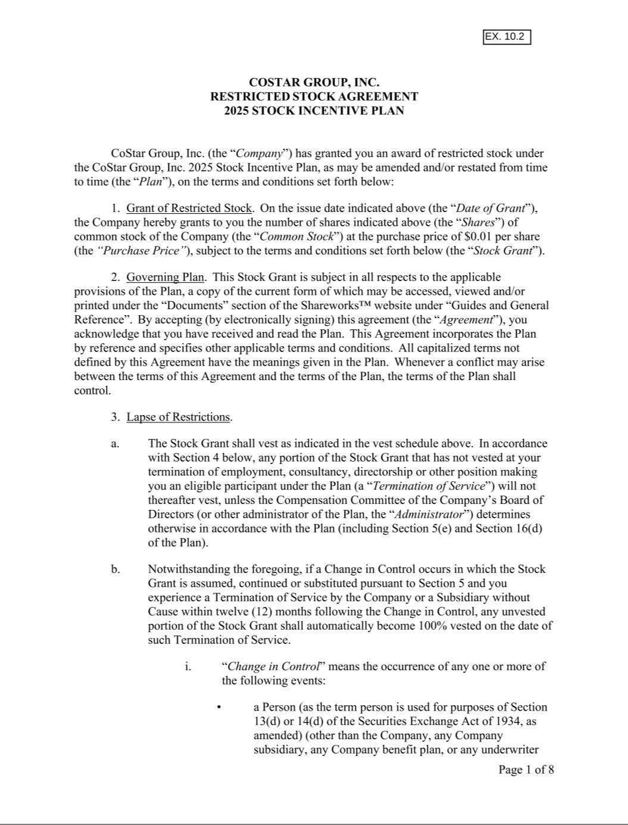

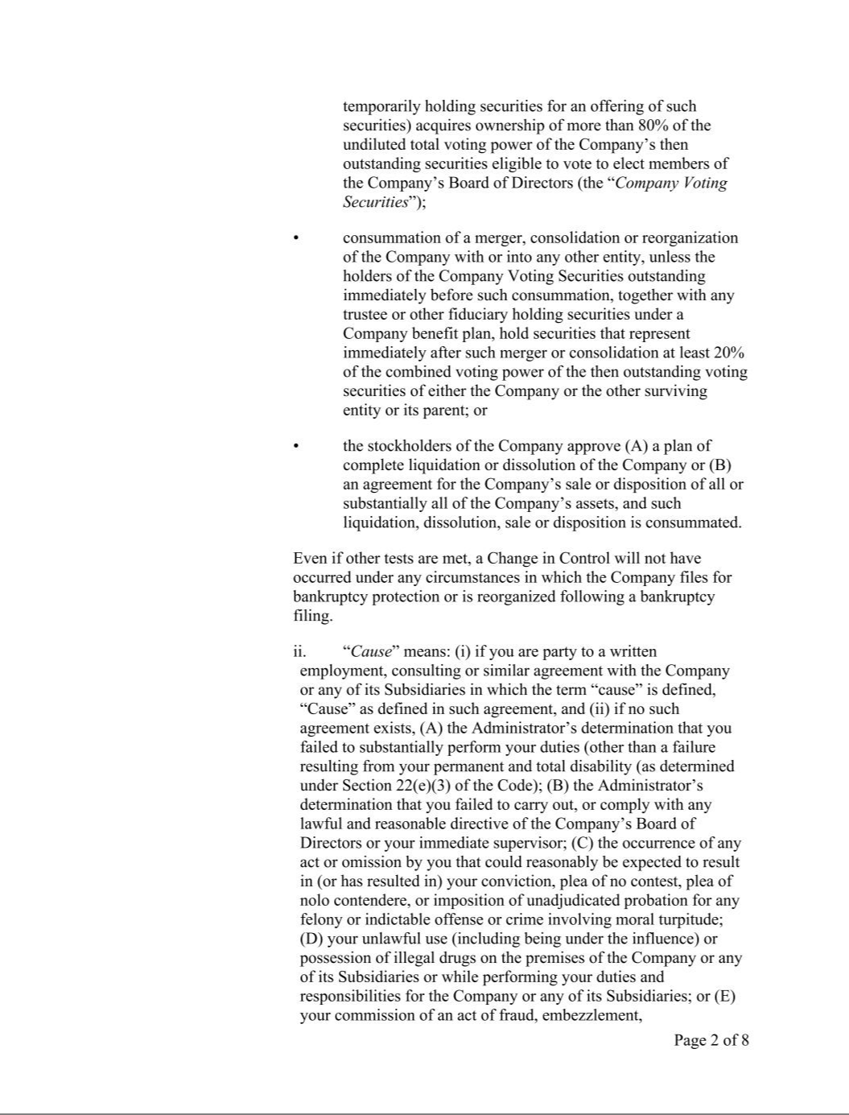



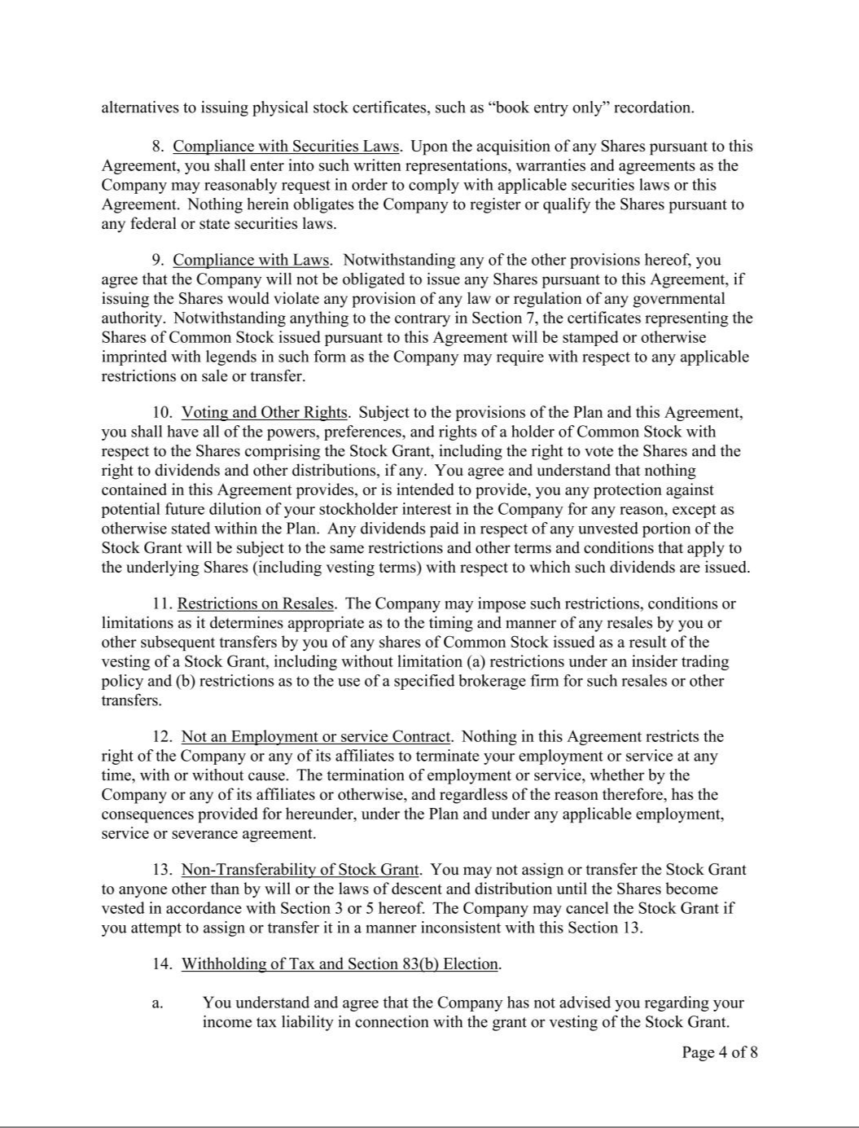

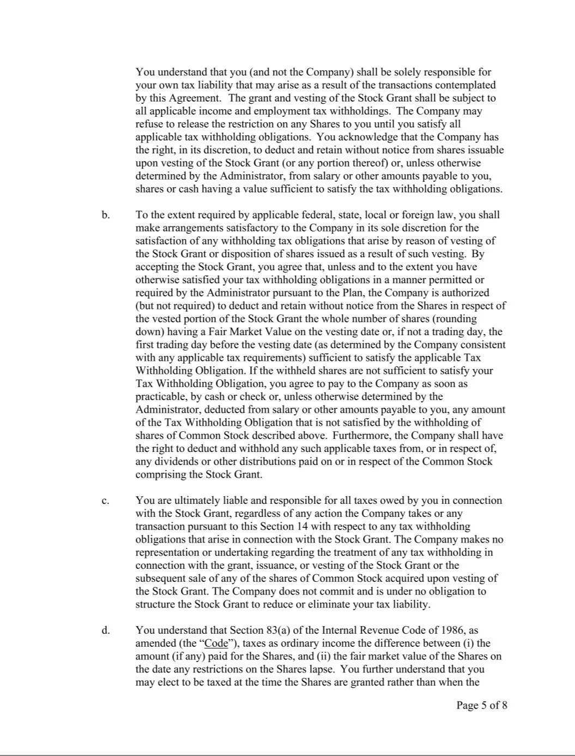

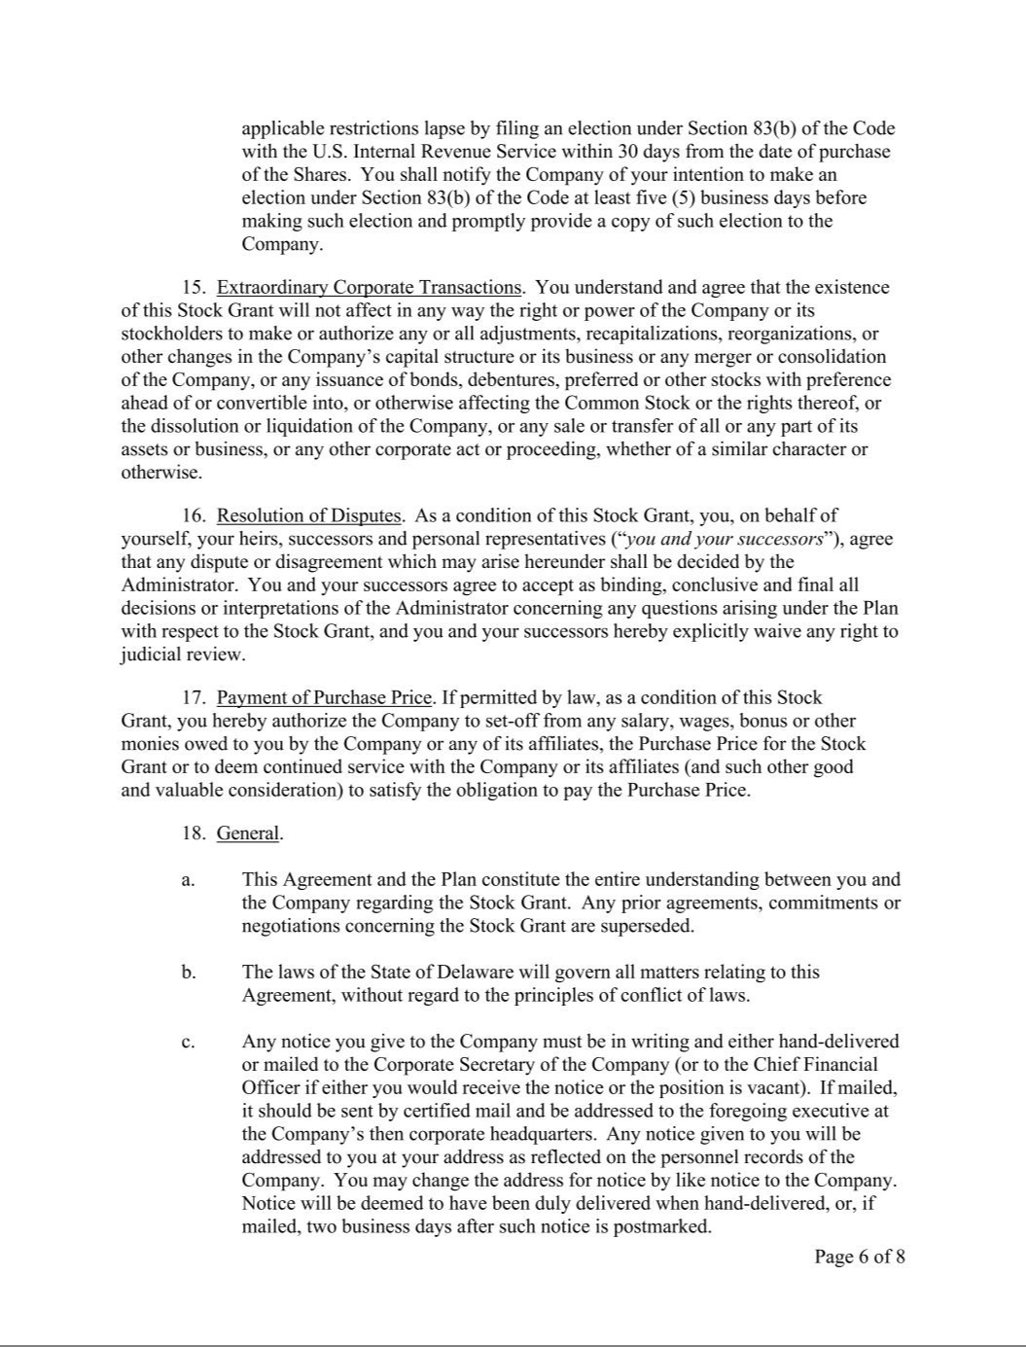

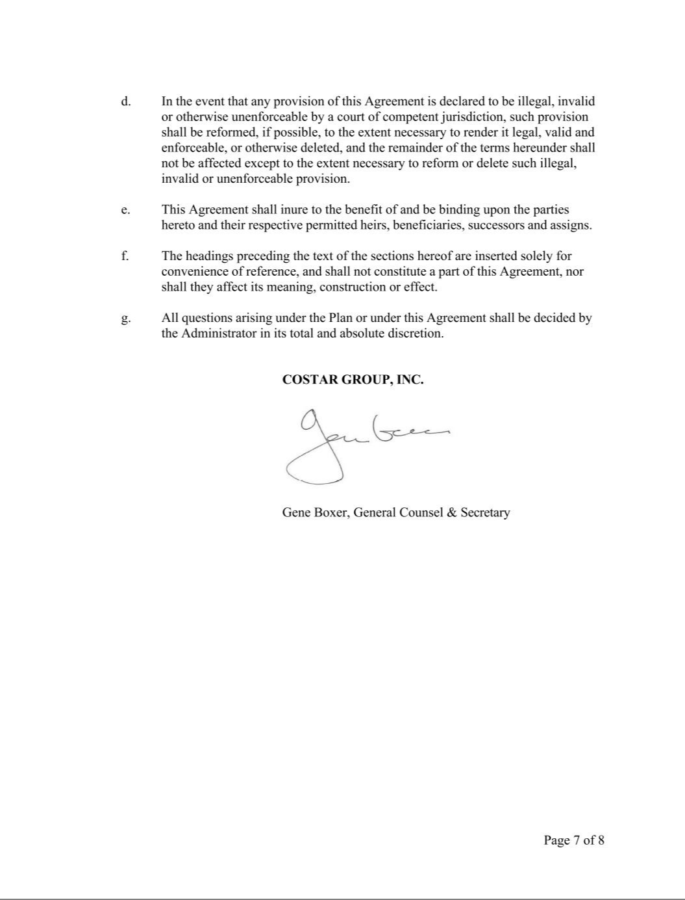

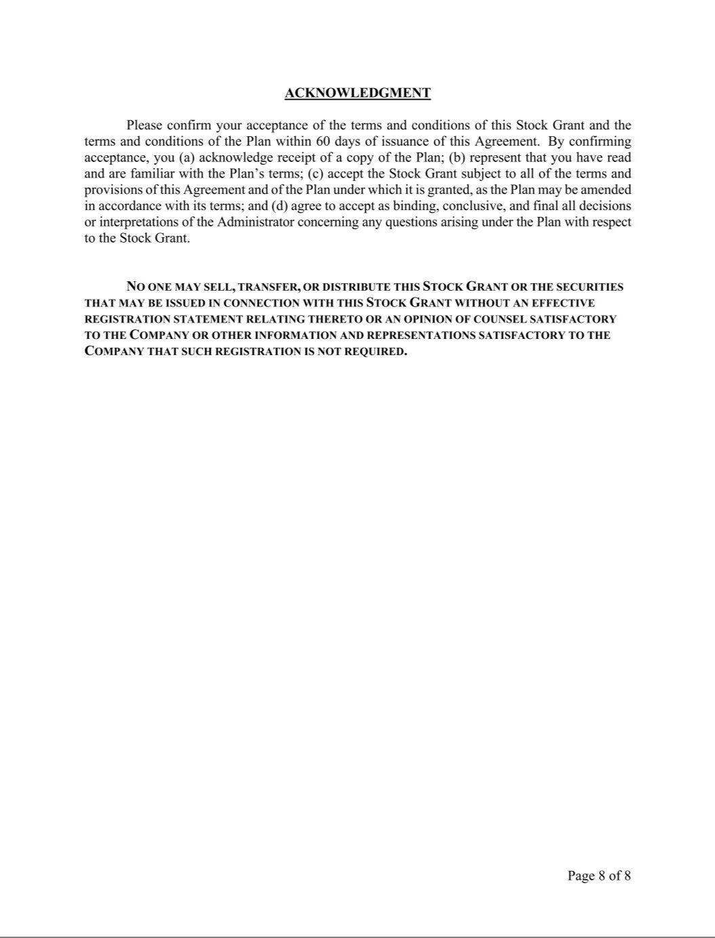

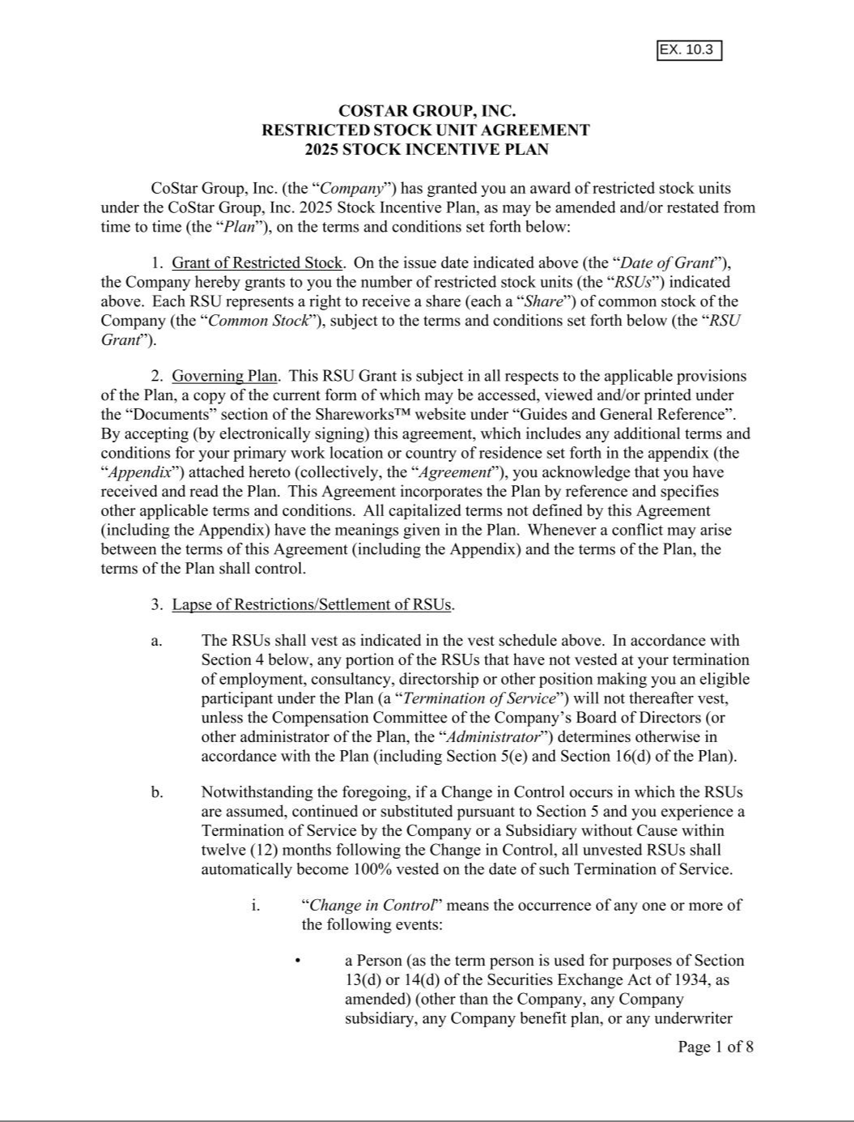

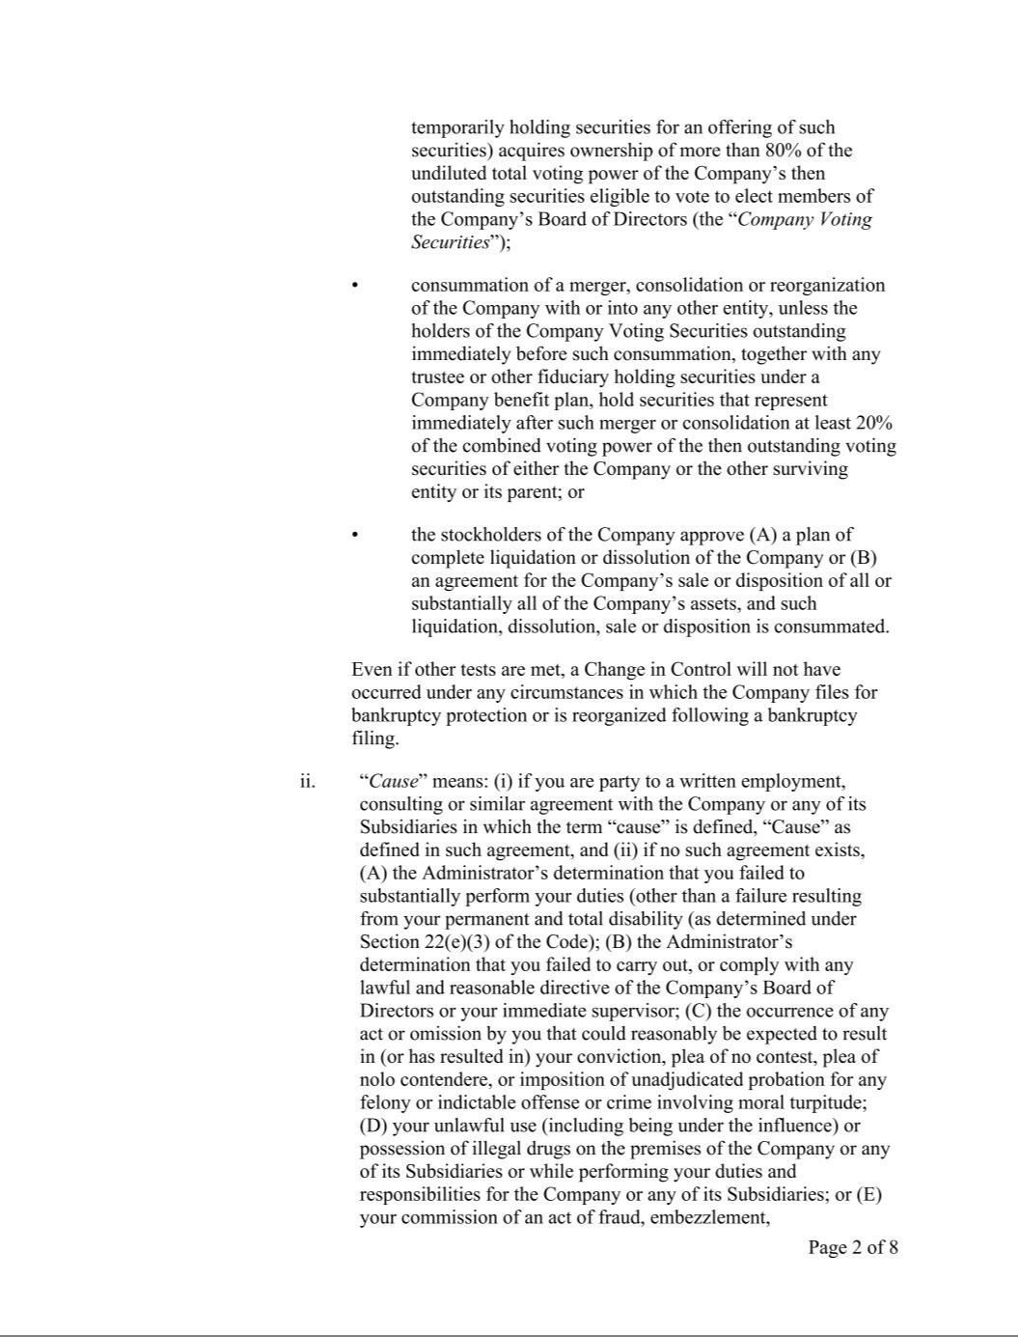

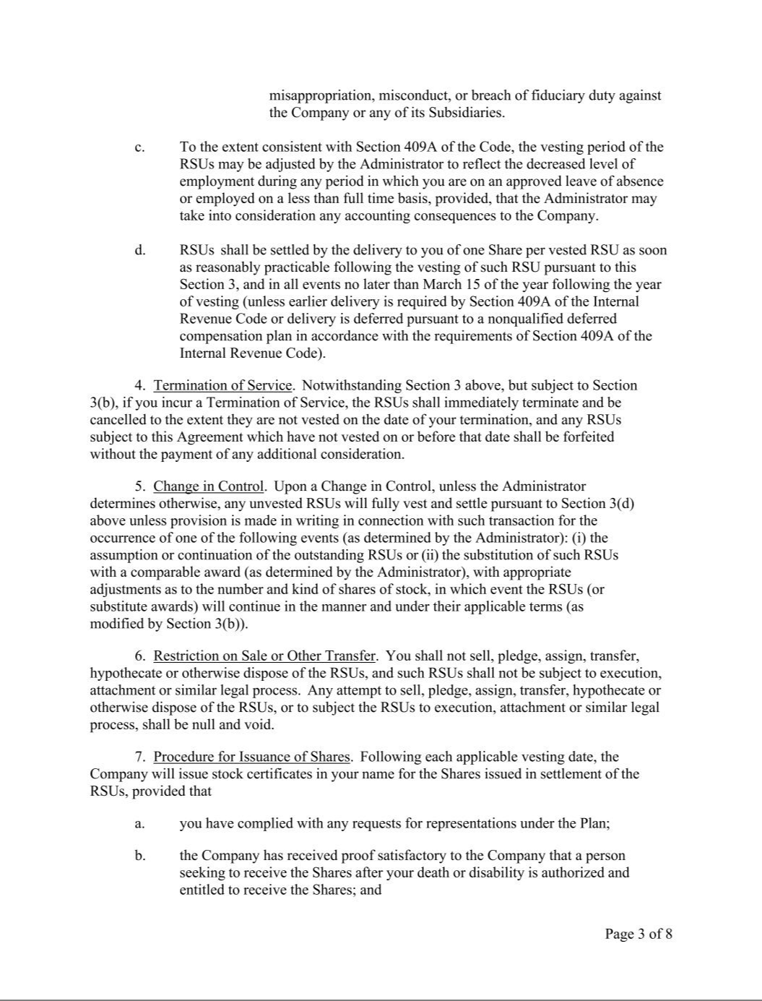

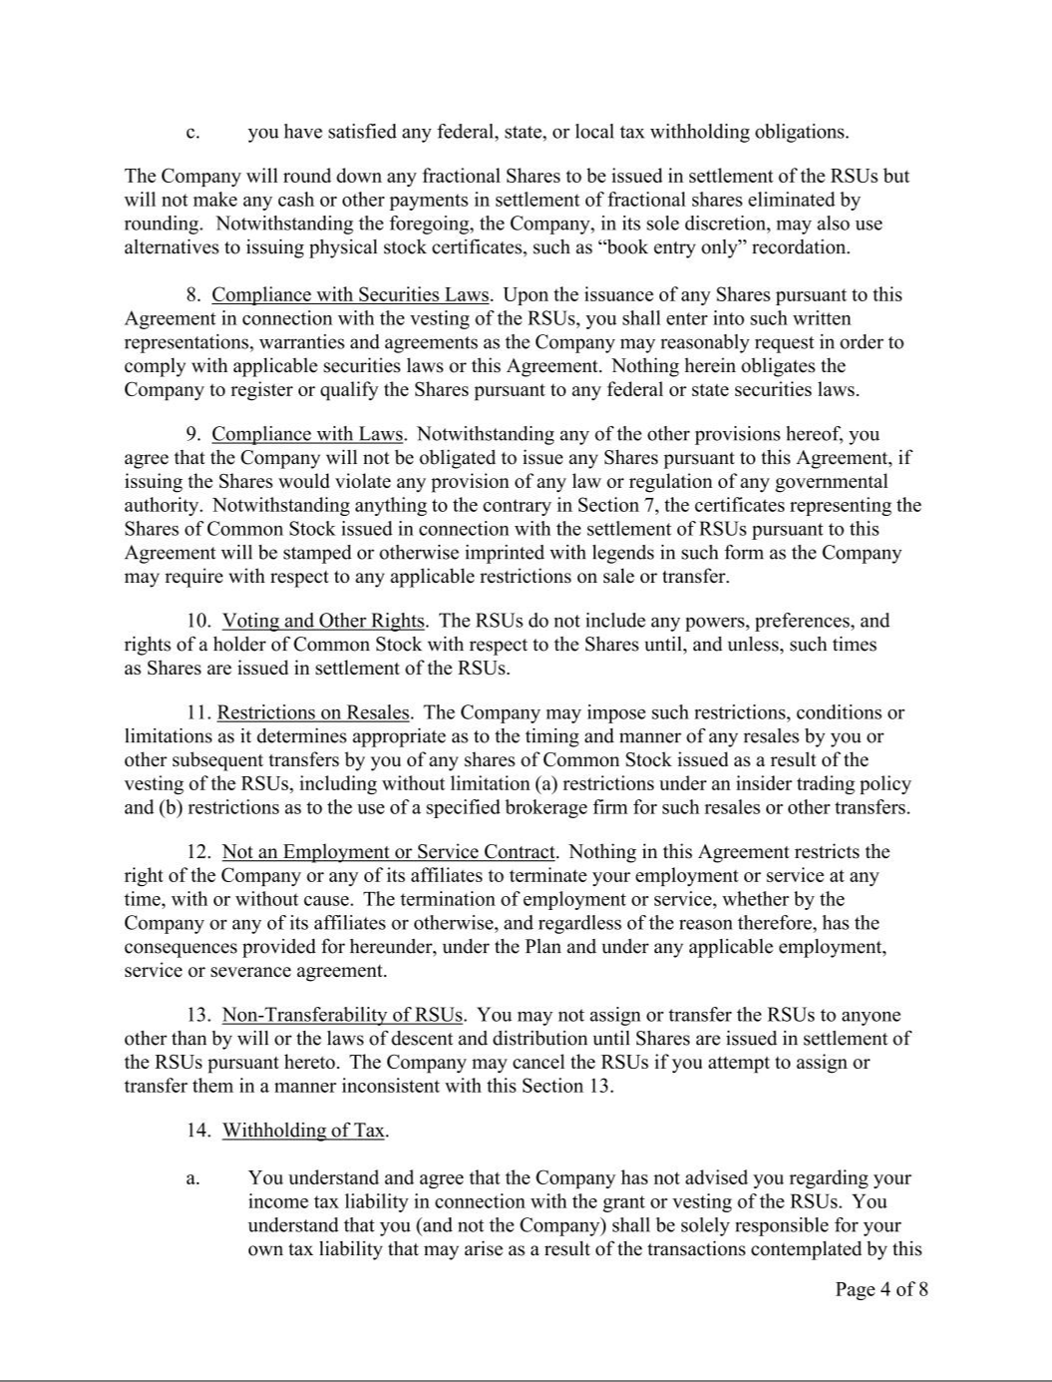

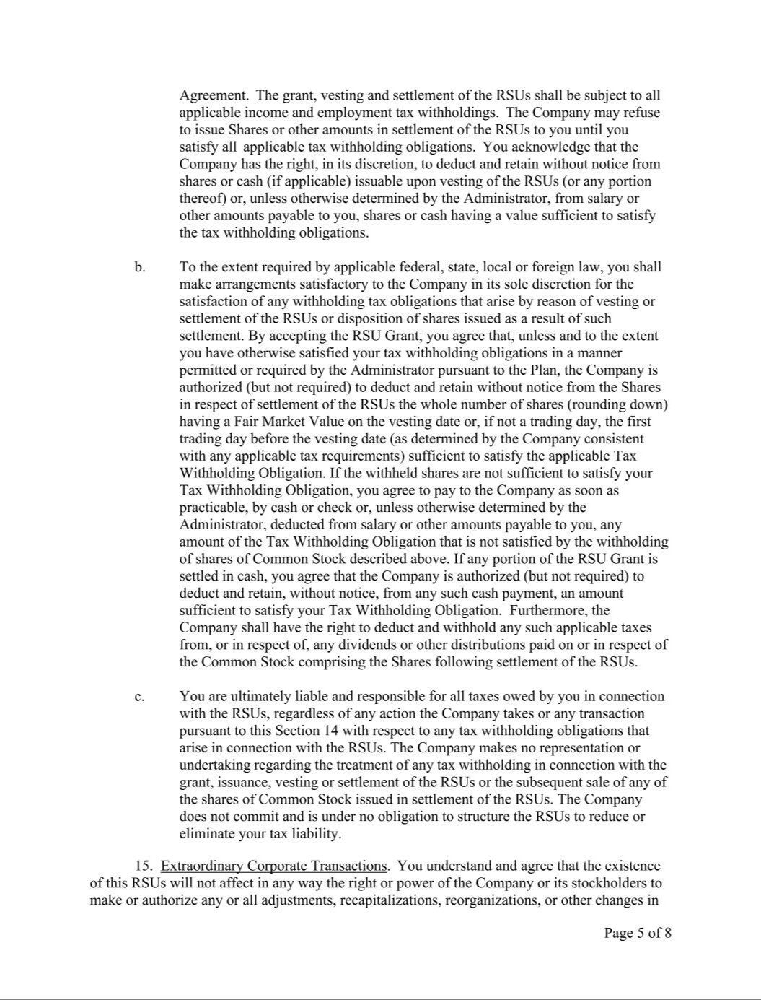

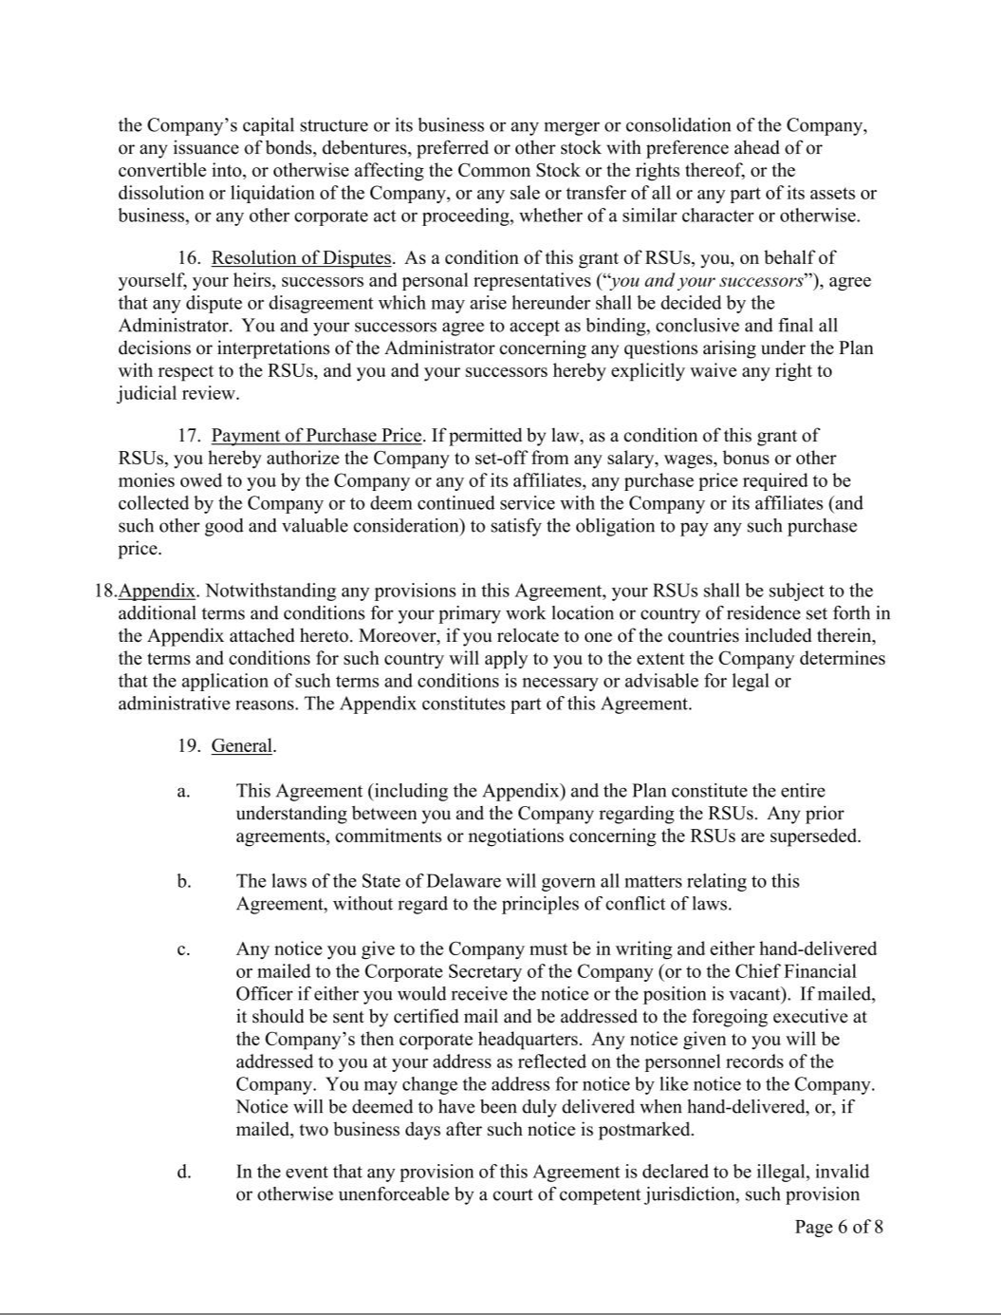

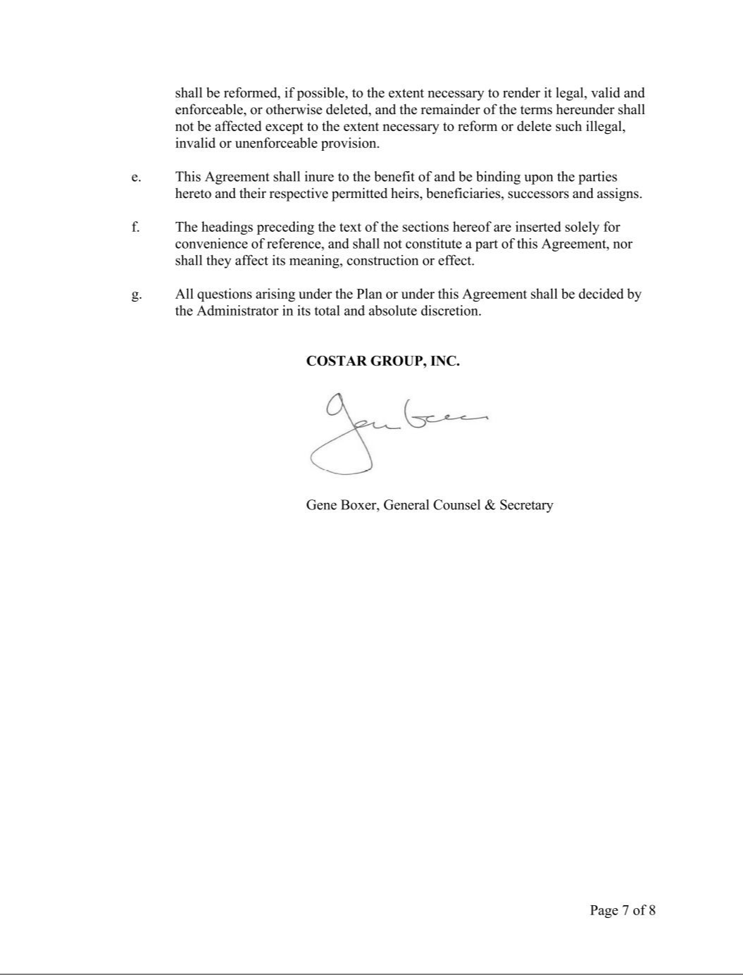

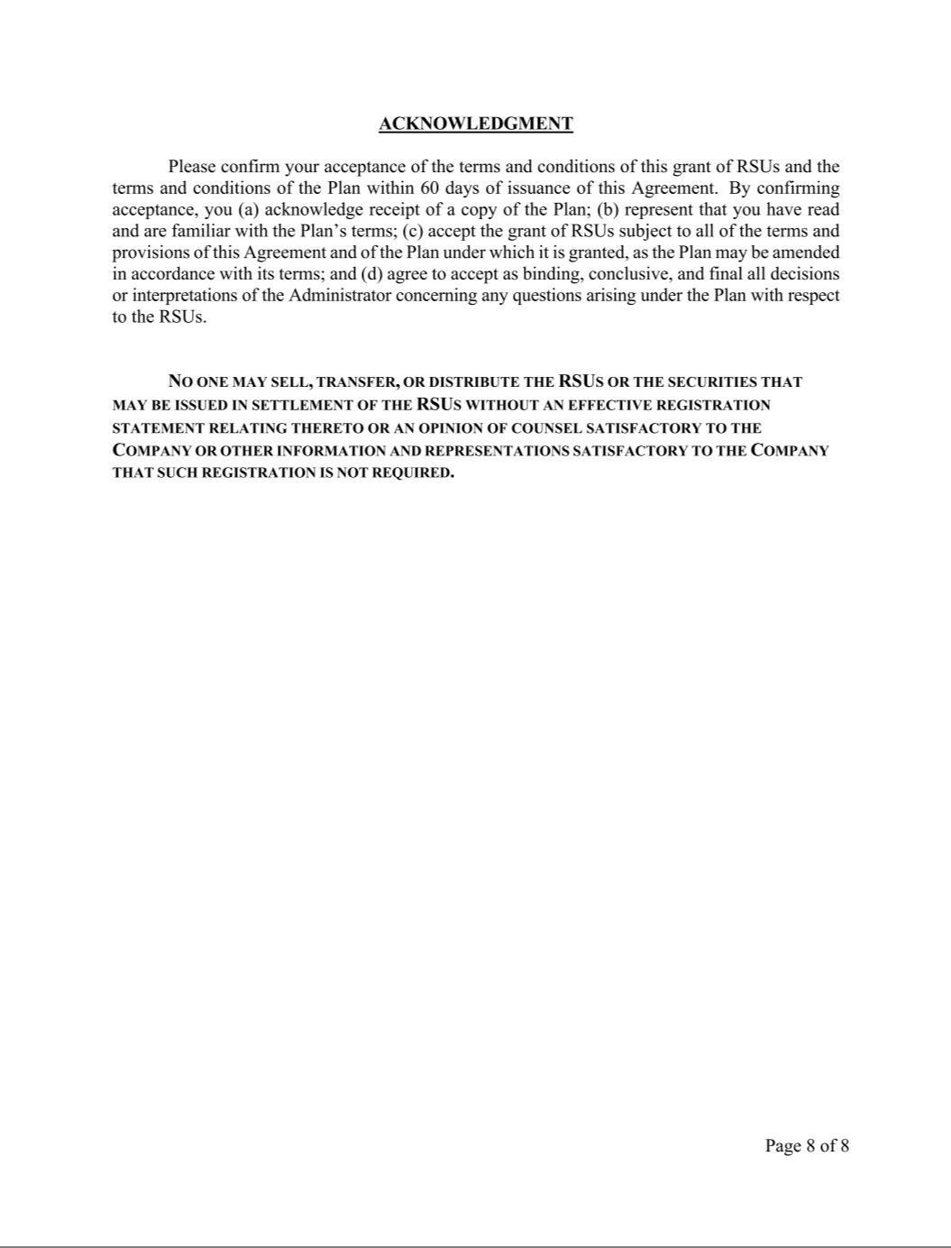

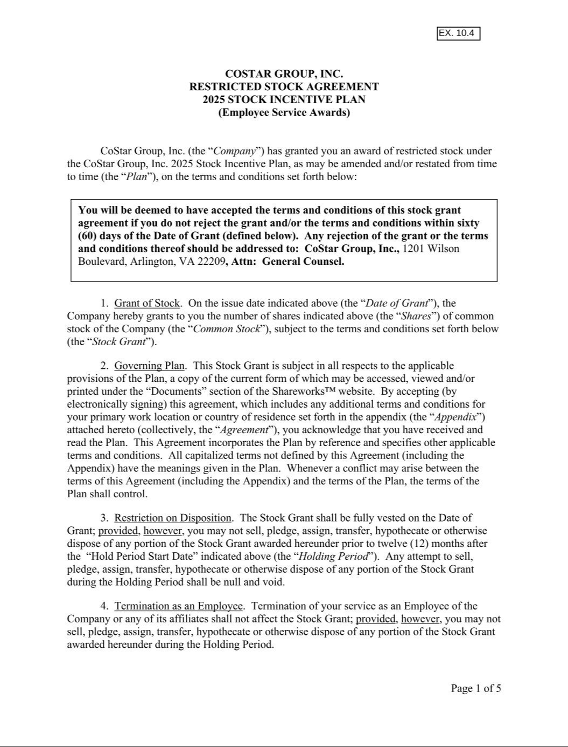

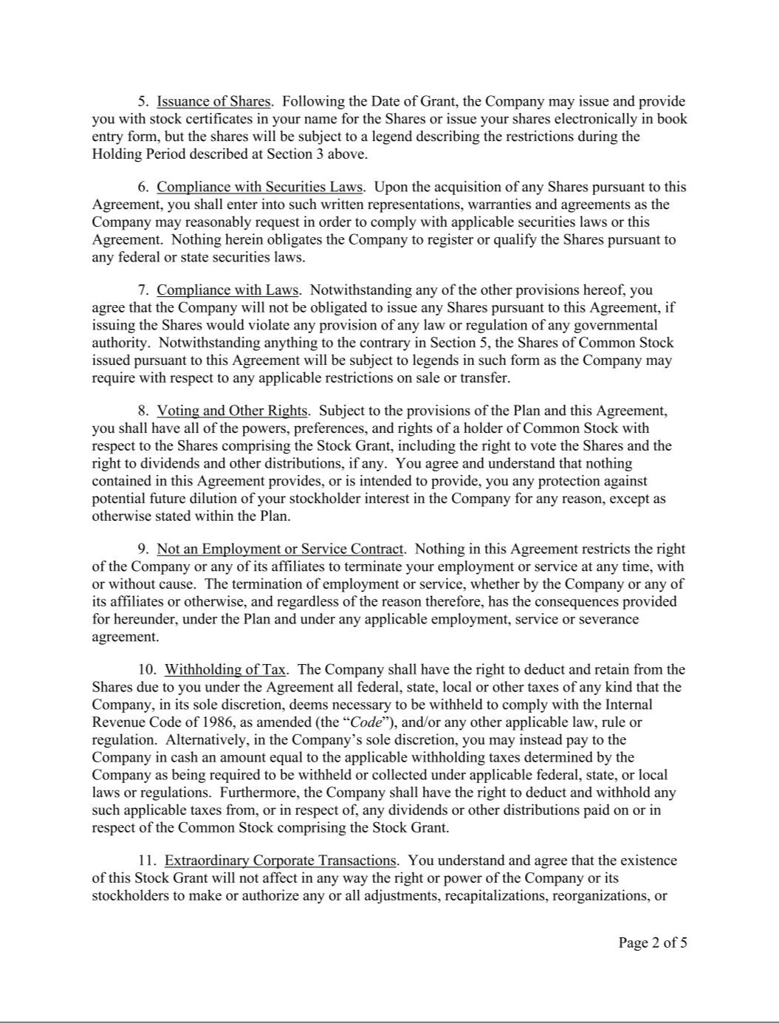

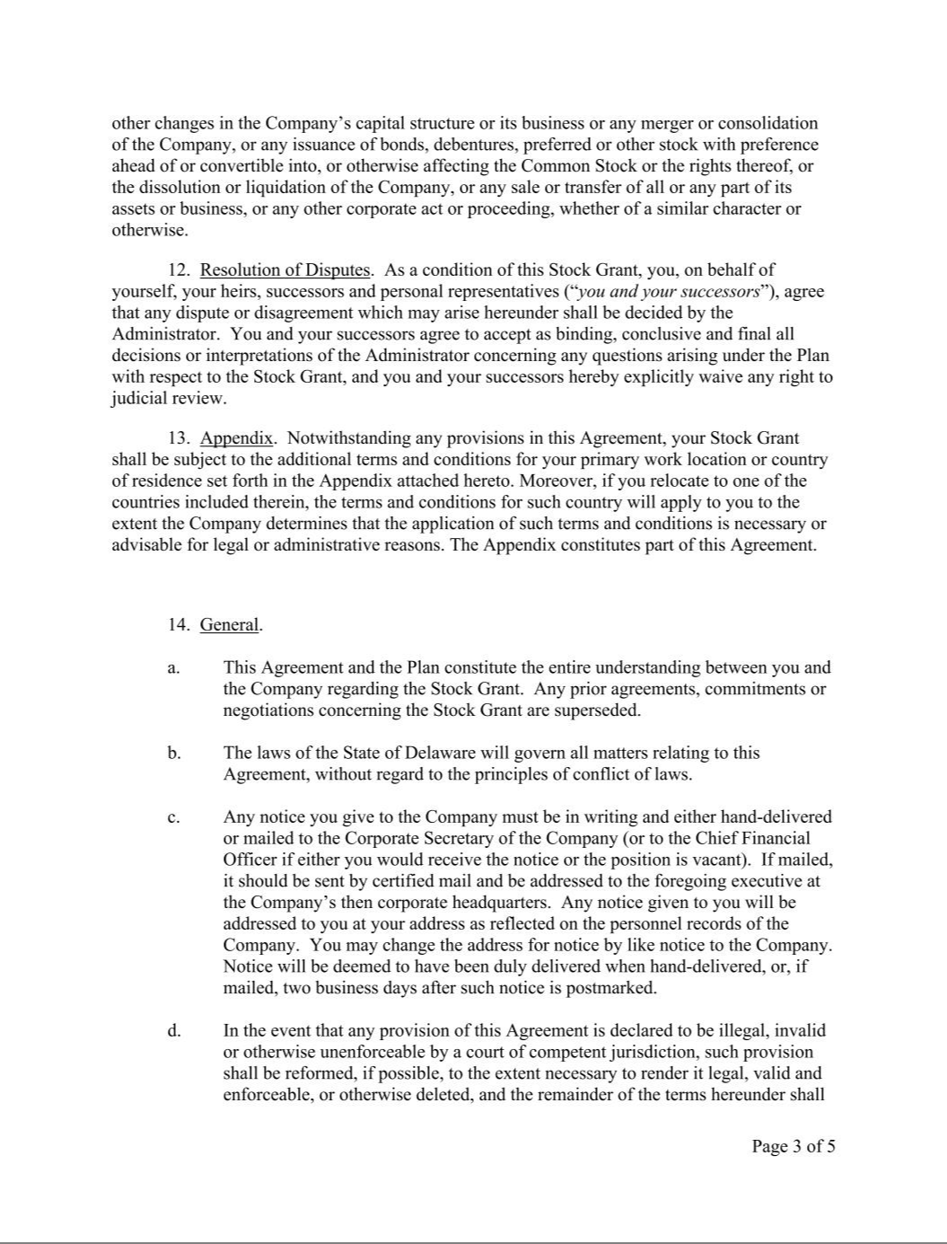



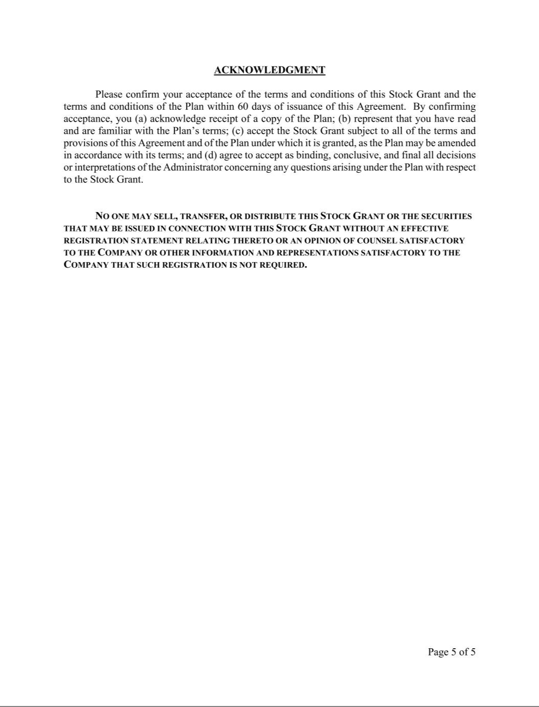

EXHIBIT 31.1

CERTIFICATION

I, Andrew C. Florance, certify that:

- I have reviewed this Quarterly Report on Form 10-Q of CoStar Group, Inc.;

- Based on my knowledge, this report does not contain any untrue statement of a material fact or omit to state a material fact necessary to make the statements made, in light of the circumstances under which such statements were made, not misleading with respect to the period covered by this report;

- Based on my knowledge, the financial statements, and other financial information included in this report, fairly present in all material respects the financial condition, results of operations and cash flows of the registrant as of, and for, the periods presented in this report;

- The registrant's other certifying officer(s) and I are responsible for establishing and maintaining disclosure controls and procedures (as defined in Exchange Act Rules 13a-15(e) and 15d-15(e)) and internal control over financial reporting (as defined in Exchange Act Rules 13a-15(f) and 15d-15(f)) for the registrant and have:

  - Designed such disclosure controls and procedures, or caused such disclosure controls and procedures to be designed under our supervision, to ensure that material information relating to the registrant, including its consolidated subsidiaries, is made known to us by others within those entities, particularly during the period in which this report is being prepared;

  - Designed such internal control over financial reporting, or caused such internal control over financial reporting to be designed under our supervision, to provide reasonable assurance regarding the reliability of financial reporting and the preparation of financial statements for external purposes in accordance with generally accepted accounting principles;

  - Evaluated the effectiveness of the registrant's disclosure controls and procedures and presented in this report our conclusions about the effectiveness of the disclosure controls and procedures, as of the end of the period covered by this report based on such evaluation; and

  - Disclosed in this report any change in the registrant's internal control over financial reporting that occurred during the registrant's most recent fiscal quarter (the registrant's fourth fiscal quarter in the case of an annual report) that has materially affected, or is reasonably likely to materially affect, the registrant's internal control over financial reporting; and

- The registrant's other certifying officer(s) and I have disclosed, based on our most recent evaluation of internal control over financial reporting, to the registrant's auditors and the audit committee of the registrant's board of directors (or persons performing the equivalent functions):

  - All significant deficiencies and material weaknesses in the design or operation of internal control over financial reporting which are reasonably likely to adversely affect the registrant's ability to record, process, summarize and report financial information; and

  - Any fraud, whether or not material, that involves management or other employees who have a significant role in the registrant's internal control over financial reporting.

Date: October 29, 2025 By: /s/ Andrew C. Florance

Andrew C. Florance

President and Chief Executive Officer

(Principal Executive Officer and Duly Authorized Officer)

EXHIBIT 31.2

CERTIFICATION

I, Christian M. Lown, certify that:

- I have reviewed this Quarterly Report on Form 10-Q of CoStar Group, Inc.;

- Based on my knowledge, this report does not contain any untrue statement of a material fact or omit to state a material fact necessary to make the statements made, in light of the circumstances under which such statements were made, not misleading with respect to the period covered by this report;

- Based on my knowledge, the financial statements, and other financial information included in this report, fairly present in all material respects the financial condition, results of operations and cash flows of the registrant as of, and for, the periods presented in this report;

- The registrant's other certifying officer(s) and I are responsible for establishing and maintaining disclosure controls and procedures (as defined in Exchange Act Rules 13a-15(e) and 15d-15(e)) and internal control over financial reporting (as defined in Exchange Act Rules 13a-15(f) and 15d-15(f)) for the registrant and have:

  - Designed such disclosure controls and procedures, or caused such disclosure controls and procedures to be designed under our supervision, to ensure that material information relating to the registrant, including its consolidated subsidiaries, is made known to us by others within those entities, particularly during the period in which this report is being prepared;

  - Designed such internal control over financial reporting, or caused such internal control over financial reporting to be designed under our supervision, to provide reasonable assurance regarding the reliability of financial reporting and the preparation of financial statements for external purposes in accordance with generally accepted accounting principles;

  - Evaluated the effectiveness of the registrant's disclosure controls and procedures and presented in this report our conclusions about the effectiveness of the disclosure controls and procedures, as of the end of the period covered by this report based on such evaluation; and

  - Disclosed in this report any change in the registrant's internal control over financial reporting that occurred during the registrant's most recent fiscal quarter (the registrant's fourth fiscal quarter in the case of an annual report) that has materially affected, or is reasonably likely to materially affect, the registrant's internal control over financial reporting; and

- The registrant's other certifying officer(s) and I have disclosed, based on our most recent evaluation of internal control over financial reporting, to the registrant's auditors and the audit committee of the registrant's board of directors (or persons performing the equivalent functions):

  - All significant deficiencies and material weaknesses in the design or operation of internal control over financial reporting which are reasonably likely to adversely affect the registrant's ability to record, process, summarize and report financial information; and

  - Any fraud, whether or not material, that involves management or other employees who have a significant role in the registrant's internal control over financial reporting.

Date: October 29, 2025 By: /s/ Christian M. Lown

Christian M. Lown

Chief Financial Officer

(Principal Financial Officer and Duly Authorized Officer)

EXHIBIT 32.1

CoStar Group, Inc.

1331 L Street, NW

Washington, DC 20005

October 29, 2025

Securities and Exchange Commission

100 F Street, NE

Washington, DC 20549

Re: Certification Of Principal Executive Officer Pursuant To 18 U.S.C. Sec. 1350

Dear Ladies and Gentlemen:

In connection with the accompanying Quarterly Report on Form 10-Q of CoStar Group, Inc., for the quarter ended September 30, 2025, I, Andrew C. Florance, Chief Executive Officer of CoStar Group, Inc., hereby certify pursuant to 18 U.S.C. Section 1350, as adopted pursuant to Section 906 of the Sarbanes-Oxley Act of 2002, that:

- such Quarterly Report on Form 10-Q of CoStar Group, Inc., for the quarter ended September 30, 2025, fully complies with the requirements of Section 13(a) or 15(d) of the Securities Exchange Act of 1934 (15 U.S.C. 78m or 78o(d)); and

- the information contained in such Quarterly Report on Form 10-Q of CoStar Group, Inc., for the quarter ended September 30, 2025, fairly presents, in all material respects, the financial condition and results of operations of CoStar Group, Inc.

By: /s/ Andrew C. Florance

Andrew C. Florance

President and Chief Executive Officer

(Principal Executive Officer and Duly Authorized Officer)

A signed original of this written statement required by Section 906, or other document authenticating, acknowledging or otherwise adopting the signature that appears in typed form within the electronic version of this written statement required by Section 906, has been provided to CoStar Group, Inc. and will be retained by CoStar Group, Inc. and furnished to the Securities and Exchange Commission or its staff upon request.

In accordance with Item 601 of Regulation S-K, this certification is being “furnished” as Exhibit 32.1 to CoStar Group, Inc.'s quarterly report and shall not be deemed “filed” for purposes of Section 18 of the Securities Exchange Act of 1934 (the “Exchange Act”) or otherwise subject to the liabilities of that section, nor shall it be deemed incorporated by reference in any filing under the Securities Act of 1933 or the Exchange Act, except as expressly set forth by specific reference in such a filing.

EXHIBIT 32.2

CoStar Group, Inc.

1331 L Street, NW

Washington, DC 20005

October 29, 2025

Securities and Exchange Commission

100 F Street, NE

Washington, DC 20549

Re: Certification Of Principal Financial Officer Pursuant To 18 U.S.C. Sec. 1350

Dear Ladies and Gentlemen:

In connection with the accompanying Quarterly Report on Form 10-Q of CoStar Group, Inc., for the quarter ended September 30, 2025, I, Christian M. Lown, Chief Financial Officer of CoStar Group, Inc., hereby certify pursuant to 18 U.S.C. Section 1350, as adopted pursuant to Section 906 of the Sarbanes-Oxley Act of 2002, that:

- such Quarterly Report on Form 10-Q of CoStar Group, Inc., for the quarter ended September 30, 2025, fully complies with the requirements of Section 13(a) or 15(d) of the Securities Exchange Act of 1934 (15 U.S.C. 78m or 78o(d)); and

- the information contained in such Quarterly Report on Form 10-Q of CoStar Group, Inc., for the quarter ended September 30, 2025, fairly presents, in all material respects, the financial condition and results of operations of CoStar Group, Inc.

By: /s/ Christian M. Lown

Christian M. Lown

Chief Financial Officer

(Principal Financial Officer and Duly Authorized Officer)

A signed original of this written statement required by Section 906, or other document authenticating, acknowledging or otherwise adopting the signature that appears in typed form within the electronic version of this written statement required by Section 906, has been provided to CoStar Group, Inc. and will be retained by CoStar Group, Inc. and furnished to the Securities and Exchange Commission or its staff upon request.

In accordance with Item 601 of Regulation S-K, this certification is being “furnished” as Exhibit 32.2 to CoStar Group, Inc.'s quarterly report and shall not be deemed “filed” for purposes of Section 18 of the Securities Exchange Act of 1934 (the “Exchange Act”) or otherwise subject to the liabilities of that section, nor shall it be deemed incorporated by reference in any filing under the Securities Act of 1933 or the Exchange Act, except as expressly set forth by specific reference in such a filing.

